PRCP schedule: DRAFT P-PRCP-100663802_V1_Blair Athol
PRCP schedule holder(s)

Name(s) | Registered address
Orion Mining Pty Ltd | Blair Athol Mine Access Road, CLERMONT QLD 4721
Location details
Location(s)
Mining Lease (ML) 1804
Take effect
In accordance with section 202B of the Environmental Protection Act 1994 (EP Act), the PRCP schedule has effect on the day the environmental authority for carrying out relevant activities on land to which the schedule relates takes effect. Pursuant to section 202C of the EP Act, a PRCP schedule continues in force until the environmental authority for the relevant activities to which the PRCP schedule relates is cancelled or surrendered, even if the resource tenure expires or is cancelled and even if the relevant environmental authority is suspended under Chapter 5, part 11 or 11A of the EP Act.
 |  |  | DRAFT
 | Signature |  | Date
DRAFT |  |  | Enquiries:
Department of the Environment, Tourism, Science and Innovation  Delegate of the administering authority  Environmental Protection Act 1994 |  |  | Coal Business Centre  PO Box 3028, Emerald QLD 4720  Phone: (07) 4987 9320  Email: CRMining@detsi.qld.gov.au

Obligations under the Environmental Protection Act 1994
Pursuant to section 202E of the EP Act, if there is an inconsistency between an environmental authority and a PRCP schedule, the environmental authority prevails to the extent of the inconsistency.
Pursuant to section 285 of the EP Act:
- the holder of a PRCP schedule must commission an audit of the schedule by a rehabilitation auditor for the following periods (each an audit period) —
(a) the 3-year period starting on the day the schedule takes effect
(b) each 3-year period starting on the day after the previous audit period ended.
- the holder must, within 4 months after the end of each audit period, give the administering authority -
(a) the rehabilitation auditor’s report (an audit report) about the audit that complies with section 286 of the EP Act, and
(b) a declaration for the audit report that complies with section 285 of the EP Act.
In addition to the requirements found in the conditions of this PRCP schedule, the holder must also meet their obligations under the environmental authority, the EP Act, and the regulations made under the EP Act. For example, the holder must comply with the following provisions of the EP Act:
- general environmental duty (section 319)
- duty to notify environmental harm (section 320-320G)
- offence of causing serious or material environmental harm (sections 437-439)
- offence of causing environmental nuisance (section 440)
- offence of depositing prescribed water contaminants in waters and related matters (section 440ZG)
- offence to place contaminant where environmental harm or nuisance may be caused (section 443).
PRCP schedule
The PRCP schedule incorporates the following sections:
- Section A - Conditions of PRCP schedule
- Section B - Final site design and reference maps
- Section C - Post mining land uses
- Section D - Non-use management areas
- Section E – Attachments

Definitions
Activity (EP Regulation) | includes that part, if any, of an activity relating to the following—  (a) preparing a place for the activity before carrying out the activity;  (b) rehabilitating a place after it has been used for carrying out the activity.
Appropriately qualified person (AQP) | means a person who has professional qualifications, training, skills and experience relevant to the nominated subject matter and can give authoritative assessment, advice and analysis on performance relative to the subject matter using the relevant protocols, standards, methods or literature.
BioCondition | refers to the BioCondition Assessment Manual (Eyre, T.J., Kelly, A.L, Neldner, V.J., Wilson, B.A., Ferguson, D.J., Laidlaw, M.J. and Franks, A.J. (2015)) and BioCondition: A Condition Assessment Framework for Terrestrial Biodiversity in Queensland. Assessment Manual. Version 2.2 (Queensland Herbarium, Department of Science, Information Technology, Innovation and Arts, Brisbane) or later versions thereof.
Contaminants | can be a gas, liquid or solid; or an odour; or an organism (whether alive or dead), including a virus; or energy, including noise, heat, radioactivity and electromagnetic radiation; or a combination of contaminants.
Contaminated Land Auditor | A contaminated land auditor is responsible for auditing the work of the suitably qualified person (SQP) by evaluating and certifying site investigation and validation reports and drafting the site management plans that are submitted for a decision on a land contamination matter.
Environmentally problematic material | means material (e.g. PAF) that will negatively impact water quality and stability or vegetation growth.
Exploration, Ancillary and other authorised activities (RA4) | Includes the following activities:  - Exploration; and  - Ancillary activities such as roads, fences, underground services, telecommunications facilities, pipelines, electrical infrastructure, storage depots, laydown or shutdown pads and monitoring stations and bores.  *Rehabilitation milestones applicable to RA4 Exploration, Ancillary and other authorised activities only applicable where activities have been undertaken.  PMLU of Grazing.
Flood stress | is the pressure on structures from rapid water rise, erosion, and saturation during extreme floods, risking instability.
Growth media | is defined as all soil and soil-like material that will support the final vegetation cover. This includes the topsoil and subsoil where these materials are applied independently. Where the topsoil is incorporated into the underlying subsoil/spoil, topsoil refers to the depth of incorporation and the remaining depth is regarded as subsoil. The total depth of growth media is nominally considered to be the effective plant root zone
Gully | A gully is a channel excavated by water, more than 0.3 m deep.
Independent AQP | is an AQP who is a third party, being independent of the PRCP schedule holder, and has not previously provided advice on the matter the subject of the review.
Independently peer reviewed | means a peer reviewer who is a third-party to the PRCP schedule holder and the AQP whose report is being reviewed and substantiated. The peer reviewer shall also be an AQP and documentation provided must contain sufficient detail to allow for independent technical review and substantiation and provide and justify site-specific landform performance (SMART) criteria.
Potentially acid forming (PAF) | means material with either a Net Acid Producing Potential of greater than 5 kg of H₂SO₄/tonne or a Net Acid Generation oxidation pH of less than 4.5 (pH unit).
Rehabilitation activity | means any activity that the holder is required to carry out in relation to this PRCP schedule.
Relevant material | includes:  - Final landform design report,  - Durability assessment/ report,  - “As Constructed” report;  - All monitoring data  - Assessment of monitoring data,  - All maintenance records; and  - Modelling and technical assessments.
Relevant structure | To be defined during the assessment and listed here. Typically includes TSF and higher risk structures, including WRDs.
Rill | A rill is a channel excavated by water, less than 0.3 m deep.
Stable | in relation to land, means landform dimensions are or will be stable within tolerable limits now and in the foreseeable future.  Stability includes consideration of environmental context, geotechnical stability, settlement and consolidation allowances, bearing capacity (trafficability), erosion resistance and geochemical stability with respect to seepage, leachate and related contaminant generation.
Stabilised | means one or both of the following conditions apply: no evidence of sediment movement; sides and/or floors of erosion form are revegetated (Australian Soil and Land Survey Field Handbook Third Edition).
Stable condition | see section 111A of the Environmental Protection Act 1994.
Suitably qualified and experienced person (SQP) | for performing a regulatory function under chapter 7, part 8 (Contaminated Land) of the EP Act or another function prescribed under a regulation, means a person who—  (a) has qualifications and experience relevant to performing the function; and  (b) if a regulation prescribes an organisation for this paragraph—is a member of the organisation.
Vegetative groundcover | Means plants, plant litter, tree leaf litter, twigs and woody debris capable of protecting the soil surface from erosion

Section A - Conditions of PRCP schedule
Pursuant to section 206A of the EP Act:
- it is a condition of this PRCP schedule that, in carrying out a relevant activity under the schedule, the holder must comply with a requirement stated in the environmental authority relevant to carrying out the activity.
- it is a condition of this PRCP schedule that the holder must comply with the following matters stated in the schedule -
(a) each rehabilitation milestone and management milestone
(b) when each rehabilitation milestone and management milestone is to be achieved

There are no conditions beyond those contained in section 206A of the Environmental Protection Act 1994 that apply to this PRCP schedule.
General conditions
PRCP | Condition
PRCP1 | All mining disturbance authorised under EA EPML00876713 must have an associated rehabilitation outcome provided in this PRCP Schedule.
PRCP2 | The holder must for each rehabilitation and improvement area, achieve the corresponding rehabilitation or management milestone criterion (milestone reference):  - For the cumulative area available specified in this schedule; and  - By the milestone completion date specified in this schedule.
PRCP3 | Where land becomes ‘available for rehabilitation’ earlier than the date nominated in this schedule, the holder must:  - Notify the administering authority in writing within 30 days of the land becoming ‘available for rehabilitation’;  - Describe in the notification why or why not it considers that it would be reasonable and appropriate to apply to the administering authority to amend this schedule; and  - Unless otherwise agreed to by the administering authority in writing, apply to the administering authority within sixty (60) days of the notification to amend this schedule in a way that maximises the progressive rehabilitation to a stable condition.  Note:  - Reference to "earlier than the nominated date in the schedule" means a date that is greater than 1 year prior to the date nominated in the schedule.  - Assessment of land becoming available is undertaken on a nominally annual basis.  - Rehabilitation of land size must be practicable.  - The dates by which subsequent milestones are to be completed is brought forward, by the same amount of time as the commencement was brought forward, to the extent it is reasonably practicable to do so.
PRCP4 | Where an area achieves a rehabilitation or management milestone, the holder must continue to achieve the milestone for that rehabilitation milestone until:  - A progressive certification area has satisfied the provisions of section 318ZB (4) of the EP Act; and  - A surrender is approved.
PRCP5 | The holder must maintain a risk register that identifies the risks to not achieving:  - A stable condition for post-mining land uses (PMLU);  - Sufficient improvement for non use management areas (NUMA); and  - How the risks are being managed or minimised.
PRCP6 | The risk register (PRCP5) must be reviewed annually and include consideration of the outcomes of PRCP monitoring data.
PRCP7 | The holder must carry out monitoring in accordance with:  - The monitoring and maintenance program described in the rehabilitation planning part for the activity version XXXXXXXX;  - Any requirement under this schedule; and  - As necessary to demonstrate achievement of each rehabilitation milestone or management milestone criteria.  Note: Where there is any inconsistency between this schedule and the rehabilitation planning part, the schedule criteria prevail to the extent of the inconsistency.
PRCP8 | The holder must make and keep up to date records on:  - Achievement and maintenance of each rehabilitation or management milestone criteria of this schedule;  - Rehabilitation activities and the results of those activities (including but not limited to, actions taken, date, location, methods, data collected, QA/QC, photos, waste tracking and disposal records; appropriately qualified person details and assumptions);  - Maintenance of rehabilitation and the results of maintenance activities;  - Monitoring of rehabilitation and the results of monitoring;  - Details and results of rehabilitation trials;  - Designs, drawings, specifications and any similar documents developed in accordance with good professional practice in relation to rehabilitation milestones or milestone criteria;  - All documents in relation to the requirements of this schedule, including reports (e.g. site investigation report), statements (e.g. site suitability statement), certifications, assessments, investigations, inspections, audits or any similar documents developed in relation to rehabilitation milestones or milestone criteria;  - Landholder agreements; and  - Details of community consultation in the community consultation register relating to rehabilitation and closure activities.
PRCP9 | Records made under PRCP8 must be kept until the relevant environmental authority has been surrendered.
PRCP10 | Records made under PRCP8 must be provided to the administering authority in the specified format within 10 business days of a written request.
PRCP11 | All AQP designs, specifications, certifications, assessments and any similar documents, must:  - Include documented consideration of any relevant guideline or publication material, including material published by the administering authority;  - Detail the boundary conditions (of any model);  - Detail any assumptions made, limitations and areas of uncertainty; and  - Must contain sufficient detail to allow for independent peer review and substantiation.
PRCP12 | Disturbance due to exploration and minor ancillary activities in areas not planned to be mined and not within a Rehabilitation Area in this Schedule must be rehabilitated in accordance with the provisions detailed in the ‘Eligibility criteria and standard conditions for exploration and mineral development projects’ or its successor, with the exception that land must be rehabilitated to a stable condition which includes achieving the relevant post mining land use for the disturbance location as detailed in Figure 1 – Final Site Design.
PRCP13 | The holder must, by 10 December 2030, provide to the administering authority up-to-date closure groundwater, residual void and water balance model/s (calibrated once data becomes available) which must be maintained with predictions rerun at least every five (5) years and within a year of any surrender application
PRCP14 | The holder must, by 10 December 2028, provide to the administering authority a flood assessment prepared by an appropriately qualified person (AQP) that addresses the requirements of section 3.6.1 of the PRCP guideline and includes further detail and clarity regarding -  - Flood depth and velocity for the 0.1%AEP for the final landform;  - The influence of flooding on the final landform (including but not limited to overtopping risk for residual voids) and justify that this is a stable condition;  - The future conditions of watercourses, including the geotechnical assessment against flood modelling velocities, the post mining flood model, and justify how this will form a stable condition; and  - Mitigation measures to address the issues identified in the PRC planning part.
PRCP15 | By 10 December 2028, the holder must submit to the administering authority, a report outlining:  - Conceptual and detailed design reports detailing the proposed upgrades of Eastern and Western Diversion Drains (EDD and WDD), clearly demonstrating their performance (at least 0.1% AEP flood), long-term structural integrity and resilience. The reports must align with OSW/2019/4599 and other relevant guidelines.  - Consequence category assessment (CCA) (under ESR/2016/1933) required to evaluate risk and use design flood greater than 0.1% AEP in design of diversion and levees up to PMF if risk management requires.  - Updated flood modelling to reflect a realistic scenario, using upgrades dimensions (instead of artificial break-line constraints) and verifying that diversions and levees provide effective long-term flood protection, as required by the EP Reg 2019 and PRCP Guideline.
PRCP16 | By 10 December 2027, the holder must submit to the administering authority a report that includes:  - The proposed methodology of assessing rehabilitation against the reference site; and  - An AQP review of the adequacy of reference sites listed in Attachment 10 – Rehabilitation Reference Sites which at a minimum must consider:  - The location of the reference site (GDA2020);  - The number of reference sites nominated;  - The rehabilitation area/domain to which each reference site relates; and  - Justification for the suitability of each nominated reference site.
PRCP17 | Once endorsed by the administering authority, the methodology for assessing rehabilitation against the reference sites attributes identified in condition PRCP16 will replace the BioCondition benchmark criteria listed in RM6.7, RM6.8, RM7.16 and RM7.17 and Attachment 4 – BioCondition Benchmark Criteria.
PRCP18 | By 30 September 2027, the holder must submit to the administering authority a report that proposes soil quality for inclusion in Attachment 1 – Soil Quality Criteria based on site specific data.
PRCP19 | By 30 December 2027, the holder must submit to the administering authority a report that proposes surface water quality and monitoring frequency for inclusion in Attachment 6 – Surface Water Quality Criteria based on site specific data.
PRCP20 | The holder must, by 10 December 2027, provide to the administering authority a report which:  - reviews the criteria / quality limits based on site-specific data for Attachment 8 – Groundwater quality criteria;  - Considers the requirements of the administering authority’s, or its successor’s, most recent edition of the Guideline: “Using monitoring data to assess groundwater quality and potential environmental impacts” (DES, 2021); and  - Reviews the adequacy of the groundwater monitoring network for closure.
PRCP21 | The holder must apply to amend Attachment 7 – Groundwater monitoring bores and Attachment 8 – Groundwater quality criteria of this PRCP schedule, within 3 months of finalising the:  (a) updated modelling required by condition PRCP13; and  (b) groundwater quality and bore network review required by PRCP20.
PRCP22 | Erosion modelling  By 10 December 2027, provide to the administering authority a final landform design and supporting technical assessments to demonstrate that the proposed design can be expected to remain erosionally stable in the long term, including:  - Landform erosion assessment of all relevant landforms using measured material erodibility properties, undertaken in accordance with the recommendations of the Office of the Qld Mine Rehabilitation Commissioner's technical papers on the use of erosion and landform evolution modelling.¹  - Current milestone criteria are consistent with the assumptions, findings, and recommendations of the erosion assessment.  Note:  (1) Leading practice guidance on erosion and landform evolution modelling to design post-mining landforms, July 2025 and Applying erosion and landform evolution models to assess post-mining landform stability, February 2025.

END OF CONDITIONS

Section B - Final site design and reference maps

Figure 1 – Final Site Design
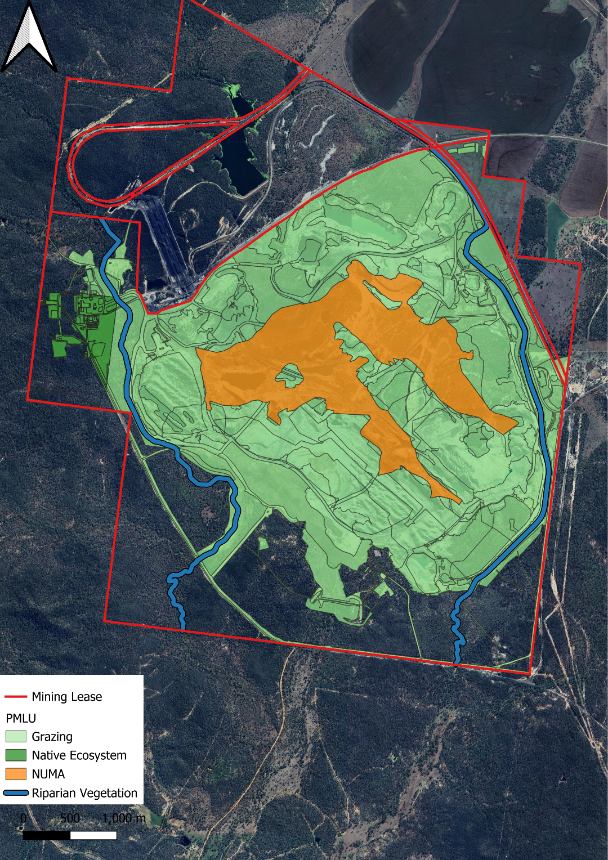

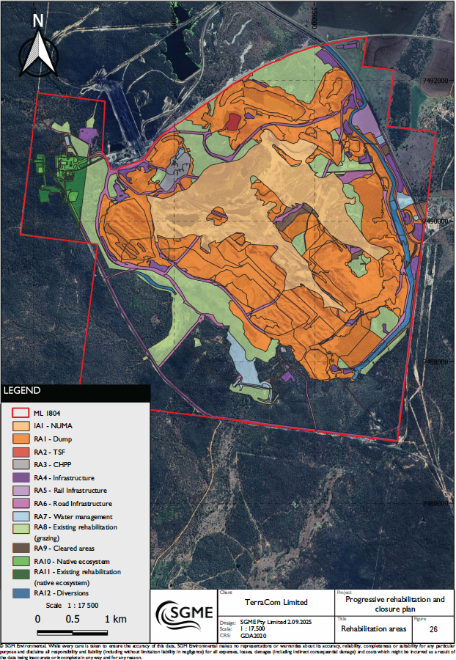
Figure 2 – Reference Map

Section C – Post mining land uses

(RA1) Rehabilitation Area 1
Post-mining land uses (PMLU)
Rehabilitation area |  |  |  | RA1
Relevant activities |  |  |  | Dump
Total rehabilitation area size (ha) |  |  |  | 736
Commencement of first milestone: RM4 |  |  |  | 10-Dec-33
PMLU |  |  |  | Light grazing pasture
Date area is available | 1012/33 | 10/12/42 | 10/12/45 | 10/12/48
Cumulative area available (ha) | 736 | 736 | 736 | 736
Milestone completed by | 10/12/38 | 10/12/45 | 10/12/48 | 10/12/55
Milestone Reference | Cumulative area achieved (ha)
RM 3 | 736
RM 4 | 736
RM 5 | 736
RM 6 |  | 736
RM7 |  |  | 736
RM8 |  |  |  | 736

(RA2) Rehabilitation Area 2
Post-mining land uses (PMLU)

Rehabilitation area |  |  |  | RA2
Relevant activities |  |  |  | TSF
Total rehabilitation area size (ha) |  |  |  | 4
Commencement of first milestone: RM3 |  |  |  | 10-Dec-33
PMLU |  |  |  | Light grazing pasture
Date area is available | 10/12/33 | 10/12/34 | 10/12/42 | 10/12/46
Cumulative area available (ha) | 4 | 4 | 4 | 4
Milestone completed by | 10/12/34 | 10/12/42 | 10/12/46 | 10/12/55
Milestone Reference | Cumulative area achieved (ha)
RM 3 | 4
RM 4 |  | 4
RM 5 |  | 4
RM 6 |  | 4
RM 7 |  |  | 4
RM 8 |  |  |  | 4

(RA3) Rehabilitation Area 3
Post-mining land uses (PMLU)
Rehabilitation area |  |  |  | RA3
Relevant activities |  |  |  | CHPP
Total rehabilitation area size (ha) |  |  |  | 13
Commencement of first milestone: RM1 |  |  |  | 10-Dec-33
PMLU |  |  |  | Light grazing pasture
Date area is available | 10/12/33 | 10/12/35 | 10/12/37 | 10/12/42 | 10/12/46 | 10/12/50
Cumulative area available (ha) | 13 | 13 | 13 | 13 | 13 | 13
Milestone completed by | 10/12/35 | 10/12/37 | 10/12/42 | 10/12/46 | 10/12/50 | 10/12/55
Milestone Reference | Cumulative area achieved (ha)
RM1 | 13
RM2 |  | 13
RM3 |  |  | 13
RM4 |  |  | 13
RM5 |  |  | 13
RM6 |  |  |  | 13
RM7 |  |  |  |  | 13
RM8 |  |  |  |  |  | 13

(RA4) Rehabilitation Area 4
Post-mining land uses (PMLU)
Rehabilitation area |  |  |  | RA4
Relevant activities |  |  |  | Infrastructure
Total rehabilitation area size (ha) |  |  |  | 73
Commencement of first milestone: RM1 |  |  |  | 10-Dec-33
PMLU |  |  |  | Light grazing pasture
Date area is available | 10/12/33 | 10/12/35 | 10/12/37 | 10/12/43 | 10/12/45 | 10/12/50
Cumulative area available (ha) | 73 | 73 | 73 | 73 | 73 | 73
Milestone completed by | 10/12/35 | 10/12/37 | 10/12/43 | 10/12/45 | 10/12/50 | 10/12/55
Milestone Reference | Cumulative area achieved (ha)
RM1 | 73
RM2 |  | 73
RM3 |  |  | 73
RM4 |  |  | 73
RM5 |  |  | 73
RM6 |  |  |  | 73
RM7 |  |  |  |  | 73
RM8 |  |  |  |  |  | 73

(RA5) Rehabilitation Area 5
Post-mining land uses (PMLU)
Rehabilitation area |  |  |  | RA5
Relevant activities |  |  |  | Rail infrastructure
Total rehabilitation area size (ha) |  |  |  | 11
Commencement of first milestone: RM1 |  |  |  | 10-Dec-33
PMLU |  |  |  | Light grazing pasture
Date area is available | 10/12/33 | 10/12/35 | 10/12/37 | 10/12/42 | 10/12/46 | 10/12/50
Cumulative area available (ha) | 11 | 11 | 11 | 11 | 11 | 11
Milestone completed by | 10/12/35 | 10/12/37 | 10/12/42 | 10/12/46 | 10/12/50 | 10/12/55
Milestone Reference | Cumulative area achieved (ha)
RM1 | 11
RM2 |  | 11
RM3 |  |  | 11
RM4 |  |  | 11
RM5 |  |  | 11
RM6 |  |  |  | 11
RM7 |  |  |  |  | 11
RM8 |  |  |  |  |  | 11

(RA6) Rehabilitation Area 6
Post-mining land uses (PMLU)
Rehabilitation area |  |  |  | RA6
Relevant activities |  |  |  | Road infrastructure
Total rehabilitation area size (ha) |  |  |  | 104
Commencement of first milestone: RM1 |  |  |  | 10-Dec-33
PMLU |  |  |  | Light grazing pasture
Date area is available | 10/12/33 | 10/12/35 | 10/12/36 | 10/12/43 | 10/12/47 | 10/12/50
Cumulative area available (ha) | 104 | 104 | 104 | 104 | 104 | 104
Milestone completed by | 10/12/35 | 10/12/36 | 10/12/43 | 10/12/47 | 10/12/50 | 10/12/55
Milestone Reference | Cumulative area achieved (ha)
RM1 | 104
RM2 |  | 104
RM3 |  |  | 104
RM4 |  |  | 104
RM5 |  |  | 104
RM6 |  |  |  | 104
RM7 |  |  |  |  | 104
RM8 |  |  |  |  |  | 104

(RA7) Rehabilitation Area 7
Post-mining land uses (PMLU)
Rehabilitation area |  |  |  | RA7
Relevant activities |  |  |  | Water management
Total rehabilitation area size (ha) |  |  |  | 27
Commencement of first milestone: RM1 |  |  |  | 10-Dec-33
PMLU |  |  |  | Light grazing pasture
Date area is available | 10/12/33 | 10/12/35 | 10/12/36 | 10/12/43 | 10/12/47 | 10/12/50
Cumulative area available (ha) | 27 | 27 | 27 | 27 | 27 | 27
Milestone completed by | 10/12/35 | 10/12/36 | 10/12/43 | 10/12/47 | 10/12/50 | 10/12/55
Milestone Reference | Cumulative area achieved (ha)
RM1 | 27
RM2 |  | 27
RM3 |  |  | 27
RM4 |  |  | 27
RM5 |  |  | 27
RM6 |  |  |  | 27
RM7 |  |  |  |  | 27
RM8 |  |  |  |  |  | 27

(RA8) Rehabilitation Area 8
Post-mining land uses (PMLU)
Rehabilitation area |  |  |  | RA8
Relevant activities |  |  |  | Existing rehabilitation (Grazing)
Total rehabilitation area size (ha) |  |  |  | 289
Commencement of first milestone: RM1 |  |  |  | 10-Dec-23
PMLU |  |  |  | Light grazing pasture
Date area is available | 10/12/23 | 10/12/35 | 10/12/40 | 10/12/50
Cumulative area available (ha) | 289 | 289 | 289 | 289
Milestone completed by | 10/12/35 | 10/12/40 | 10/12/50 | 10/12/55
Milestone Reference | Cumulative area achieved (ha)
RM5 | 289
RM6 |  | 289
RM7 |  |  | 289
RM8 |  |  |  | 289

(RA9) Rehabilitation Area 9
Post-mining land uses (PMLU)
Rehabilitation area |  |  |  | RA9
Relevant activities |  |  |  | Cleared areas
Total rehabilitation area size (ha) |  |  |  | 21
Commencement of first milestone: RM1 |  |  |  | 10-Dec-23
PMLU |  |  |  | Light grazing pasture
Date area is available | 10/12/23 | 10/12/34 | 10/12/40 | 10/12/46
Cumulative area available (ha) | 21 | 21 | 21 | 21
Milestone completed by | 10/12/34 | 10/12/40 | 10/12/46 | 10/12/55
Milestone Reference | Cumulative area achieved (ha)
RM3 | 21
RM4 | 21
RM5 | 21
RM6 |  | 21
RM7 |  |  | 21
RM8 |  |  |  | 21

(RA10) Rehabilitation Area 10
Post-mining land uses (PMLU)
Rehabilitation area |  |  |  | RA10
Relevant activities |  |  |  | Native ecosystem
Total rehabilitation area size (ha) |  |  |  | 21
Commencement of first milestone: RM1 |  |  |  | 10-Dec-33
PMLU |  |  |  | Native ecosystem (RE 11.11.1 and RE 11.3.4)
Date area is available | 10/12/33 | 10/12/35 | 10/12/38 | 10/12/45 | 10/12/47 | 10/12/50
Cumulative area available (ha) | 21 | 21 | 21 | 21 | 21 | 21
Milestone completed by | 10/12/35 | 10/12/38 | 10/12/45 | 10/12/47 | 10/12/50 | 10/12/55
Milestone Reference | Cumulative area achieved (ha)
RM1 | 21
RM2 |  | 21
RM3 |  |  | 21
RM4 |  |  | 21
RM5 |  |  | 21
RM6 |  |  |  | 21
RM7 |  |  |  |  | 21
RM8 |  |  |  |  |  | 21

(RA11) Rehabilitation Area 11
Post-mining land uses (PMLU)
Rehabilitation area |  |  |  | RA11
Relevant activities |  |  |  | Existing rehabilitation (Native ecosystem)
Total rehabilitation area size (ha) |  |  |  | 21
Commencement of first milestone: RM1 |  |  |  | 10-Dec-23
PMLU |  |  |  | Native ecosystem (RE 11.11.1 and RE 11.3.4)
Date area is available | 10/12/23 | 10/12/30 | 10/12/35 | 10/12/40
Cumulative area available (ha) | 21 | 21 | 21 | 21
Milestone completed by | 10/12/30 | 10/12/35 | 10/12/40 | 10/12/55
Milestone Reference | Cumulative area achieved (ha)
RM5 | 21
RM6 |  | 21
RM7 |  |  | 21
RM8 |  |  |  | 21

(RA12) Rehabilitation Area 12
Post-mining land uses (PMLU)
Rehabilitation area |  |  |  | RA12
Relevant activities |  |  |  | Diversions
Total rehabilitation area size (ha) |  |  |  | 35
Commencement of first milestone: RM1 |  |  |  | 10-Dec-33
PMLU |  |  |  | Riparian vegetation
Date area is available | 10/12/33 | 10/12/38 | 10/12/46 | 10/12/50
Cumulative area available (ha) | 35 | 35 | 35 | 35
Milestone completed by | 10/12/38 | 10/12/42 | 10/12/50 | 10/12/55
Milestone Reference | Cumulative area achieved (ha)
RM3 | 35
RM5 | 35
RM6 |  | 35
RM7 |  |  | 35
RM8 |  |  |  | 35
^{A}What is referred to as ‘Other minor disturbance: Disturbance associated with topsoil stockpiles on natural ground; and Minor disturbance from other approved disturbance activities resulting in compacted land requiring rehabilitation’ implies areas that are disturbed as a consequence of construction or rehabilitation works that are to be undertaken in close proximity or areas that may be used for future stockpiling of topsoil resources or may be used as minor access tracks to rehabilitation areas. For PRCP purposes, these areas will have vegetation cleared and potentially have topsoil stripped.

Rehabilitation area milestones
Milestone reference | Rehabilitation milestone | Applicant proposed Milestone criteria | Department proposed Milestone criteria
RM1 | Infrastructure decommissioning and removal | a) decommissioning and removing services;  b) removing infrastructure;  c) decommissioning dams;  d) removing all general and regulated waste; and  e) decommissioning or converting water or monitoring bores, exploration drill holes. | - With the exception of any infrastructure to remain as part of the post-mining land use (PMLU) or where infrastructure is agreed to be retained by the landholder as evidenced by a signed landholder agreement, the following are complete:  - All services disconnected and removed;  - All buildings and associated infrastructure dismantled and removed offsite.  - All hardstand, concrete areas and roads (bitumen, blue metal, aggregate etc.) removed.  - All fencing and associated foundations removed.  - All pipelines drained and removed.  - All waste not authorised to be disposed of on-site under Environmental Authority EPML00876713 removed.  - All surface water drainage infrastructure that does have an associated watercourse or riparian ecosystem PMLU or forms part of a non use management area (NUMA) is removed.  - All drillholes, bores, sediment ponds and sumps decommissioned.  - All machinery and equipment, not required for rehabilitation works removed from site.  - All dams dewatered and desilted.  - Watercourse crossings and culverts removed.
RM2 | Identification, remediation and removal of contaminated land | a) removing or remediating contaminated land to a PMLU of grazing or native ecosystem;  b) all contaminated sediment is removed;  c) all plastic liners are removed and disposed;  d) site investigation report is prepared by an AQP; and  e) certification from an AQP that all contaminated land has been removed. | - Contaminated land investigations (investigation, remediation and validation) completed by an SQP in accordance with appropriate guidance, including but not limited to the ASC NEPM and National Remediation Framework (NRF).  - Contaminated water and sediment removed from dams.  - Contaminated and hazardous material either remediated in-situ or removed/transported to facility lawfully able to accept the material.  - Contaminated Land Auditor certifies that that no contamination unsuitable for the PMLU remains or is occurring.
RM3 | Landform development (re-profiling / re shaping | TSF  - certification by an AQP that waste products generated from the washing of coal are buried under spoil with a minimum of cover thickness of 5 m.  All other areas  a) reshaping or recontouring the landform;  b) install drainage management structures;  c) all major earthworks completed;  d) stable landform and slope angles ~15 % average; and  e) landform is assessed as geotechnically stable by an AQP.  Diversions (RA12)  f) certification from an AQP that diversions are constructed as per the requirements of the certified design, and in accordance with DNRME’s Guideline: Works that interfere with water in a watercourse for a resource activity — watercourse diversions under the Water Act 2000 (OSW/2019/4599). | - All major earthworks (including reshaping, pushing/trimming) are completed in accordance with the design specification provided by an AQP.  - Environmentally problematic material is appropriately placed and located within the final landform, consistent with the relevant designs as certified by an AQP.  - Geotechnical assessment undertaken by an AQP prior to construction confirms that the landform design will achieve long-term stability, with a Factor of safety (FOS) ≥1.5.  - Disturbed slopes not steeper than:  - 15% for rehabilitated landform, or  - 30% for Ramp 3.  - All landforms are shaped to be water shedding.  - Effective and functioning erosion and sediment control systems in place, with associated design plans.  For RA2 (TSF):  - A cover system is installed consistent with a detailed design developed by an AQP based on geochemical and geotechnical characterisation of the TSF, which at a minimum achieves the following:  - Tailings to be capped with at least 5m of competent benign spoil or suitable capping material;  - Reduces risk of upward movement of contaminants into the topsoil layer above the cover and reduces risk of environmental harm from contaminated seepage;  - Cover materials have no potential for acid mine drainage (AMD) and/or neutral mine drainage (NMD);  - Capping layer surface is water shedding and does not display surface ponding; and  - Cover installed to minimise erosion and reduce rainfall infiltration.  - An AQP endorses the installation of the cover system as per RM3.7 and certifies that:  - The cover system has been installed as per design;  - The cover system displays erosionally stability, is geotechnically stable and supports the PMLU; and  - The installed cover is effective in mitigating the potential for migration of contaminants from the TSF area to the receiving environment.  - Appropriate monitoring equipment has been installed to determine the performance of the adopted cover system and monitoring has commenced.  Diversions (RA12)  - Landform exceeds the mAHD for 0.1%AEP water surface level +0.5m freeboard.  - Selective placement of non-erosive materials and/or rock mulch protection to ensure landform stability as per AQP’s advice.  - Must be fenced to exclude stock.
RM4 | Surface preparation (topdressing, contour ripping, soil amelioration) | a) placement of a minimum of 0.15 m of topsoil;  b) contour ripping completed; and  c) fertiliser applied at rates of 250 kg/ha. | - Prior to each rehabilitation event:  - A soil health and suitability assessment of the growth media characteristics is undertaken by an AQP and endorsed as suitable to ensure achievement of the PMLU; and  - Where the soil health and suitability assessment identifies that the growth media is not suitable, an amelioration and physical treatment plan is completed by an AQP to ensure achievement of the PMLU.  - Ameliorants and physical treatments such as fertiliser, lime, gypsum and/or organic matter have been applied as identified in RM4.1.  - Topsoil/growth media placement of a minimum 0.15m in areas where topsoil has previously been removed.  - Deep ripping of compacted surfaces, at least 300mm into soil/subsoil profile along contour of slopes.  - Following amelioration as per RM4.1 and RM4.2, representative soil testing of growth media confirms that the relevant depths within the effective root zone (0-300mm) meets the soil quality criteria in Attachment 1 – Soil quality criteria.  - Where the soil assessment results identified that the characteristics in RM4.5 have not been met, soil has been treated with ameliorants as per recommendations made by an AQP.  - Surface and groundwater monitoring is underway (at least one year of sampling undertaken).
RM5 | Revegetation | Grazing PMLU  a) direct seeding at application rate determined by an AQP;  "b) seed mix applied contains a suitable range of trees, shrubs and perennial grass species and suitable leguminous species consistent  with the surrounding area; and"  c) stock exclusion fencing installed until achievement of surface requirements for grazing pasture.  Native Ecosystem PMLU  a) seed mix applied contains species consistent with RE 11.1.11 or RE 11.3.4;  b) species comprise ≥ 20 % of the average number of species described in RE 11.1.11 or RE 11.3.4 technical descriptions;  c) average height of each layer is ≥ 70 % of average layer height described in RE 11.1.11 or RE 11.3.4 technical descriptions; and  d) average fractional cover of each layer is ≥ 50 % of average fractional cover described in RE 11.1.11 or RE 11.3.4 technical description. | - Appropriate erosion controls installed/placed and functioning as designed (as per AQP certified report) to ensure plant establishment is not significantly impacted from erosive events.  Grazing PMLU  - Completed seeding with a selection of species and seeding rates listed in Attachment 2 – Species seed mixes.  Native ecosystem PMLU (RA10):  - Completed seeding with a selection of native vegetation species and seeding rates in Attachment 2 – Species seed mixes, or as amended for additional native endemic species recommended by an AQP and certified as suitable to achieve a stable landform.  - Species chosen should reflect RE 11.11.1 or RE 11.3.4.  - Non-native seed must not be used for the revegetation (except when sterile cover crops are used  Riparian vegetation PMLU (RA12):  - Completed seeding with a selection of native vegetation species and seeding rates in Attachment 2 – Species seed mixes, or as amended for additional native endemic species recommended by an AQP and certified as suitable to achieve a stable landform.  - Species chosen should reflect RE 11.3.25.
RM6 | Achievement of surface requirements | Grazing PMLU  a) species richness and diversity achieved is consistent with the sown seed mix and similar to reference sites;  b) revegetation ≥70% comparable to analogue site;  c) no active areas of gully erosion and drainage follows appropriate drainage paths;  d) certification from an AQP that rehabilitation is resilient to fire; and  e) certification by an AQP that weeds and pest species are in densities no greater than at analogue sites.  Diversions (RA12)  f) an AQP prepares an assessment report annually based on the Index of Diversion Condition (IDC) assessment, where:  a. the diversions have achieved a target Geomorphic Index score of ≥ 95 % relative to baseline condition.  b. the riparian corridor has achieved a target Riparian Index score of ≥ 70 % relative to baseline condition.  Native ecosystem PMLU  a) for RE 11.1.11 species richness ≥15 native species:  - tree species richness ≥ 2 species, including Yellow Jacket (Corymbia liechhardtii);  - shrub species richness ≥ 3 species;  - grass species richness ≥5 species; and  - forb and other species richness ≥ 5 species  b) for RE 11.3.4 species richness ≥ 18 native species:  - tree species richness ≥ 3 species, including Forest Red Gum (Eucalyptus tereticornis);  - shrub species richness ≥ 4 species;  - grass species richness ≥ 6 species; and  - forb and other species richness ≥ 5 species.  c) revegetation ≥ average fractional cover derived from RE technical descriptions for RE 11.1.11:  - trees cover ≥ 57.7 %;  - shrubs ≥ 36.9 %; and  - grasses and forbs cover ≥ 29.3 %.  d) revegetation ≥ average fractional cover derived from RE technical descriptions for the RE 11.3.4:  - trees cover ≥ 37.1 %;  - shrubs ≥ 4.3 %; and  - grasses and forbs cover ≥ 61.6 %.  e) no active areas of gully erosion and drainage follows appropriate drainage paths;  f) certification from an AQP that rehabilitation is resilient to fire; and  g) certification by an AQP that weeds and pest species are in densities no greater than at analogue sites. | - Species used in revegetation remain present and show evidence of natural recruitment. Evidence of flora recruitment from rehabilitation monitoring data.  - ≥50% vegetative groundcover.  An AQP certifies that there is no evidence of erosion classified as ‘moderate’ or ‘severe’ as defined by Attachment 3 – Erosion classification framework;  - Despite RM6.4 erosion is acceptable in the achievement of surface requirements provided an AQP certifies that all active erosion has been identified and remediation activities have been completed.  - The growth media (topsoil and subsoil) physical, chemical and biological properties does not limit vegetation cover performance or restrict the potential effective depth of rooting.  - The landform is free draining.  Native ecosystem (RA10) and Riparian vegetation (RA12):  - A BioCondition assessment is completed by an AQP using the methodology outlined in the latest version of the Queensland Herbarium’s ‘‘BioCondition Assessment Manual’.  - The BioCondition assessment completed under RM6.10 complies with the >20/60 PRCP Benchmark for the PMLU, as per Attachment 4 – BioCondition Benchmark Criteria.
RM7 | Achievement of post-mining land use to a stable condition | Grazing  a) certification from an AQP that the area has achieved stable condition;  b) certification from an AQP that the landform achieved a factor of safety ≥ 1.5;  c) maximum erosion rate of < 10 t/ha/yr;  d) total percentage ground cover (vegetation, litter and rock combined) is > 70 %;  e) there are no declared Noxious Class 1 or Class 2 weeds;  f) native fauna identified at reference sites are present or indicators of these species are recorded;  g) water quality complies with Table C7 of EPML00876713.  Diversions (RA12)  h) prepare assessment report by an AQP certifying that the diversion is operating in accordance with, DNRME Guideline: Works that interfere with water in a watercourse for a resource activity — watercourse diversions under the Water Act 2000 (OSW/2019/4599) criteria and is in a stable condition. The report will include data from the IDC assessment, showing that Geomorphic Index has maintained a score of ≥ 95 % and the Riparian Vegetation Index has maintained a score of ≥ 70 % for two consecutive years.  i) certification from AQP that the diversions have achieved a stable condition, and are able to sustain a 0.1% AEP flood event.  Native ecosystem  a) certification from an AQP that the area has achieved stable condition;  b) certification from an AQP that the landform achieved a factor of safety ≥ 1.5;  c) total percentage groundcover (vegetation, litter and rock combined) is ≥ 50 %;  d) maximum erosion rate of < 10 t/ha/yr;  e) there are no declared Noxious Class 1 or Class 2 weeds;  f) native fauna at reference sites are present or indicators of these species are recorded; and  g) water quality complies with Table C7 of EPML00876713. | - Safety hazards in the rehabilitation area are not significantly different to surrounding unmined landscapes subject to the same land use.  - The land is structurally and erosionally stable.  - The final landform is geotechnically stable and achieves a factor of safety ≥ 1.5.  - Weed presence is a less than 10% of total vegetative cover, and Category 3 invasive plants (as defined in the Biosecurity Act 2014) comprise ≤5% of vegetative groundcover, confirmed by an AQP in annual monitoring.  - An AQP certifies that there is no evidence of erosion classified as ‘moderate’ or ‘severe’ as defined by Attachment 3 – Erosion classification framework.;  - Final landform survey confirms no built structures remain other than those that form part of a landholder agreement.  Contaminated Land  - There is no evidence indicating an adverse change to the contaminated land status has occurred post the completion of RM2.  - Contaminated Land Investigation Document (CLID) completed in accordance with the Environmental Protection Act 1994, including:  - Site Suitability Statement confirming the suitability of the property (all lot/plans within the mining lease area) for the PMLUs; and  - Site Investigation Report and, where required, a Validation Report and/or a draft Site Management Plan provided.  - Removal of land from Environmental Management Land Register where possible.  TSF (RA2)  - An AQP certifies that monitoring data and technical assessments ensures that the TSF has achieved stable condition, and demonstrates:  - No evidence of seepage;  - No evidence of water ponding;  - No surface expression, such as salt crusts or pans; and  - No deep-rooted species present.  Grazing PMLU  - ≥50% established and self-sustaining vegetative groundcover of species as listed in Attachment 2 – Species seed mixes.  - Minimum vegetation composition (per hectare (averaged)) of:  - 4 species of 3P native pasture species;  - 2 native legumes; and  - 2 native shade tree species, present.  - Land suitability class assessed by an AQP that the land has achieved a post-mining land suitability class of ≤ 3.  Native ecosystem (RA10) and Riparian vegetation (RA12):  - The BioCondition assessment completed under RM6.10 complies with the >35/60 PRCP Benchmark for the PMLU, as per Attachment 4 – BioCondition Benchmark Criteria.  - Where RM7.16 is not achieved, an AQP has confirmed that the ecosystem is on a trajectory to achieving the BioCondition benchmarks 10-15 years of Attachment 4 – BioCondition Benchmark Criteria.  Diversions  - An Assessment report prepared by an AQP certifying that:  - the diversion is operating in accordance with, DNRME Guideline: Works that interfere with water in a watercourse for a resource activity — watercourse diversions under the Water Act 2000 (OSW/2019/4599) criteria and is in a stable condition.  - Evidence indicating that Geomorphic Index has maintained a score of ≥ 95 % and the Riparian Vegetation Index has maintained a score of ≥ 70 % for two consecutive years.  - Certification from AQP that the diversions have achieved a stable condition, and are able to sustain a 0.1% AEP flood event.
RM8 | Achievement of post-mining land use water quality | - | - Surface water quality must be monitored monthly during flow at, but not limited to, downstream locations specified Attachment 5 – Surface water monitoring locations.  - Surface water quality monitored as per RM8.1 must not exceed the limits in Attachment 6 – Surface water quality criteria, for a minimum of 5 consecutive years prior to surrender  - If the surface water quality exceeds RM8.1, the applicable upstream/reference site must be compared to the downstream site result; and quality result measured at a downstream site must be equal to or less than the quality result measured at the applicable upstream/reference site.  - For a minimum of five consecutive years groundwater quality must be monitored quarterly at, but not limited to, compliance bores/locations specified in Attachment 7 – Groundwater monitoring bores, for all quality characteristics listed in Attachment 8 – Groundwater quality limits.  - Groundwater quality results must not exceed the limits in Attachment 8 – Groundwater quality criteria, for 3 consecutive results for 5 consecutive years immediately prior to surrender.  - Groundwater level is monitored quarterly and for a minimum of 5 consecutive years.  - Groundwater level is monitored quarterly and all results must not exceed the Level Thresholds outlined in Attachment 9 – Groundwater water level monitoring locations and thresholds, for a minimum of 10 consecutive years immediately prior to surrender.

Section D – Non-use management areas

(IA1) Improvement area 1
Non-use management area (NUMA)
Improvement area |  |  |  | IA1
Relevant activities |  |  |  | Residual void
Total size (ha) |  |  |  | 291.6
Commencement of first milestone: MM1 |  |  |  | 10-Dec-33
NUMA |  |  |  | Non-use management area
Date area is available | 10/12/33 | 10/12/45
Cumulative area available (ha) | 291.6 | 291.6
Milestone completed by | 10/12/45 | 10/12/55
Milestone Reference | Cumulative area achieved (ha)
MM1 | 291.6
MM2 | 291.6
MM3 |  | 291.6

Improvement area milestones
Milestone reference | Management milestone | Milestone criteria
MM1 | Achievement of final landform design | - Pit wall landforms must:  - prevent surface or seepage flow of floodwater into the void;  - Be geotechnically stable when floodwater is against the creek-side batter;  - Not be constructed with dispersive material; and  - Have maximum 30% slopes in competent rock with rock armouring for scour protection.  - Have a maximum 15% slopes with incompetent rock with rock armouring for scour protection.  - The final design must be completed by an AQP based on the latest flood modelling and materials data prior to construction.  - The final residual void is not subject to inundation from floodwaters up to and including the 0.1% AEP.  - The pit walls achieve a FoS ≥1.5 within the NUMA extents as determined by an AQP.  - The location of the void and associated safety bunds does not cause instability or degradation to the land outside the NUMA.  - The residual voids will not overtop.
MM2 | Achievement of safety requirements | - Competent safety bund or equivalent landform in place to prevent access to the residual void, in accordance with engineering requirements including:  - Constructed from non-weathered, non-dispersive dumped rockfill;  - a minimum 2m in height;  - a minimum of 4 m base width; and  - 1 in 3 batters.  - A minimum distance of 50m is to be designed between the residual void crest and the toe of the safety bund, where against an external perimeter mining lease boundary and/or diversion drain.  - Fencing erected, where required to prevent access to the residual void, around the perimeter of the safety bund.  - Safety signage (design in accordance with Australian standard) is erected at 100m intervals along the fence.
MM3 | Achievement of sufficient improvement | - The final landform has been constructed in accordance with the final design.  - Appropriate safety infrastructure at the geotechnical set-back distance has been installed to prevent access to the NUMA.  - The residual void is safe to humans and livestock.  - The water level and quality in the void do not and will not cause environmental harm to the receiving environment, as demonstrated by groundwater level, surface water and groundwater quality monitoring and modelling.  - An AQP demonstrates with water quality, water level and modelling data, that the residual void/s act as groundwater sinks post-closure.  - The residual void retains flood immunity ≥0.1% AEP, supported by flood modelling re-run at end of life and calibrated against the final landform.  - The residual void will not present an unacceptable risk of environmental harm.  - Erosion of the landform within the NUMA area will not negatively impact on the stability of any adjacent rehabilitation areas, or their ability to sustain their PMLU.  - Monitoring and maintenance of exclusion fences and bunds to be carried out to ensure they remain effective.

Section E – Attachments

Attachment 1 – Soil quality criteria
Parameter | Criteria |  | Comments
Parameter | Grazing | Bushland | Comments
pH (1:5) | 6.0-8.5 | 6.0-8.5
Saturate paste extract EC (ECe)  (deciSiemens per metre (dS/m) | Less than or equal to (≤) 2 | ≤2¹
Available P  (milligrams per kilogram (mg/kg))² | Greater than or equal to (≥) 8 | - | For grazing, derived from the QMRC guidelines. Criteria have not been proposed for bushland or riparian PMLUs, which contain native vegetation that can tolerate low fertility.
ESP (%) 0cm – 15cm | ≤6 | < 6 | For grazing, derived from the QMRC guidelines. QMRC guidelines separate the critical sodicity range for topsoil and subsoil. Therefore, it is considered appropriate to do the same here. These criteria have been kept for bushland and riparian PMLUs.
Soil organic matter (SOM) (%) | >1.0 | - | For grazing, agricultural industry benchmark sufficiency criteria² were used. Criteria have not been proposed for bushland or riparian PMLUs, which contain native vegetation that can tolerate low fertility.
Emerson aggregate class | >3 | > 3 | Emerson aggregate class measures the stability of the soil aggregate. An Emerson class value of ≤ 2 is indicative of unstable soil. DETSI has recommended an acceptable Emerson class of ≥ 3 in the draft PRCP schedule. This recommendation has been adopted for both bushland and riparian PMLUs.
¹pH and Ece criteria from the grazing PMLU have been applied to the bushland and riparian PMLUs.

Attachment 2 – Species seed mixes
Grazing PMLU and where required for erosional stability of the banks of water storages
Scientific name | Common name | Minimum application rate (kg/ha)
Macroptilium bracteatum | Burgundy Bean | 2
Panicum maximum | Green Panic | 2
Cenchrus ciliaris | Gayndah Buffel | 3
Macroptilium atropurpureum | Siratro | 3
Stylosanthes scabra | Seco Stylo | 2
Chloris gayana | Rhodes Grass | 2
Bothriochloa insculpta cvv. Bisset | Creeping blue grass | 3
3P Species
Themeda triandra | Kangaroo Grass | 2
Bothriochloa bladhii | Forest Bluegrass | 2
Dicanthium sericeum | Queensland Bluegrass | 2
Panicum decompositum | Native Millet | 2
Rhynchosia minima var. minima | Rhyncho | 2
Glycine tabacina | Glycine Pea | 2
Minimum total sowing rate |  | 15
Native Ecosystem - Regional Ecosystem 11.11.1 Eucalyptus woodland
Trees(T) / Shrubs(S)
Acacia salicina (T) | Doolan | 0.3
Cassia brewsteri (S) | Leichardt Bean | 0.3
Casuarina cunninghamiana subsp. Cunninghamiana (T) | River oak | 0.3
Grewia retusifolia (S) | Dogs Balls | 0.3
Lysiphyllum hookeri (T) | White Bauhinia | 0.7
Eucalyptus camaldulensis (T) | River red gum | 0.3
Corymbia tessellaris (T) | Moreton Bay Ash | 0.3
Alectryon diversifolius (S) | Scrub Boonaree | 0.3
Bridelia leichhardtii (T) | Small-leaved Scrub Ironbark | 0.3
Eucalyptus coolabah (T) | Coolabah | 0.3
Ficus opposita (T) | Sandpaper Fig | 0.3
Melaleuca bracteata (S) | Black Tea Tree | 0.3
Carissa ovata (S) | Currant Bush | 0.3
Abutilon oxycarpum (S) | Flannel Weed | 0.3
Alstonia constricta (S) | Quinine Bush | 0.3
Minimum sowing rate |  | 4
Rushes and sedges
Chrysopogon zizanioides | Vetiver Grass (sterile) | 2
Cyperus exaltatus | Tall Flat Sedge | 1
Cyperus fulvus | Sticky Sedge | 1
Cyperus gracilis | Slender Flat-Sedge | 1
Eleocharis pallens | Pale Spike Rush | 1
Lomandra longifolia | Spiny Head Matt-Rush | 1
Minimum sowing rate |  | 7
Ground cover – Grasses(G) and Forbs(F)
Bothriochloa bladhii (G) | Forest Bluegrass | 2
Dichanthium sericeum (G) | Queensland Bluegrass | 2.5
Glycine tabacina (G) | Glycine Pea (nitrogen fixer) | 2
Heteropogon contortus(G) | Black Speargrass | 1
Rhynchosia minima var. minima (G) | Rhyncho (nitrogen fixer) | 2
Themeda triandra (G) | Kangaroo Grass | 2.5
Chloris divaricata (G) | Slender Chloris | 1
Bothriochloa decipiens (G) | Red Grass | 1
Chrysopogon fallax (G) | Ribbon Grass | 1
Aristida calycina (G) | Dark Wiregrass | 1
Sida hackettiana (F) | Spiked Sida | 2
Glycine tomentella (F) | Woolly Glycine | 1
Eustrephus latifolius (F) | Wombat Berry | 2
Alternanthera denticulate (F) | Lesser Joyweed | 2
Neptunia gracilis (F) | Native Sensitive Plant | 1
Minimum sowing rate |  | 15
Native Ecosystem - Regional Ecosystem 11.3.25
Trees(T) and Shrubs(S)
Corymbia tessellaris (T) | Moreton Bay Ash | 0.3
Eucalyptus camaldulensis (T) | River Red Gum | 0.2
Eucalyptus tereticornis (T) | Forest Red Gum | 0.2
Eucalyptus populnea | Poplar Box | 0.2
Eucalyptus coolabah | Coolabah | 0.2
Casuarina cunninghamiana | River She-oak | 0.3
Angophora floribunda | Rough-barked Apple | 0.2
Acacia stenophylla | River Cooba | 0.2
Acacia salicina | Cooba/Willow Wattle | 0.2
Ficus opposita | Sandpaper Fig | 0.3
Ground Layer
Lomandra longifolia | Spiny-headed Mat-rush | 0.8
Cyperus gracilis | Slender Sedge | 0.4
Dicanthium sericeum | Queensland Bluegrass | 0.9
Themeda triandra | Kangaroo Grass | 1.6
Heteropogon contortus | Black Speargrass | 1.3
Bothriochloa bladhii | Forest Bluegrass | 0.9
Cymbopogon refractus | Barbed Wire Grass | 0.4
Arundinella nepalensis | Nepal Grass | 0.4
Paspalidium distans; jubiflorum | Water Couch | 1.8
Aristida personata | Purple Wiregrass | 0.4
Eriochloa crebra; procera | Cup Grass | 0.8
Panicum effusum; laevinode | Hairy Panic | 1.3
Sporobolus mitchellii; creber | Rat’s Tail Grass | 0.5
Imperata cylindrica | Blady Grass | 0.4
Chrysopogon filipes; refractus | Golden Beard Grass | 0.8
Minimum sowing rate |  | 15

Attachment 3 – Erosion classification framework
Erosion classification | Minor | Moderate | Severe
Sheet erosion | Shallow soil deposits downslope | Partial exposure of roots; moderate soil deposits downslope, etc | Loss of surface horizon; root exposure; moderate substantial  soil deposits downslope
Rill erosion | <15 rills/100m | 15-30 rills/100m | >30 rills/100m
Gully erosion | Absent | Absent | Present
Tunnel erosion | Absent | Absent | Present
Mass movement | Absent | Absent | Present
Erosion form definitions: NCST (2024) Australian Soil and Land Survey Field Handbook, 4th edition. The National Committee on Soil and Terrain. CSIRO Publishing, Collingwood, Australia.
* Rill frequency assessed on the contour over entirety of rehabilitation area (not only features that intersect a monitoring transect).

Attachment 4 – BioCondition Benchmark Criteria
Rehabilitated Regional Ecosystem RE 11.11.1 Eucalyptus woodland.
BioCondition Assessable  Attributes | Attribute Weighting | BioCondition  benchmark | Indicative³ measure at  RM x | BioCondition Score | Indicative³ measure at  RM x | BioCondition Score
Recruitment | 5 | 100% | 0 | 0 | ≥20% of canopy species | 3
Non-native plant cover (%) | 10 | 0% | <25% | 5 | <25% | 5
Native¹ tree species richness | 5 | 4 | ≥1 | 2.5 | ≥4 | 5
Native¹ tree species richness | 5 | 4 | (≥25% of benchmark) | 2.5 | (≥90% of benchmark) | 5
Native¹ shrub species richness | 5 | 7 | ≥2 | 2.5 | ≥2 | 2.5
Native¹ shrub species richness | 5 | 7 | (≥25% of benchmark) | 2.5 | (≥25% of benchmark) | 2.5
Native¹ grass species richness | 5 | 8 | ≥2 | 2.5 | ≥2 | 2.5
Native¹ grass species richness | 5 | 8 | (≥25% of benchmark) | 2.5 | (≥25% of benchmark) | 2.5
Native¹ forb / other species richness | 5 | 10 | ≥3 | 2.5 | ≥3 | 2.5
Native¹ forb / other species richness | 5 | 10 | (≥25% of benchmark) | 2.5 | (≥25% of benchmark) | 2.5
Tree canopy height (m) | 5 | 16 | 0 | 0 | ≥ 4m | 3
 |  |  |  |  | (≥ 25% of benchmark) | 3
Tree canopy cover (%) | 5 | 30 | ≥3% | 2 | 15-60% | 5
Tree canopy cover (%) | 5 | 30 | (≥10% of benchmark) | 2 | (≥50% and ≤200% of benchmark) | 5
Shrub canopy cover (%) | 5 | 4 | ≥ 0.4 | 3 | 2 – 8% | 5
Shrub canopy cover (%) | 5 | 4 | (≥10% of benchmark) | 3 | (≥50% and ≤200% of benchmark) | 5
Native perennial grass (%) | 5 | 30 | ≥15 – 27% | 3 | ≥15 – 27% | 3
Native perennial grass (%) | 5 | 30 | (≥50 – 90% of benchmark) | 3 | (≥50 – 90% of benchmark) | 3
Litter ground cover (%) | 5 | 32 | 0 | 0 | 3 – 16% or >64% | 3
 |  |  |  |  | (≥10 - ≤50% or >200% of benchmark | 3
Total BioCondition Assessable Score | 60 |  |  | >20 |  | >35
 |  |  |  | (Total above = 23) |  | (Total above = 39.5)
¹ Native species occurring naturally in a site identified by an AQP as a target Regional Ecosystem and/or listed in a target Regional Ecosystem technical description.
² Indicative minimum scores - a site’s BioCondition score can be comprised of different attribute scores but must meet or exceed the minimum total (modified) BC assessable score for the relevant milestone.
³ At achievement of surface conditions milestone and then at achievement of stable condition milestone.

Rehabilitated Regional Ecosystem RE 11.3.4 Tall woodland or open forest.
BioCondition Assessable  Attributes | Attribute Weighting | BioCondition  benchmark | Indicative³ measure at  RM x | BioCondition Score | Indicative³ measure at  RM x | BioCondition Score
Recruitment | 5 | 100% | 0 | 0 | ≥20% of canopy species | 3
Non-native plant cover (%) | 10 | 0% | <25% | 5 | <25% | 5
Native¹ tree species richness | 5 | 4 | ≥1 | 2.5 | ≥4 | 5
Native¹ tree species richness | 5 | 4 | (≥25% of benchmark) | 2.5 | (≥90% of benchmark) | 5
Native¹ shrub species richness | 5 | 2 | ≥1 | 2.5 | ≥1 | 2.5
Native¹ shrub species richness | 5 | 2 | (≥25% of benchmark) | 2.5 | (≥25% of benchmark) | 2.5
Native¹ grass species richness | 5 | 7 | ≥2 | 2.5 | ≥2 | 2.5
Native¹ grass species richness | 5 | 7 | (≥25% of benchmark) | 2.5 | (≥25% of benchmark) | 2.5
Native¹ forb / other species richness | 5 | 10 | ≥3 | 2.5 | ≥3 | 2.5
Native¹ forb / other species richness | 5 | 10 | (≥25% of benchmark) | 2.5 | (≥25% of benchmark) | 2.5
Tree canopy height (m) | 5 | 22 | 0 | 0 | ≥ 6m | 3
 |  |  |  |  | (≥ 25% of benchmark) | 3
Tree canopy cover (%) | 5 | 17 | ≥2% | 2 | 9-34% | 5
Tree canopy cover (%) | 5 | 17 | (≥10% of benchmark) | 2 | (≥50% and ≤200% of benchmark) | 5
Shrub canopy cover (%) | 5 | 1 | ≥ 0.1 | 3 | 0.5 – 2% | 5
Shrub canopy cover (%) | 5 | 1 | (≥10% of benchmark) | 3 | (≥50% and ≤200% of benchmark) | 5
Native perennial grass (%) | 5 | 43 | ≥22-39% | 3 | ≥22-39% | 3
Native perennial grass (%) | 5 | 43 | (≥50 – 90% of benchmark) | 3 | (≥50 – 90% of benchmark) | 3
Litter ground cover (%) | 5 | 20 | 0 | 0 | 2 – 10% or >40% | 3
 |  |  |  |  | (≥10 - ≤50% or >200% of benchmark | 3
Total BioCondition Assessable Score | 60 |  |  | >20 |  | >35
 |  |  |  | (Total above = 23) |  | (Total above = 39.5)
¹ Native species occurring naturally in a site identified by an AQP as a target Regional Ecosystem and/or listed in a target Regional Ecosystem technical description.
² Indicative minimum scores - a site’s BioCondition score can be comprised of different attribute scores but must meet or exceed the minimum total (modified) BC assessable score for the relevant milestone.
³ At achievement of surface conditions milestone and then at achievement of stable condition milestone.

PMLU | Modified BioCondition* Milestone Criteria
PMLU | BioCondition Benchmarks  RE 11.3.25 | Modified BioCondition attributes and weightings
Native riparian vegetation  Target RE 11.3.25 consistent with surrounding landscape | - Non-native plant cover 0%  - Dominant canopy species present as regeneration 100%  - Tree height 23m  - Native tree species richness  - Native shrub species richness  - Native grass species richness 8  - Native forb/other species richness 13  - Native tree canopy cover 34%  - Native shrub canopy cover 7%  - Native perennial grass cover 35%  - Litter cover 21% | a. Non-native cover (weighting = 10)  b. Recruitment (weighting = 5)  c. Tree canopy height (weighting = 5)  d. Native species¹ richness in four lifeforms (weighting=20)  e. Tree canopy cover (weighting = 5)  f. Shrub layer cover (weighting = 5)  g. Native perennial grass cover (weighting = 5)  h. Litter cover (weighting = 5)  Weighting total = 60
Score to achieve | Established rehabilitation  (5 years) | Score ≥ 20/60*
Score to achieve | On-track to stable condition  (15 years) | Score ≥ 30/60*
* excluding the landscape, large tree, and coarse woody debris BioCondition attributes
¹ These should be species that occur in RE 11.3.25 (or 11.3.27 for Phillips Creek diversion)
Modified BioCondition score (BC) for a site can be calculated as: BC = a+b+c+d+e+f+g+h/60.
Refer to the BioCondition Assessment Manual for assessment methods and calculating an overall area-weighted BC score for the area of interest: Eyre, T.J., Kelly, A.L, Neldner, V.J., Wilson, B.A., Ferguson, D.J., Laidlaw, M.J. and Franks, A.J. (2015). BioCondition: A Condition Assessment Framework for Terrestrial Biodiversity in Queensland. Assessment Manual. Version 2.2. Queensland Herbarium, Department of Science, Information Technology, Innovation and Arts, Brisbane.

Rehabilitated RE11.3.25 Eucalyptus tereticornis or E. camaldulensis woodland to open forest.
BioCondition  Assessable  Attributea | BioCondition Assessable Attribute Weighting | BioCondition  benchmark | Indicative¹ measure at c. 5yrs | BioCondition Score | Indicative¹ measure at c.15-20 yrs | BioCondition Score
Recruitment | 5 | 100% | 0 | 0 | 20% | 3
Non-native plant cover (%) | 10 | 0% | <25% | 5 | <25% | 5
Native tree species richness | 5 | 4 | ≥1 | 2.5 | ≥4 | 5
Native shrub species richness | 5 | 4 | ≥1 | 2.5 | ≥1 | 2.5
Native grass species richness | 5 | 8 | ≥2 | 2.5 | ≥2 | 2.5
Native forb other species richness | 5 | 13 | ≥3 | 2.5 | ≥3 | 2.5
Tree canopy height (m) | 5 | 23 | 0 | 0 | ≥6.0m | 3
Tree canopy cover (%) | 5 | 34 | ≥3.4% | 2 | ≥17% | 5
Shrub canopy cover (%) | 5 | 7 | ≥1% | 3 | ≥3.5% | 3
Native perennial grass (%) | 5 | 35 | ≥18% | 3 | ≥18% | 3
Litter ground cover (%) | 5 | 21 | 0 | 0 | ≥2% | 3
Total BioCondition Assessable Score | 60 |  |  | >20 |  | >35
 |  |  |  | Total above = 23 |  | Total above = 37.5
1A site’s total BioCondition score can be comprised of different attribute scores but must meet or exceed the minimum (modified) total BC score for the relevant milestone

Attachment 5 – Surface water monitoring locations
Monitoring Locations | Receiving waters location description | Latitude (Decimal degrees, GDA2020) | Longitude (Decimal degrees, GDA2020)
Upstream monitoring locations
Monitoring Point 1 | Washpool Creek upstream | -22° 40’ 02.3’’ | 147° 31’ 52.7’’
Monitoring Point 2 | Back Creek upstream | -22° 41’ 17.5’’ | 147° 33’ 16’’
Monitoring Point 3 | Breaker Creek North upstream of the mine | -22° 41’ 10.1’’ | 147° 30’ 40.7’’
Downstream monitoring locations
Monitoring Point 4 | Breaker Creek Diversion | -22° 42’ 53’’ | 147° 31’ 17’’
Monitoring Point 5 | Bath Creek East | -22° 43’ 27’’ | 147° 32’ 53’’
Monitoring Point 6 | Bath Creek Downstream | -22° 44’ 59’’ | 147° 32’ 13’’

Figure 3. Surface water monitoring locations
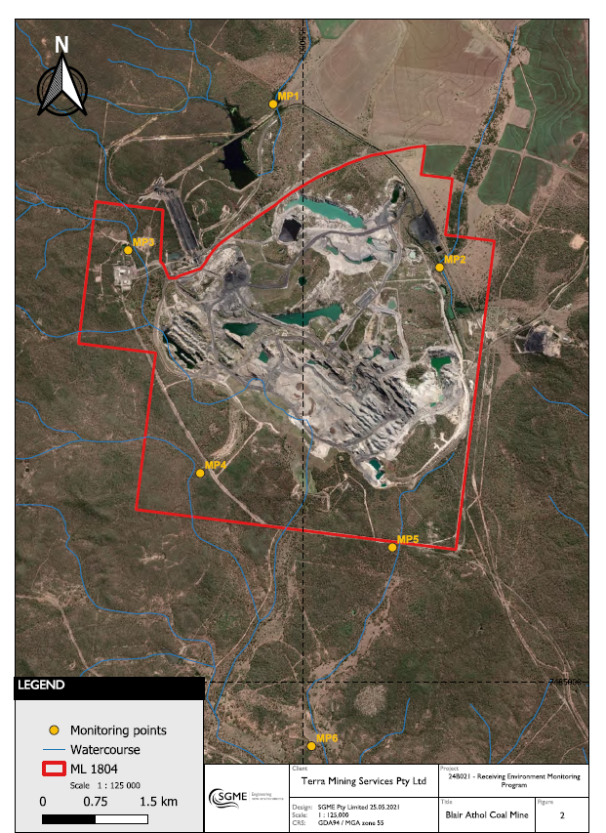

Attachment 6 – Surface water quality criteria

Quality characteristic (units) | Limit | Comment on limit
pH | 6.5-8.5 | Lower Nogoa and Theresa Creek WQO
Electrical Conductivity (µS/cm) | 720 | Base flow – Theresa Creek WQO
Turbidity (NTU) | 50 | Lower Nogoa and Theresa Creek WQO
Suspended Solids (mg/L) | 10 | Lower Nogoa and Theresa Creek WQO
Sulphate (mg/L) | 25 | Lower Nogoa and Theresa Creek WQO
Aluminium - dissolved (µg/L) | 55 | ANZG (2018)
Ammonia (µg/L) | 900 | ANZG (2018)
Arsenic - dissolved (µg/L) | 13 | ANZG (2018)
Boron - dissolved (µg/L) | 970 | ANZG (2018)
Cadmium - dissolved (µg/L) | 0.2 | ANZG (2018)
Chromium - dissolved (µg/L) | 1 | ANZG (2018)
Cobalt - dissolved (µg/L) | 1.4 | ANZG (2018)
Copper - dissolved (µg/L) | 1.4 | ANZG (2018)
Fluoride (mg/L) | 1.7 | ANZG (2018)
Iron - dissolved (µg/L) | 280 | ANZG (2018)
Lead - dissolved (µg/L) | 3.4 | ANZG (2018)
Manganese - dissolved (µg/L) | 1,900 | ANZG (2018)
Mercury - dissolved (µg/L) | 0.06 | ANZG (2018)
Molybdenum - dissolved (µg/L) | 34 | ANZG (2018)
Nickel - dissolved (µg/L) | 11 | ANZG (2018)
Nitrate (µg/L) | 2,400 | ANZG (2018)
Selenium - dissolved (µg/L) | 5 | ANZG (2018)
Silver - dissolved (µg/L) | 0.05 | ANZG (2018)
Uranium - dissolved (µg/L) | 0.5 | ANZG (2018)
Vanadium - dissolved (µg/L) | 6 | ANZG (2018)
Zinc - dissolved (µg/L) | 8 | ANZG (2018)
Total recoverable hydrocarbons (C6-C9) (µg/L) | 20 | LOR for analytical method
Total recoverable hydrocarbons (C10-C36) (µg/L) | 100 | LOR for analytical method
Major ions (mg/L)  Calcium, chloride, potassium, magnesium, sodium, bicarbonate, carbonate | For interpretation purposes
Hardness (mg/L) | For interpretation purposes
Notes:
  - All metals and metalloids must be measured as ‘dissolved’ (from analysis of a field filtered sample) and total (unfiltered).
  - Limits for metals and metalloids apply to dissolved results.
  - ANZG (2018) Aquatic ecosystem protection for moderately disturbed system (95% protection).
  - Lower Nogoa and Theresa Creek Sub-basin.

Attachment 7 – Groundwater monitoring bores
Monitoring Bore | Hydrogeological Unit | Compliance assessment required |  | Location
Monitoring Bore | Hydrogeological Unit | Water quality (Y/N) | Water level  (Y/N) | Latitude (GDA2020) | Longitude (GDA2020)
BA Station (Mayes Bore) | Tertiary Basalt | Y | Y | -22.67855 | 147.55946
Curtis Windmill | Tertiary Basalt | Y | Y | -22.66615 | 147.56694
GW04B | Permian conglomerate | Y | Y | -22.69090 | 147.55675

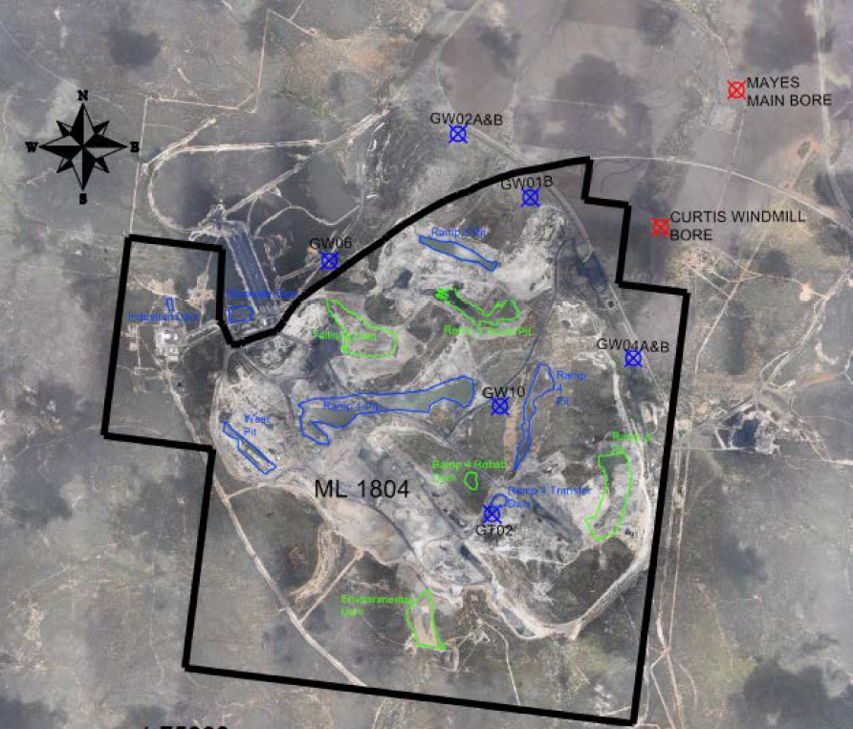
Figure 4. Groundwater monitoring locations

Attachment 8 – Groundwater quality criteria
Quality characteristic (units) | Monitoring Bore | Limit | Comment
pH (pH units) | All bores | 6.5-8.5 | WQO
Electrical Conductivity (µS/cm) | All bores | 1,950¹
Sulfate (mg/L) | All bores | 67 | WQO
Fluoride (mg/L) | All bores | 1.7 | ANZG 2018
Ammonia (µg/L) | All bores | 900 | ANZG 2018
Nitrate (µg/L) | All bores | 2,400 | ANZG 2018
Aluminium - dissolved (µg/L) | All bores | 55 | ANZG 2018
Arsenic - dissolved (µg/L) | All bores | 13 | ANZG 2018
Boron - dissolved (µg/L) | All bores | 940 | ANZG 2018
Cadmium - dissolved (µg/L) | All bores | 0.2 | ANZG 2018
Chromium - dissolved (µg/L) | All bores | 1 | ANZG 2018
Cobalt - dissolved (µg/L) | All bores | 1.4 | ANZG 2018
Copper - dissolved (µg/L) | All bores | 1.4 | ANZG 2018
Iron - dissolved (µg/L) | All bores | 280 | ANZG 2018
Lead - dissolved (µg/L) | All bores | 3.4 | ANZG 2018
Manganese - dissolved (µg/L) | All bores | 1,900 | ANZG 2018
Mercury - dissolved (µg/L) | All bores | 0.06 | ANZG 2018
Molybdenum - dissolved (µg/L) | All bores | 34 | ANZG 2018
Nickel - dissolved (µg/L) | All bores | 11 | ANZG 2018
Selenium - total (µg/L) | All bores | 5 | ANZG 2018
Silver - dissolved (µg/L) | All bores | 0.05 | ANZG 2018
Uranium - dissolved (µg/L) | All bores | 0.5 | ANZG 2018
Vanadium - dissolved (µg/L) | All bores | 6 | ANZG 2018
Zinc - dissolved (µg/L) | All bores | 8 | ANZG 2018
Major ions (mg/L) - calcium, chloride, potassium, magnesium, sodium, bicarbonate, carbonate | All bores | For interpretation purposes
Hardness (mg/L) | All bores
Water level (mAHD) | All bores | For interpretation purposes

Notes:
- WQO - Fitzroy River Basin Groundwater Zone 13 Deep 80th percentile. Source: Environmental Protection (Water) Policy 2009 Nogoa River Sub-basin Environmental Values and Water Quality Objectives Basin No. 130 (part), including all waters of the Nogoa River Sub-basin
- All metals and metalloids must be measured as ‘dissolved’ (from analysis of a field filtered sample) and total (unfiltered).
- Limits for metals and metalloids apply to dissolved results.

Attachment 9 – Groundwater water level monitoring locations and thresholds
Monitoring Bore* | Hydrogeological Unit | Surface RL (mAHD) | Baseline Water Level (mAHD) | Level Threshold – End of mining drawdown (m) | End of Mining Water Level (mAHD)
BA Station (Mayes Bore) | Tertiary Basalt | 324 | TBD | TBD | TBD
Curtis Windmill | Tertiary Basalt | 325 | TBD | TBD | TBD
GW04B | Permian conglomerate | 314 | TBD | TBD | TBD

Attachment 10 – Rehabilitation Monitoring Locations
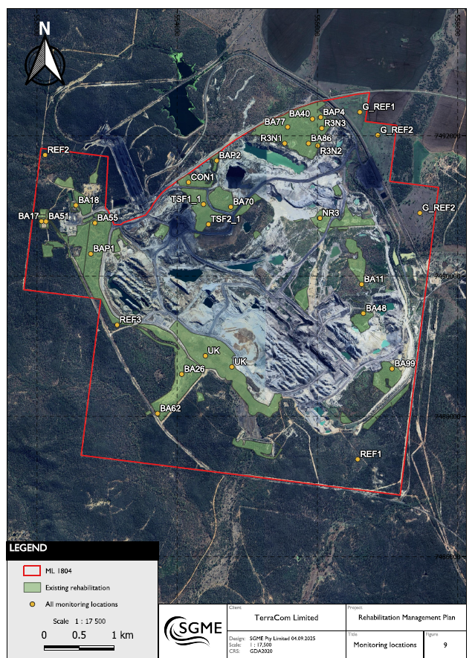

END OF PRCP SCHEDULE

For pH, the quality result measured at the downstream location must be within the prescribed range. However, where pH at the downstream location is greater-than (>) the highest limit in the range, the pH at the applicable upstream location must be greater-than or equal-to (≥) the downstream location. Conversely, where pH at the downstream location is less than (<) the lowest limit in the range, the upstream pH at the applicable upstream location must be less-than or equal-to (≤) the downstream location.

