
PRCP schedule
Environmental Protection Act 1994

PRCP schedule P-PRCP-100987739
This is the approved form for a PRCP schedule issued by the administering authority under Chapter 5 of the Environmental Protection Act 1994.
PRCP schedule: P-PRCP-100987739_V1
PRCP schedule holder(s)

Name(s) | Registered address
METRES PTY LTD | Level 32,  12 Creek Street, Brisbane City,  QLD, 4000 Australia
Location details
Location(s)
ML70344, ML70457, ML70313, ML70485, ML70401, ML70483

Take effect
In accordance with section 202B of the Environmental Protection Act 1994 (EP Act), the PRCP schedule has effect on the day the environmental authority for carrying out relevant activities on land to which the schedule relates takes effect. Pursuant to section 202C of the EP Act, a PRCP schedule continues in force until the environmental authority for the relevant activities to which the PRCP schedule relates is cancelled or surrendered, even if the resource tenure expires or is cancelled and even if the relevant environmental authority is suspended under Chapter 5, part 11 or 11A of the EP Act.
 |  | Date
Juliana McCosker  Department of the Environment, Tourism, Science  and Innovation  Delegate of the administering authority  Environmental Protection Act 1994 |  | Enquiries:  Business Centre Coal  PO Box 3028, Emerald QLD 4720  Phone: (07) 4987 9320  Email: CRMining@detsi.qld.gov.au

Obligations under the Environmental Protection Act 1994
Pursuant to section 202E of the EP Act, if there is an inconsistency between an environmental authority and a PRCP schedule, the environmental authority prevails to the extent of the inconsistency.
Pursuant to section 285 of the EP Act:
- the holder of a PRCP schedule must commission an audit of the schedule by a rehabilitation auditor for the following periods (each an audit period) —
(a) the 3-year period starting on the day the schedule takes effect
(b) each 3-year period starting on the day after the previous audit period ended.
- the holder must, within 4 months after the end of each audit period, give the administering authority -
- the rehabilitation auditor’s report (an audit report) about the audit that complies with section 286 of the EP Act, and
- A declaration by the authorised representative of the EA holder, for the audit report stating the EA holder –
- Has not knowingly given false or misleading information to the rehabilitation auditor; and
- has given all relevant information to the rehabilitation auditor.

An audit report for a PRCP schedule must be in the approved form, and include the following:
- A statement about whether the holder has complied with the schedule during the audit period, including –
- Details of actions the holder has taken, or failed to take, in relation to the rehabilitation milestones and management milestones under the schedule; and
- whether the holder has complied, or failed to comply, with conditions imposed on the schedule; and
- whether information given to the administering authority under this Act about rehabilitation carried out under the schedule is accurate;
- an assessment of whether the post-mining land use for land the subject of the schedule is likely to be achieved, having regard to the rehabilitation that has been and is to be carried out under the schedule;
- recommendations about actions the holder should take to ensure rehabilitation milestones and management milestones are achieved or conditions of the schedule are complied with;
- the other information the administering authority considers necessary to decide whether to take action to amend the schedule under part 6 of the Environmental Protection Act 1994 (Qld) (EP Act).

In addition to the requirements found in the conditions of this PRCP schedule, the holder must also meet their obligations under the environmental authority, the EP Act, and the regulations made under the EP Act. For example, the holder must comply with the following provisions of the EP Act:
- general environmental duty (section 319)
- duty to notify environmental harm (section 320-320G)
- offence of causing serious or material environmental harm (sections 437-439)
- offence of causing environmental nuisance (section 440)
- offence of depositing prescribed water contaminants in waters and related matters (section 440ZG)
- offence to place contaminant where environmental harm or nuisance may be caused (section 443).

PRCP schedule
The PRCP schedule incorporates the following sections:
- Section A - Conditions of PRCP schedule
- Section B - Final site design and reference maps
- Section C - Definitions
- Section D - Post mining land uses
- Section E - Non-use management areas
- Section F - Appendix

Section A - Conditions of PRCP schedule
Pursuant to section 206A of the EP Act:
- it is a condition of this PRCP schedule that, in carrying out a relevant activity under the schedule, the holder must comply with a requirement stated in the environmental authority relevant to carrying out the activity.
- it is a condition of this PRCP schedule that the holder must comply with the following matters stated in the schedule -
  - each rehabilitation milestone and management milestone; and
  - when each rehabilitation milestone and management milestone is to be achieved.
General conditions

- The holder must, for each rehabilitation and improvement area, achieve the corresponding rehabilitation or management milestone criterion (milestone reference):
- for the cumulative area available specified in this schedule; and
- by the milestone completion date specified in this schedule.
- Where an area achieves a rehabilitation or management milestone, it must continue to comply with the criteria for that milestone until the next milestone is achieved. For the final rehabilitation or management milestone, compliance with the criteria for the final milestone must be maintained until the area is progressively certified in accordance with the EP Act requirements or the area is surrendered.
- The holder must carry out monitoring in accordance with:
- any requirement under this schedule; and
- as necessary to demonstrate achievement of each rehabilitation milestone or management milestone criteria.
- The holder must keep up to date records in relation to relevant matters until the relevant environmental authority (EPML00819213) has been surrendered and must provide such records to the administering authority on request. Relevant matters for this condition include, but are not necessarily limited to, the following:
- rehabilitation, maintenance and monitoring activities, and the results of these activities;
- designs, drawings, specifications or any similar documents required under this schedule;
- certifications, assessments, investigations, inspections, audits or any similar processes required under this schedule.
- Records made under PRCP4 must be provided to the administering authority in the specified format within 10 business days of a written request or a longer duration as agreed by the administering authority.
- All Appropriately Qualified Person/Suitably Qualified person (AQP/SQP) designs, specifications, certifications, assessments and any similar documents, must:
- include documented consideration of any relevant guideline or publication material, including material published by the administering authority;
- detail the boundary conditions (of any model);
- detail any assumptions made, limitations and areas of uncertainty; and
- must contain sufficient detail to allow for independent peer review and substantiation.

- Disturbance due to exploration and minor ancillary activities in areas not planned to be mined and not within a Rehabilitation Area in this schedule must be rehabilitated in accordance with the provisions detailed in the ‘Eligibility criteria and standard conditions for exploration and mineral development projects’ or its successor, with the exception that land must be rehabilitated to a stable condition and achieves the pre-disturbance land use as detailed in Figure 1 – Final Site Design.
- Closure groundwater and water balance model predictions must be rerun if there is a change to the final landform design that would affect the model predictions and requires an amendment to this schedule, and at the last management milestone in this schedule.
- With respect to surface water:
- Surface water quality must be monitored monthly during flow events (whenever there is sufficient flow as determined by an AQP) at, but not limited to, upstream and downstream locations specified in PRCP schedule Appendix 10 and 10.1: Surface water monitoring locations, must not exceed the limits in PRCP schedule Appendix 11: Surface water quality limits, for a minimum of 5 consecutive years immediately prior to surrender;
- If the surface water quality exceeds Appendix 11: Surface water quality limits, the applicable upstream site must be compared to the downstream site result; and the quality result measured at a downstream site must be equal to or less than the quality result measured at the applicable upstream site.
- With respect to groundwater:
- The groundwater levels and quality must be monitored quarterly at, but not limited to, bores specified in PRCP schedule Appendix 12 and 12.1: Groundwater monitoring locations, for all quality characteristics listed in PRCP schedule Appendix 13: Groundwater quality limits for a minimum of five consecutive years immediately prior to surrender; and
- Groundwater quality results must not exceed the limits in PRCP schedule Appendix 13: Groundwater quality limits, for 3 consecutive results within the five-year immediately prior to surrender.

END OF CONDITIONS

Section B - Final site design and reference maps
Figure 1 – Final Site Design

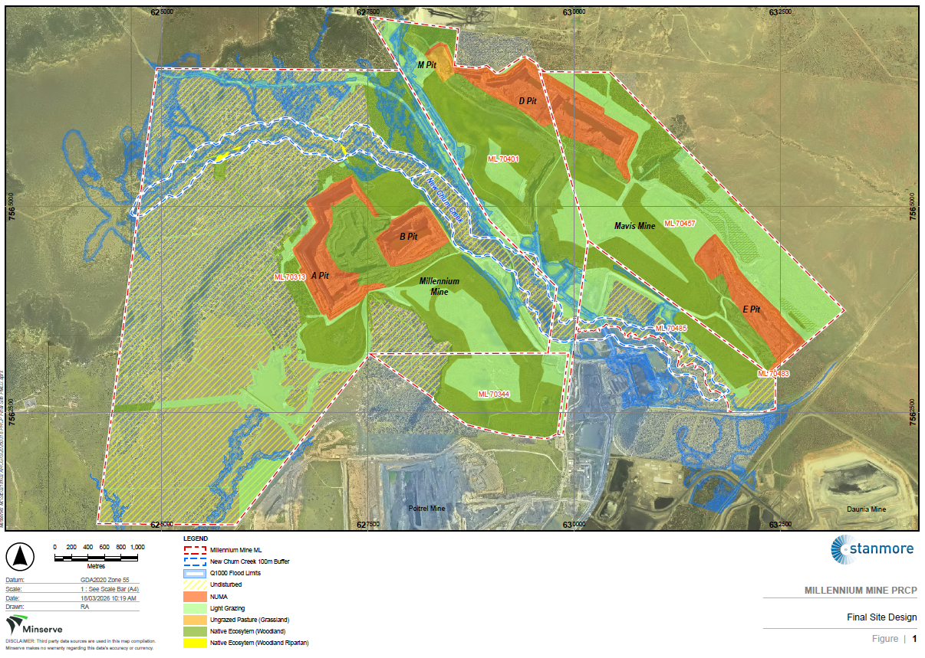
Figure 2 – Rehabilitation Areas (PMLU) and Improvement Areas (NUMA)

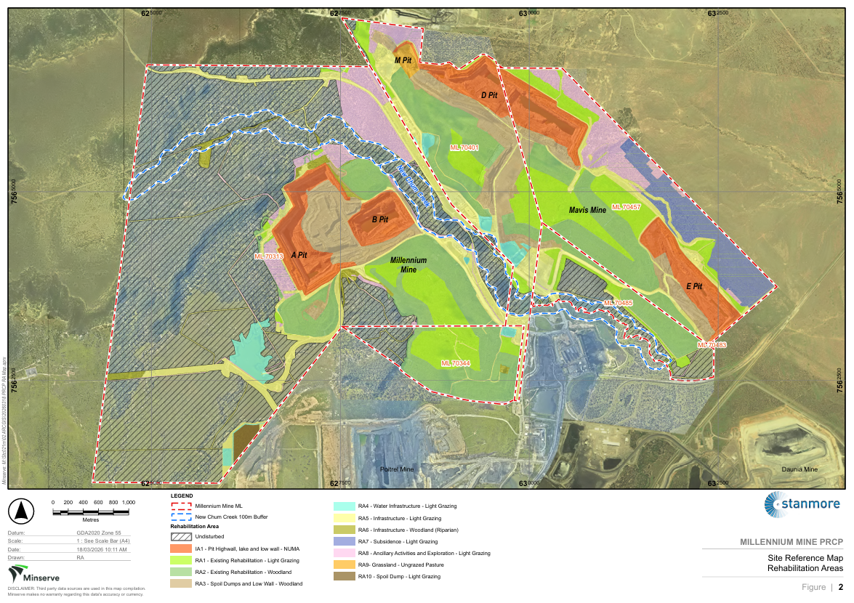

Section C – Definitions
Appropriately qualified person (AQP) | means a person who has professional qualifications, training, skills and experience relevant to the nominated subject matter and can give authoritative assessment, advice and analysis on performance relative to the subject matter using the relevant protocols, standards, methods or literature.
Activity (EP Regulation) | includes that part, if any, of an activity relating to the following—  (a) preparing a place for the activity before carrying out the activity; and  (b) rehabilitating a place after it has been used for carrying out the activity.
Annual Exceedance Probability (AEP) | the probability that a given rainfall total accumulated over a given duration will be exceeded in any one year.
Contaminants | can be a gas, liquid or solid; or an odour; or an organism (whether alive or dead), including a virus; or energy, including noise, heat, radioactivity and electromagnetic radiation; or a combination of contaminants.
Flood stress | is the pressure on structures from rapid water rise, erosion, and saturation during extreme floods, risking instability.
Growth media | is defined as all soil and soil-like material that will support the final vegetation cover. This includes the topsoil and subsoil where these materials are applied independently. Where the topsoil is incorporated into the underlying subsoil/spoil, topsoil refers to the depth of incorporation and the remaining depth is regarded as subsoil. The total depth of growth media is nominally considered to be the effective plant root zone.
Gully | a gully is a channel excavated by water, more than 0.3 m deep.
Third party AQP | means an AQP who is not the PRCP schedule holder.
Independent AQP | means an AQP who is not the PRCP schedule holder and has not previously provided advice on the subject matter.
Major earthworks | large scale movement of materials like soil, rock with use of machines to reshape, regrade the landscape, stabilise slopes to create safe, stable landform to sustain a designated post-mine land use or a non-use management area.
Light grazing | means grazing on land suitability assessment (LSA) Class 4 which is not suitable for a sustained grazing PMLU but may be grazed for short periods (e.g., land stewardship purposes). This requires careful management of stocking rates and pasture condition to prevent land and water degradation.
Rehabilitation activity | means any activity that the holder is required to carry out in relation to this PRCP schedule.
Relevant material | includes:  - Final landform design report,  - All monitoring data  - Assessment of monitoring data,  - All maintenance records; and  - Modelling and technical assessments.
Rill | a rill is a channel excavated by water, less than 0.3 m deep.
Stable | in relation to land, means landform dimensions are or will be stable within tolerable limits now and in the foreseeable future.  Stability includes consideration of environmental context, geotechnical stability, settlement and consolidation allowances, bearing capacity (trafficability), erosion resistance and geochemical stability with respect to seepage, leachate and related contaminant generation.
Stabilised | means one or both of the following conditions apply: no evidence of sediment movement; sides and/or floors of erosion form are revegetated (Australian Soil and Land Survey Field Handbook Fourth Edition).
Stable condition | see section 111A of the Environmental Protection Act 1994.
Suitably qualified and experienced person (SQP) | for performing a regulatory function under chapter 7, part 8 (Contaminated Land) of the EP Act or another function prescribed under a regulation, means a person who—  (a) has qualifications and experience relevant to performing the function; and  (b) if a regulation prescribes an organisation for this paragraph—is a member of the organisation.
Subsidence | means the gradual or sudden sinking, lowering, or collapse of the ground surface due to underground mining activities.
Vegetative groundcover | means plants, plant litter, tree leaf litter, twigs, mulch and woody debris capable of protecting the soil surface from erosion
Water cap | the residual void fills to its long term equilibrium level, permanently submerging the underlying tailings material.
Weed | Weed include:  - Category 3 restricted invasive plant species, defined by the Biosecurity Act 2014; and  - Weeds of National Significance, defined by Invasive Plants and Animals Committee 2016, Australian Weeds Strategy 2017 to 2027, Australian Government Department of Agriculture and Water Resources, Canberra.

Section D – Post mining land uses

(RA1) Rehabilitation area 1
Post-mining land uses (PMLU)
Rehabilitation area | RA1
Relevant activities | Existing Rehabilitation
Total rehabilitation area size (ha) | 290.1
Commencement of first milestone: RM7 | 10-12-2025
PMLU | Light Grazing
Date area is available | 10-12-2025
Cumulative area available (ha) | 290.1
Milestone completed by | 10-12-2030
Milestone Reference | Cumulative area achieved (ha)
RM7 | 290.1

(RA2) Rehabilitation area 2
Post-mining land uses (PMLU)
Rehabilitation area | RA2
Relevant activities | Existing Rehabilitation
Total rehabilitation area size (ha) | 492.0
Commencement of first milestone: RM5 | 10-12-2025
PMLU | Woodland Habitat
Date area is available | 10-12-2025 | 10-12-2035 | 10-12-2040
Cumulative area available (ha) | 492.0 | 492.0 | 492.0
Milestone completed by | 10-12-2035 | 10-12-2040 | 10-12-2050
Milestone Reference | Cumulative area achieved (ha)
RM5 | 492.0
RM6 |  | 492.0
RM7 |  |  | 492.0

(RA3) Rehabilitation area 3

Post-mining land uses (PMLU)
Rehabilitation area | RA3
Relevant activities | Spoil Dumps and Low Wall
Total rehabilitation area size (ha) | 208.7
Commencement of first milestone: RM3 | 10-12-2025
PMLU | Woodland Habitat
Date area is available | 10-12-2025 | 10-12-2035 | 10-12-2040 | 10-12-2040 | 10-12-2045
Cumulative area available (ha) | 59.0 | 171.6 | 208.7 | 208.7 | 208.7
Milestone completed by | 10-12-2030 | 10-12-2035 | 10-12-2040 | 10-12-2045 | 10-12-2055
Milestone Reference | Cumulative area achieved (ha)
RM3 | 28.2 | 171.6 | 177.8
RM4 | 59.0 | 150.0 | 208.7
RM5 | 59.0 | 150.0 | 208.7
RM6 |  | 59.0 | 150.0 | 208.7
RM7 |  |  | 59.0 | 150.0 | 208.7

(RA4) Rehabilitation area 4
Post-mining land uses (PMLU)
Rehabilitation area | RA4
Relevant activities | Water Infrastructure
Total rehabilitation area size (ha) | 48.1 ha
Commencement of first milestone: RM3 | 10-12-2035
PMLU | Light Grazing
Date area is available | 10-12-2035 | 10-12-2040 | 10-12-2045
Cumulative area available (ha) | 43.9 | 43.9 | 43.9
Milestone completed by | 10-12-2040 | 10-12-2045 | 10-12-2050
Milestone Reference | Cumulative area achieved (ha)
RM3 | 43.9
RM4 | 43.9
RM5 | 43.9
RM6 |  | 43.9
RM7 |  |  | 43.9

(RA5) Rehabilitation area 5
Post-mining land uses (PMLU)
Rehabilitation area |  |  |  | RA5
Relevant activities |  |  |  | Infrastructure - roads, cleared areas, topsoil stockpiles, laydowns
Total rehabilitation area size (ha) |  |  |  | 284.3
Commencement of first milestone: RM1 |  |  |  | 10-12-2025
PMLU |  |  |  | Light grazing
Date area is available | 10-12-2025 | 10-12-2035 | 10-12-2040 | 10-12-2045 | 10-12-2050 | 10-12-2055 | 10-12-2060 | 10-12-2065
Cumulative area available (ha) | 14.6 | 24.6 | 54.6 | 100.6 | 284.3 | 284.3 | 284.3 | 284.3
Milestone completed by | 10-12-2035 | 10-12-2040 | 10-12-2045 | 10-12-2050 | 10-12-2055 | 10-12-2060 | 10-12-2065 | 10-12-2070
Milestone Reference | Cumulative area achieved (ha)
RM1 | 14.6 | 24.6 | 54.6 | 100.6 | 284.3
RM2 | 14.6 | 24.6 | 54.6 | 100.6 | 284.3
RM3 | 14.6 | 24.6 | 54.6 | 100.6 | 284.3
RM4 |  | 14.6 | 24.6 | 54.6 | 100.6 | 284.3
RM5 |  | 14.6 | 24.6 | 54.6 | 100.6 | 284.3
RM6 |  |  | 14.6 | 24.6 | 54.6 | 100.6 | 284.3
RM7 |  |  |  | 14.6 | 24.6 | 54.6 | 100.6 | 284.3

(RA6) Rehabilitation area 6
Post-mining land uses (PMLU)
Rehabilitation area |  |  |  | RA6
Relevant activities |  |  |  | Infrastructure - roads, cleared areas, topsoil stockpiles, laydowns
Total rehabilitation area size (ha) |  |  |  | 22.6
Commencement of first milestone: RM1 |  |  |  | 10-12-2025
PMLU |  |  |  | Woodland Habitat
Date area is available | 10-12-2025 | 10-12-2035 | 10-12-2040 | 10-12-2045 | 10-12-2050 | 10-12-2055 | 10-12-2060 | 10-12-2065
Cumulative area available (ha) | 1.0 | 2.0 | 3.0 | 4.0 | 22.6 | 22.6 | 22.6 | 22.6
Milestone completed by | 10-12-2035 | 10-12-2040 | 10-12-2045 | 10-12-2050 | 10-12-2055 | 10-12-2060 | 10-12-2065 | 10-12-2075
Milestone Reference | Cumulative area achieved (ha)
RM1 | 1.0 | 2.0 | 3.0 | 4.0 | 22.6
RM2 | 1.0 | 2.0 | 3.0 | 4.0 | 22.6
RM3 | 1.0 | 2.0 | 3.0 | 4.0 | 22.6
RM4 |  | 1.0 | 2.0 | 3.0 | 4.0 | 22.6
RM5 |  | 1.0 | 2.0 | 3.0 | 4.0 | 22.6
RM6 |  |  | 1.0 | 2.0 | 3.0 | 4.0 | 22.6
RM7 |  |  |  | 1.0 | 2.0 | 3.0 | 4.0 | 22.6

(RA7) Rehabilitation area 7
Post-mining land uses (PMLU)
Rehabilitation area | RA7
Relevant activities | Subsidence Area
Total rehabilitation area size (ha) | 74.8
Commencement of first milestone: RM5 | 10-12-2025
PMLU | Light Grazing
Date area is available | 10-12-2025 | 10-12-2030 | 10-12-2035
Cumulative area available (ha) | 74.8 | 74.8 | 74.8
Milestone completed by | 10-12-2030 | 10-12-2035 | 10-12-2040
Milestone Reference | Cumulative area achieved (ha)
RM5 | 74.8
RM6 |  | 74.8
RM7 |  |  | 74.8

(RA8) Rehabilitation area 8
Post-mining land uses (PMLU)
Rehabilitation area | RA8
Relevant activities | Ancillary Activities and Exploration
Total rehabilitation area size (ha) | 166.0
Commencement of first milestone: RM7 | 10-12-2040
PMLU | Woodland Habitat
Date area is available | 10-12-2040
Cumulative area available (ha) | 166.0
Milestone completed by | 10-12-2045
Milestone Reference | Cumulative area achieved (ha)
RM7 | 166.0

(RA9) Rehabilitation area 9
Post-mining land uses (PMLU)
Rehabilitation area | RA9
Relevant activities | Overburden Dumps and Rejects
Total rehabilitation area size (ha) | 8.7
Commencement of first milestone: RM3 | 10-12-2025
PMLU | Grassland - Ungrazed Pasture
Date area is available | 10-12-2025 | 10-12-2040 | 10-12-2045
Cumulative area available (ha) | 8.7 | 8.7 | 8.7
Milestone completed by | 10-12-2040 | 10-12-2045 | 10-12-2050
Milestone Reference | Cumulative area achieved (ha)
RM3 | 8.7
RM4 | 8.7
RM5 | 8.7
RM6 |  | 8.7
RM7 |  |  | 8.7

(RA3) Rehabilitation area 10

Post-mining land uses (PMLU)
Rehabilitation area | RA10
Relevant activities | Spoil Dump (extended Poitrel OOPD on ML70313)
Total rehabilitation area size (ha) | 9.6
Commencement of first milestone: RM3 | 10-12-2030
PMLU | Light Grazing
Date area is available | 10-12-2030 | 10-12-2035 | 10-12-2040 | 10-12-2045
Cumulative area available (ha) | 9.6 | 9.6 | 9.6 | 9.6
Milestone completed by | 10-12-2035 | 10-12-2040 | 10-12-2045 | 10-12-2060
Milestone Reference | Cumulative area achieved (ha)
RM3 | 9.6
RM4 |  | 9.6
RM5 |  | 9.6
RM6 |  |  | 9.6
RM7 |  |  |  | 9.6

Rehabilitation area milestones
Milestone reference | Rehabilitation milestone | Milestone criteria
RM1 | Infrastructure decommissioning and removal | 1.1 Other than as required by this schedule or agreed to be retained by the landholder (as evidenced by landholder agreement):  - All services are disconnected and decommissioned;  - All buildings are demolished and/or removed offsite;  - All hardstands, concrete areas, road materials (bitumen and gravel) are removed;  - All mine roads, access tracks and fences are removed;  - All pipelines are drained and removed;  - All waste removed from site unless authorised by the Environmental Authority (EPML00819213) for disposal onsite;  - All exploration drill holes rehabilitated in accordance with the eligibility criteria and standard conditions for exploration and mineral development projects – V2 (DEHP 2016);  - Infrastructure required for the ongoing health and safety of operators such as road safety bunds are to be retained until deemed safe to remove in accordance with the Coal Mining Safety and Health Act 1999;  - All dams dewatered, desilted and liners removed;  - Watercourse crossings and culverts, excluding retained infrastructure, removed;  - All machinery and equipment, not required for rehabilitation works removed; and  - Infrastructure to be retained for use by underlying landholders, deemed fit for purpose and accepted by signed agreement from the underlying landholder.  1.2 Underground mining infrastructure, equipment are removed and construction of seal from surface into the underground workings complies with regulation 325 of the Queensland Coal Mining Safety and Health Regulations 2020 (CMSHR) to prohibit unauthorised access to underground workings.  1.3 For all surface to seam boreholes (including but not limited to, exploration bores, water monitoring bores, dewatering bores, ventilation and gas drainage bores must:  - grouted and/or plugged;  - capped 0.5m below surface; and  - exploration bores decommissioned in accordance with ‘Eligibility criteria and standard conditions for exploration and mineral development projects.’
RM2 | Identification and remediation of contaminated land | - Contaminated land investigations (investigation, remediation and validation) completed in accordance with the Environmental Protection Act (1994) EP Act, including a site investigation report, and if required, a validation report and/or a draft Site Management Plan.  - A Contaminated Land Auditor certifies that no contamination unsuitable for the PMLU remains or is occurring.
RM3 | Landform development and reshaping/reprofiling | The following criteria apply to all RA’s unless otherwise specified:  - All major earthworks completed, slopes and general reshaping and pushing/ trimming are completed in accordance with the design specification provided by an AQP.  - Erosion and sediment control systems are designed by an AQP, installed where required and demonstrated to be fit for purpose.  - Final landform drainage installed as designed by AQP where required.  - Final rehabilitated landforms assessed as geotechnically stable by an AQP with a factor of safety (FOS) of ≥1.5.  - AQP confirms that final landform (out of pit dump) associated with the north-eastern side of the A and B pit as shown in the PRCP schedule Appendix 1: Location of scour protection for PMF event continue to provide flood protection to the voids to at least the 0.1% AEP flood event plus 0.5m freeboard.  - The final landform (out of pit dump) as per RM3.5 established with native vegetation suitable to resist erosion at the toe of the landform in the 0.1% AEP event.  - Where the final landform (out of pit dump) locations as per RM3.5 interact with PMF flood velocities greater than 3 m/s, non-erosive materials and/or rock mulch are selectively placed in the locations and sized as shown per PRCP schedule Appendix 1: Location of scour protection for PMF event ensuring that the rock covers the wetted perimeter of the toe in the specified locations.  Light Grazing  - The rehabilitated landform reshaped to:  - For RA4 slopes of ≤5%.  - For RA5 slopes are ≤10%.  - For RA10 slopes are ≤15%.  - All legacy reject encapsulation cells within rehabilitated out of pit dumps remain intact and are not exposed through erosion or other forms of weathering (RA1).  - If to be maintained at closure, the portions of final landforms (dirt roads) as shown in PRCP schedule Appendix 2: PMF event high velocity areas, where peak flood velocities predicted to exceed 3.5 m/s, should apply 300mm d50 rock on either side of the dirt road or other mitigation measures to control potential flood damage.  Woodland Habitat  - The rehabilitated landform reshaped to:  - For RA3 all external draining slopes are ≤33.33% overall.  - For RA6 slopes are ≤10%.  - All legacy reject encapsulation cells within rehabilitated out of pit dumps remain intact and are not exposed through erosion or other forms of weathering (RA2).  - As part of erosion control for RA3:  - Continuous slope length restricted to 100m by installation of appropriate erosion control measures as determined by an AQP; or  - A topsoil/permian rock mulch layer placed over the reshaped overburden at a depth of 100mm and ripped to depths between 300-800mm.  - Reshape watercourse crossings to a profile similar to the pre-disturbance condition (RA6).  - Disturbed natural watercourse bed and banks returned to a profile similar to the pre-disturbance condition (RA6).  Grassland – Ungrazed Pasture (RA9)  - For rejects disposal in M pit an AQP to determine appropriate type of cover based on geochemical and geotechnical characterisation of tailings and rejects, which at minimum achieves the following:  - Tailings and rejects to be capped with at least 2m of competent benign spoil or of a thickness determined by an AQP;  - Reduces risk of upward movement of contaminants into the topsoil layer above the cover and reduce risk of environmental harm from contaminated seepage;  - RA9 reshaped with overall slopes ≤33.33%; and  - Landform surface to drain into residual void (IA1).  Underground Mining (RA7)  - Surface above underground mining areas maintain pre-mining contour  ± 50mm.  Retained water structure  - Water storages are safe for stock access and have vegetated banks.
RM4 | Surface preparation | All RAs except RA1, RA2, RA7 and RA8.  - Assessment of growth media characteristics and the development of an amelioration and physical treatment plan is completed by an AQP to achieve the target vegetation establishment, prior to growth media placement.  - Ameliorant and physical treatments such as fertiliser, lime, gypsum and/or organic matter are applied as identified by AQP through assessment of growth media as per RM4.1.  - Deep ripping of compacted surfaces, at least 300mm into soil/subsoil profile along contour of slopes.  - Remediate any erosion or subsidence by, but not limited to, addition of rock and/or log cover to assist erosion resistance of eventual vegetative groundcover.  RA1 & RA2 Existing Rehab  - Based on AQP advice, if need be, appropriate amelioration measures implemented to ensure growth media supports target vegetation development as per designated PMLU.  Light Grazing and Grassland  - Growth media spread at a depth of at least 150mm for RA4, RA5, RA7 (if required for subsidence or associated surface disturbance) and RA9.  Woodland Habitat  - Growth media depth of at least 100mm, spread over RA3, RA6 and RA8 (for RA8 if disturbed) where possible.
RM5 | Revegetation | Light Grazing RA4, RA5, RA7 and RA 10 and Grassland RA9  - Completed seeding using a selection of species and application rates outlined in PRCP schedule Appendix 3 : Seed species list and application rate for light grazing and grassland revegetation.  - A seed mix and a rate consistent with PRCP schedule Appendix 3: Seed species list and application rate for light grazing used for revegetation of disturbance areas associated with underground mining surface infrastructure areas within RA7.  Woodland Habitat RA6 (certain areas within RA6 - Riparian)  - Completed seeding using a selection of species and application rates outlined in PRCP schedule Appendix 4: Recommended species to be established for woodland habitat riparian revegetation to establish Woodland Habitat Riparian (RE 11.3.4) at locations specified in Appendix 4.1: PMLU woodland habitat remnant locations.  Woodland Habitat RA2 & RA3, RA6 & RA8 (For RA8 limited to disturbed area only)  - Completed seeding using a selection of species and application rates outlined in PRCP schedule Appendix 5: Recommended species to be established for woodland habitat revegetation (RE 11.10.1) or other planting methods (e.g. tube stock planting) to establish Woodland Habitat.
RM6 | Achievement of surface requirements | All RAs (Except RA1 and RA8)  - With respect to erosion in rehabilitated landforms:  - AQP certifies there are no active areas of rill or gully erosion present as per PRCP schedule Appendix 9: Erosion classification framework and all active erosion has been identified and remediation activities have been completed;  - The remediated erosion does not impact achieving the PMLU; and  - Mass movement and tunnel erosion are absent.  - All temporary Erosion and Sediment Controls (ESC) are confirmed by an AQP to be safe to remove from site.  - Permanent drainage structures have been reviewed and endorsed by third party AQP as appropriate to the landform, materials and PMLU, with consideration given to long term performance and stability.  - Weeds of National Significance presence is <10% of total vegetative groundcover as confirmed by an AQP.  - Species used in revegetation remain present and show evidence of natural recruitment based on rehabilitation monitoring data.  - Surface water runoff from rehabilitation areas collected at appropriate location/s determined by an AQP for monitoring surface water runoff quality when surface flows occur and when it is safe to do so (RA1, RA2, RA3 and RA10).  - Surface water runoff monitoring in accordance with RM6.6 shows surface water runoff is non-polluting to receiving waters when compared to the upstream catchment values for pH, EC and turbidity.  Woodland Habitat (RA2, RA3, RA8) & Riparian (RA6) PMLUs  - Groundcover ≥80% comprising of at least 50% vegetation and 30% rock, logs, leaf, litter etc. with no bare areas greater than 100 m².  Light Grazing PMLU (RA1, RA4, RA5, RA7 and RA10) and Grassland (RA9)  - Vegetative groundcover is ≥70% with no bare areas greater than 100 m².  - Western Dam stored water quality meets the requirements for stock watering under the ANZECC Guidelines.  - Achievement of land class 4 as per Guidelines for Agricultural Land Evaluation in Queensland for RA4, RA5 and RA7.  - Subsided areas in RA7 do not have residual ponding, and overland flows and surface runoff drain freely from these areas.  - If subsidence monitoring shows an exceedance of the following trigger levels remediate with RM6.12:  - LiDAR sourced topography >100mm movement when LiDAR surfaces are compared on an annual basis; and  - Impact has been identified by an AQP as requiring remediation.  - For RA7, remediate any erosion or subsidence by, but not limited to:  - Addition of rock and/or log cover to assist erosion resistance of eventual vegetative groundcover;  - Filling and ripping of surface cracks greater than 20cm wide to a depth as required prior to growth media application; and  - If required application of topsoil as per RM4.6 for surface areas in RA7 that are impacted by subsidence, using a seed mix and a rate consistent with PRCP schedule Appendix 3: Seed species list and application rate for light grazing and grassland revegetation.
RM7 | Achievement of post-mining land use to a stable condition | The following criteria apply to all RA’s unless otherwise specified:  - Final landform survey confirms no built structures remain.  - No evidence of erosion classified as ‘moderate’ or ‘severe’ as defined by Appendix 9: Erosion classification framework.  - Despite RM7.2 gullies are acceptable in the achievement of a stable landform provided they meet the following criteria as certified by an AQP:  - does not exceed 1 m in depth at any point  - has not exposed environmentally problematic materials  - the cause of the gully is known and has been resolved  - has established and persistent vegetation cover, and/ or rock armouring at the head of the gully  - is in a stabilised state, demonstrated by monitoring data over a 5-year period; and  - does not provide a safety hazard within the context of the PMLU.  - No evidence of scouring, overtopping or destabilisation in or associated with permanent engineered drainage structures.  - No evidence of saline, metalliferous or acid mine drainage evidenced by groundwater monitoring.  Woodland Habitat PMLU  - A BioCondition assessment completed by an AQP using current methodology prescribed in the latest version of the Queensland Herbarium’s BioCondition Assessment Manual, demonstrating that the final landform for RA2, RA3, RA6 (certain areas) & RA8 achieves the ‘Revised PRCP benchmark’ criteria in PRCP schedule Appendix 6: Woodland habitat revegetation monitoring benchmarks.  Woodland Habitat PMLU (certain areas within RA6 - Riparian)  - A BioCondition assessment completed by an AQP using current methodology prescribed in the latest version of Queensland Herbarium’s BioCondition Assessment Manual (Eyre et al., 2015), demonstrating that the final landform for RA6 achieves the ‘Revised PRCP benchmark’ criteria in PRCP schedule Appendix 7: Woodland habitat riparian revegetation monitoring benchmarks.  Light Grazing and Grassland PMLU (RA1, RA4, RA5, RA7, RA9 and RA10)  - >70% established and self-sustaining vegetative groundcover of species as listed in PRCP schedule Appendix 3: Seed species list and application rate for light grazing and grassland revegetation.  - Pasture meets condition rating provided in PRCP schedule Appendix 8: Pasture condition assessment as follows:  - For existing rehab (RA1) ≤3  - For proposed rehab (RA4, RA5, RA7 and RA10) ≤2  - Subsidence monitoring does not show an exceedance of trigger levels stated in RM6.13 within 5 years of the cessation of Mavis underground mining activities.  - No surface cracking or ponding or impacts to drainage attributed to mining activities which does not impact achieving the PMLU.  Retained infrastructure/ Water storage (RA4)  - Infrastructure to be transitioned to a future landholder is deemed fit for purpose, safe and stable by AQP and accepted, by signed agreement with the future landholder.  - The retained dam (Western dam) is safe, accessible to animals and stock and have vegetated banks.  - Water storages monitored for water quality annually must meet ANZECC 2000 stock water guideline values, for a minimum of 5 consecutive years prior to surrender.

Section E – Non-use management areas

(IA1) Improvement area 1
Non-use management area (NUMA)
Improvement area | IA1
Relevant activities | Residual voids  Millennium pit (A, B)  Mavis pit (M, D, E)
Total size (ha) | 281.0
Commencement of first milestone: MM1 | 10-12-2025
NUMA | Highwall, Low wall, End wall, Pit Lake and Inpit Tailings Storage
Date area is available | 10-12-2025 | 10-12-2035
Cumulative area available (ha) | 281.0 | 281.0
Milestone completed by | 10-12-2035 | 10-12-2045
Milestone Reference | Cumulative area achieved (ha)
MM1 | 281.0
MM2 |  | 281.0
MM3 |  | 281.0
MM4 |  | 281.0

Improvement area milestones

Milestone reference | Management milestone | Milestone criteria
MM1 | Achievement of structural stability | - Confirmation by a third party AQP that final voids are stable, including:  - That the highwall and end wall (where not backfilled) have:  - overall slope angle 65° void highwall and end wall in competent (unweathered) rock;  - overall slope angle 45° highwall and end wall in less competent (weathered) rock; and  - Prevent the ingress of floodwater into void.  - The highwall and end wall demonstrates achievement of geotechnical stability by achieved factor of safety ≥1.5.  - AQP confirms portal sealed off as per regulation 325 of the Queensland Coal Mining Safety and Health Regulations 2020 (CMSHR).
MM2 | Installation of cover system (in-pit tailings) | - An AQP certifies:  - Two metres of benign material placed as a cover system giving consideration to the consolidation of tailings.  - Installed cover displays erosional and geotechnical stability.  - Installed cover is effective in mitigating the potential for interaction of contaminants from tailings storage areas with the surrounding environment, up until when the natural water level rise in D Pit North to create a water cap.
MM3 | Achievement of surface requirements | - Safety bund setback distance is in accordance with a calculated geotechnical FoS of ≥1.5 as determined by an AQP.  - The safety bund is constructed in accordance with engineering requirements including:  - constructed from non-weathered dumped rockfill;  - a minimum 2 m in height;  - a minimum of 7 m base width; and  - 1 in 1.5 batters.  - Bunding constructed in accordance with the Department of Industry and Resources (1997) Guideline safety bund walls around abandoned open pit mines or as recommended by AQP and confirmed to be geotechnically stable by an AQP.  - Fencing installed at nominated offset from safety bund to restrict public access to highwall or end wall areas.  - Appropriate signage placed at suitable intervals around the perimeter of the void to clearly identify and convey the purpose.
MM4 | Achievement of sufficient improvement | - Confirmation by a third party AQP, that final voids are stable (including):  - the high wall and end wall (where not backfilled) have:  - 65⁰ overall void high wall in competent (unweathered) rock.  - 45⁰ overall high wall in less competent (weathered) rock.  - Lowwall spoil at angle of repose.  - voids retain minimum 0.1% AEP flood immunity from inundation or overtopping, supported by flood modelling re-run prior to completion of MM4 and calibrated against the final landform;  - geotechnically stable;  - evidence that any erosion at the high-wall and low-wall does not cause instability or degradation to the land beyond IA1;  - drainage measures and structures have been appropriately established and are directing overland flow away from the highwall edge;  - erosion and sediment control measures have been installed and are operating as per design;  - surface water managed along the pit crests to ensure that surface erosion is minimised and evidence that ground cover between the void crests and bunds is >60%; and  - the safety bund and fencing are present and functional continuing to keep the residual voids safe to humans and livestock.  - The groundwater monitoring conducted as per PRCP condition 10 and the residual void water level monitoring results within the five-years immediately prior to surrender are supported by groundwater modelling that demonstrates:  - the voids do not and will not cause environmental harm to receiving environment; and  - are on trajectory to act collectively as a groundwater sink in the long term.

Section F – Appendix
List of Appendices
Appendix 1: Location of scour protection for PMF event.
Appendix 2: PMF event high velocity areas.
Appendix 3: Seed species list and application rate for light grazing and grassland revegetation.
Appendix 4: Recommended species to be established for woodland habitat riparian revegetation (RE11.3.4).
Appendix 4.1: PMLU woodland habitat remnant locations.
Appendix 5: Recommended species to be established for woodland habitat revegetation (RE11.10.1) RA2, RA3, RA6 & RA8 (For RA8 limited to disturbed area only).
Appendix 6: Woodland habitat revegetation monitoring benchmarks (RE11.10.1) RA2, RA3, RA6 & RA8 (For RA8 limited to disturbed area only).
Appendix 7: Woodland habitat riparian revegetation monitoring benchmarks (certain areas within RA6).
Appendix 8: Pasture condition assessment.
Appendix 9: Erosion classification framework.
Appendix 10: Surface water monitoring locations.
Appendix 10.1: Surface water monitoring locations.
Appendix 11: Surface water quality limits .
Appendix 12: Groundwater monitoring locations.
Appendix 12.1: Groundwater monitoring locations.
Appendix 13: Groundwater quality limits.

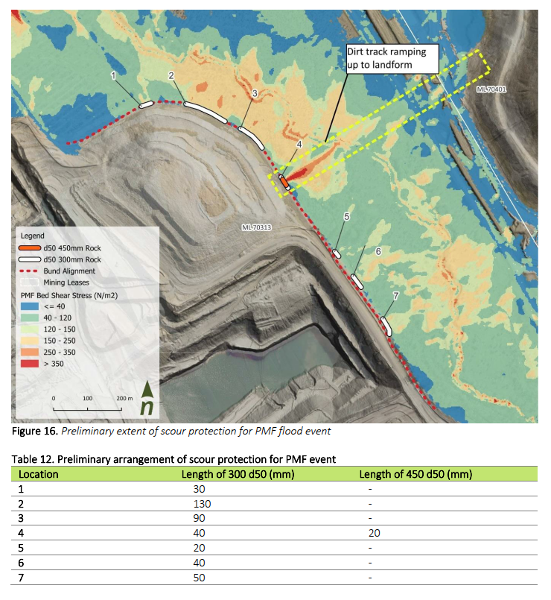
Appendix 1: Location of Scour Protection for PMF Event.

Appendix 2: PMF Event High Velocity Areas.
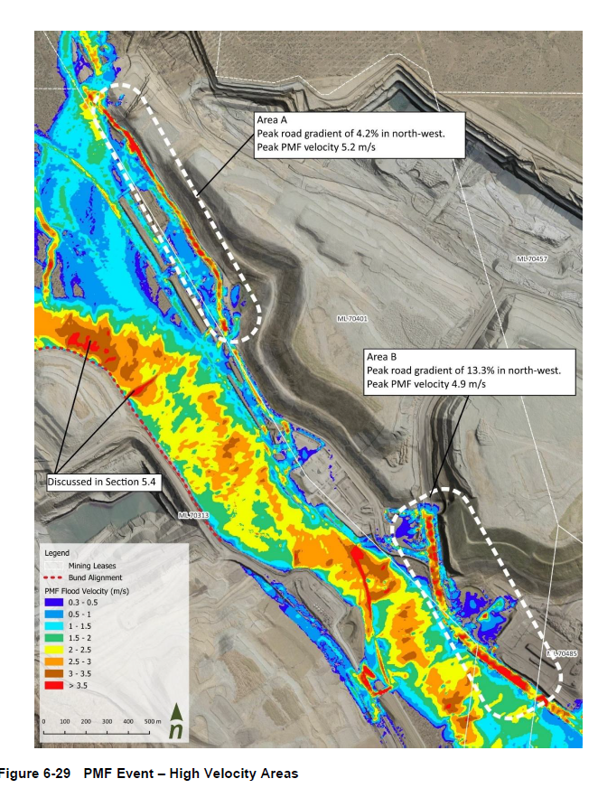
Appendix 3: Seed Species List and Application Rate for Light Grazing and Grassland Revegetation (RA4, RA5, RA7 &RA9).

Scientific Name | Common Name | Application Rate
Native Grasses
Astrebla lappacea | Curly mitchell grass | 2-3 species from the list with a bulked seed weight of 3 kg/ha
Dichanthium sericeum | Queensland bluegrass
Heteropogon contortus | Black speargrass
Panicum decompositum | Native Millet
Improved Pasture
Chloris gayana | Katambora rhodes | 2-3 species from the list with a bulked seed weight of 3 kg/ha
Chloris gayana | Reclaimer rhodes
Clitoria Ternatea | Butterfly Pea
Bothriochloa insculpta | Bisset Creeping Bluegrass
Stylosonthes scabra | Stylo/ Seca Stylo

Appendix 4: Recommended species to be established for Woodland Habitat Riparian Revegetation (RE11.3.4) (Riparian RA6 location per Appendix 4.1).

Scientific Name | Common Name | Application Rate
Native Trees (T) and Shrubs (S)
Eucalyptus tereticornis (T) | Queensland blue gum | Between 6-10 species from the list with bulk seed at 3 kg/ha (assuming some chaff and impurities in seed lots). Use 1.5 kg/ha if using pure seed for Trees.  And
Corymbia tessellaris (T) | Moreton Bay ash
Angophora subvelutina (T) | broad-leaved apple
Corymbia clarksoniana (T) | grey bloodwood
Lophostemon suaveolens (T) | swamp box
Angophora floribunda (T) | rough-barked apple
Eucalyptus melanophloia (T) | silver-leaf ironbark
Eucalyptus populnea (T) | poplar box
Alstonia constricta (S) | bitterbark
Blakella citriodora (T) | lemon-scented gum
Corymbia intermedia (T) | pink bloodwood
Eucalyptus camaldulensis (T) | river red gum
Eucalyptus longirostrata (T) | grey gum
Planchonella cotinifolia (S) | coondoo
Acacia salicina (S) | Sally wattle
Erythrina vespertilio | bat-wing coral tree
Acacia glaucoparpa (S) | hickory wattle
Acacia disparrima subsp. Disparrima (S) | brown salwood | Between 8-12 species from the list with bulk seed at 8 kg/ha, subject to availability of seed stock for shrubs.
Alphitonia excelsa (S) | soap tree
Acacia crassa subsp. Longicoma (S) | curracabah
Acacia falcata (S) | sickle wattle
Acacia leiocalyx subsp. Leiocalyx (S) | black wattle
Acacia maidenii (S) | maiden's wattle
Breynia oblongifolia (S) | coffee bush
Bursaria spinosa subsp. Spinosa (S) | Christmas bush
Capparis lasiantha | nipan
Carissa ovata (S) | currantbush
Cassia brewsteri (S) | Brewster's Cassia
Citrus glauca (S) | desert lemon
Denhamia cunninghamii (S) | yellow berry bush
Grewia latifolia (S) | dysentery plant
Hibiscus divaricatus (S) | native Hibiscus
Mallotus philippensis (S) | red kamala
Pittosporum angustifolium (S) | butterbush
Native Grasses
Themeda triandra | kangaroo grass | 3-6 species from the list with a bulked seed weight of 3 kg/ha.
Dichanthium sericeum | Queensland bluegrass
Capillipedium spicigerum | scented top
Chloris divaricata
Cymbopogon refractus | barbed-wire grass
Panicum simile | two-colour panic
Sporobolus creber | slender rat's tail grass
Eragrostis leptostachya | paddock love grass
Eragrostis sororia | woodland love grass
Imperata cylindrica | blady grass
Panicum effusum | hairy panic
Native Forbs and Other
Eustrephus latifolius | wombat berry | 3-6 species from the list with a bulked seed weight of 3 kg/ha.
Sida hackettiana | Queensland hemp
Cyperus gracilis | slender flat sedge
Cyperus fulvus | sticky sedge
Fimbristylis dichotoma | common fringe-rush
Scleria brownii
Cyanthillium cinereum | vernonia
Glycine tomentella | woolly glycine
Desmodium varians | slender tick trefoil
Euphorbia dallachyana | caustic-weed
Oxalis perennans | sorrel
Wahlenbergia gracilis | sprawling bluebell
Abutilon oxycarpum | flannel weed
Brunoniella australis | blue trumpet
Einadia hastata | ruby saltbush
Eremophila debilis | winter apple
Glycine clandestina | twining glycine
Goodenia glabra | smooth goodenia
Lobelia purpurascens | white root
Lomandra multiflora | many-flowered matrush
Phyllanthus virgatus

Appendix 4.1: PMLU Woodland Habitat Remnant Locations (RA6).

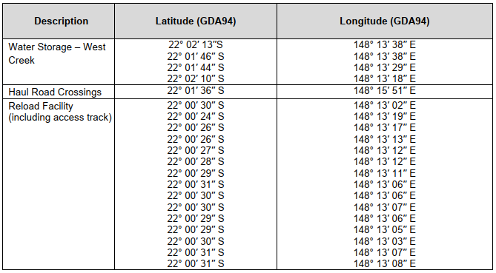

Appendix 5: Recommended species to be established for Woodland Habitat Revegetation (RE11.10.1) RA2, RA3, RA6 (Certain parts which are not associated to riparian PMLU) & RA8 (For RA8 limited to disturbed area only).
Scientific Name | Common Name | Application Rate
Native Trees and Shrubs
Blakella citriodora (T) | lemon-scented gum | Between 6-10 species from the list with bulk seed at 3 kg/ha (assuming some chaff and impurities in seed lots). Use 1.5 kg/ha if using pure seed for Trees.  And
Eucalyptus crebra (T) | narrow-leaved ironbark
Angophora leiocarpa (T) | rusty gum
Eucalyptus fibrosa subsp. Nubilis (T) | blue-leaved ironbark
Eucalyptus longirostrata (T) | grey gum
Eucalyptus melanophloia (T) | silver-leaf ironbark
Eucalyptus cloeziana (T) | Gympie messmate
Corymbia clarksoniana (T) | grey bloodwood
Callitris glaucophylla (T) | white cypress pine
Blakella (corymbia) watsoniana (T) | large-fruited yellowjacket
Lysicarpus angustifolius (T) | budgeroo
Acacia leiocalyx subsp. leiocalyx | black wattle
Acacia shirleyi (S) | lancewood
Allocasuarina torulosa (T) | forest oak
Alphitonia excelsa (S) | soap tree | Between 8-12 species from the list with bulk seed at 8 kg/ha, subject to availability of seed stock for shrubs.
Petalostigma pubescens (S) | quinine tree
Acacia longispicata (S)
Acacia crassa (S) | curracabah
Breynia oblongifolia (S) | coffee bush
Capparis canescens (S) | wild pomegranite
Acacia falciformis (S) | broad-leaved hickory
Grewia latifolia (S) | dysentery plant
Jacksonia scoparia (S) | dogwood
Acacia bancroftiorum (S)
Acacia caroleae (S) | narrow-leaved currawang wattle
Allocasuarina luehmannii (T) | bull oak
Cassinia laevis (S) | wild rosemary
Erythroxylum australe (S) | cocaine tree
Macrozamia moorei (T) | Moore's zamia palm
Persoonia falcata (S) | geebung
Native Grasses
Cleistochloa subjuncea |  | 3-6 species from the list with a bulked seed weight of 3 kg/ha.
Aristida spp. | three-awns
Eremochloa bimaculata | poverty grass
Arundinella nepalensis | reedgrass
Themeda triandra | kangaroo grass
Panicum effusum | hairy panic
Cymbopogon refractus | barbed-wire grass
Entolasia stricta | wiry panic
Aristida caput-medusae | many-headed wiregrass
Eragrostis elongata | clustered love grass
Heteropogon contortus | black speargrass
Native Forbs and Other
Fimbristylis dichotoma | common fringe-rush | 3-6 species from the list with a bulked seed weight of 3 kg/ha.
Scleria sphacelata | trefoil rattlepod
Cyanthillium cinereum | vernonia
Brunoniella australis | blue trumpet
Lomandra multiflora | many-flowered matrush
Phyllanthus virgatus
Dianella longifolia | flax-lily
Acacia leiocalyx subsp. Leiocalyx | black wattle
Goodenia delicata
Chrysocephalum apiculatum | yellow buttons
Dianella revoluta | black-anther flax lily
Rostellularia adscendens | pink tongues
Desmodium rhytidophyllum | hairy trefoil
Laxmannia gracilis | slender wire lily
Evolvulus alsinoides | tropical speedwell
Lomandra filiformis | fine-leaved matrush
Cheilanthes sieberi | mulga fern
Desmodium brachypodum | large ticktrefoil
Lomandra confertifolia | clumped matrush
Lomandra longifolia | spiny-headed mat-rush

Appendix 6: Woodland Habitat Revegetation Monitoring Benchmarks RA2, RA3, RA6 & RA8 (For RA8 limited to disturbed area only).
Attribute | RE 11.10.1 Benchmark | RE 11.10.1 Adapted Benchmark | RE 11.10.1 Revised Adapted Benchmark (for RA2)
Short description | Corymbia citriodora woodland on coarse-grained sedimentary rocks | Corymbia citriodora woodland on coarse-grained sedimentary rocks | Corymbia citriodora woodland on coarse-grained sedimentary rocks
Recruitment | 100 % | 100 % | 100 %
Non-native plant cover | 0 % | <10 % | <10 %
Tree species richness | 4 | 3 | 2
Shrub species richness | 4 | 3 | 2
Grass species richness | 9 | 4 | 3
Forb and other species richness | 17 | 5 | 5
Canopy height | 24 m | 12 m | 12 m
Canopy cover (crown cover) | 30 % | 15 % | 5%
Shrub canopy cover (crown cover) | 13 % | 5 % | 5 %
Native perennial grass cover | 16 % | 10% | 10%
Organic litter | 50 % | 20% | 20%

Appendix 7: Woodland habitat riparian revegetation monitoring benchmarks (certain areas within RA6).
Attribute | RE 11.3.4 Benchmark | RE 11.3.4 Adapted Benchmark
Short description | Eucalyptus tereticornis and/or Eucalyptus spp. woodland on alluvial plains | Eucalyptus tereticornis and/or Eucalyptus spp. woodland on alluvial plains
Recruitment | 100 % | 100 %
Non-native plant cover | 0 % | <10 %
Tree species richness | 4 | 3
Shrub species richness | 3 | 3
Grass species richness | 11 | 4
Forb and other species richness | 17 | 5
Canopy height | 24 m | 12 m
Canopy cover (crown cover) | 30 % | 15 %
Shrub canopy cover (crown cover) | 3 % | -
Native perennial grass cover | 55 % | 20%
Organic litter | 37 % | 10%

Appendix 8: Pasture condition assessment.
Condition Rating | Condition Indicators
Condition Rating | Preferred Pasture Species |  | Annual Grass % DM Yield | Undesirable Grasses and Other Weeds % DM Yield | Preferred Pasture Species Diversity
Condition Rating | % DM Yield | Crown Cover | Annual Grass % DM Yield | Undesirable Grasses and Other Weeds % DM Yield | Preferred Pasture Species Diversity
1 | >80% | Dense and plants healthy | <20% | <20% | >5 species
2 | 60 – 80% | High to moderate density and some plants unhealthy | 20 – 40% | 20 – 30% | 3 – 5 species
3 | 10 – 60% | Moderate to low density and some plants dead | 40 – 70% | 30 – 80% | 2 – 3 species
4 | <10% | Sparse and many plants dead | >70% | >80% | 0 or 1 species
Source: Pasture Condition Assessment Table as per “Stocktake: Balancing Supply and Demand” (Developed by FutureBeef – futurebeef.com.au)

Appendix 9: Erosion classification framework.
Erosion classification | Minor | Moderate | Severe
Sheet erosion | Shallow soil deposits downslope | Partial exposure of roots; moderate soil deposits downslope, etc. | Loss of surface horizon; root exposure; moderate substantial soil deposits downslope
Rill erosion  (≤0.3m deep) | <15 rills pre transect* or  Occasional rills | 15-30 rills per transect* or  Common rills | >30 rills per transect* or  Numerous rills forming corrugated ground  surface.
Gully erosion  (>0.3m deep) | Gullies are isolated, linear, discontinuous, and restricted to primary or minor drainage lines | Gullies are linear, continuous, and restricted to primary or minor drainage lines | Gullies are continuous or discontinuous, and either tend to branch away from primary drainage lines and on to foot slopes, or have multiple branches within drainage lines

Source: NCST (2024) Australian Soil and Land Survey Field Handbook, 4th edition. The National Committee on Soil and Terrain. CSIRO Publishing, Collingwood, Australia.
*Transect linear 100 m across the contour (Source: Tongway, D. J. and Hindley, N. L. 2005. Landscape Function Analysis: Procedures for Monitoring and Assessing Landscapes. CSIRO Publishing, Canberra, Australia)

Appendix 10: Surface water monitoring locations.
Monitoring Points | Receiving Waters Location Description | Latitude (GDA 2020) | Longitude (GDA 2020)
Upstream Background Monitoring Points
MP1 | New Chum Creek 3713 metres upstream of RP2 | 22° 00' 15.95" S | 148° 13' 35.03" E
Downstream Monitoring Points
MP2 | New Chum Creek 2539 metres downstream of RP2 | 22° 02' 2.95" S | 148° 16' 35.03" E
MP3 | Downstream of A Pit | 22°02'11.76'' S | 148°13'24.45'' E
MP4 | Downstream of Mavis Mine | 22°00'23.14'' S | 148°16'21.75'' E

Appendix 10.1: Surface water monitoring locations.
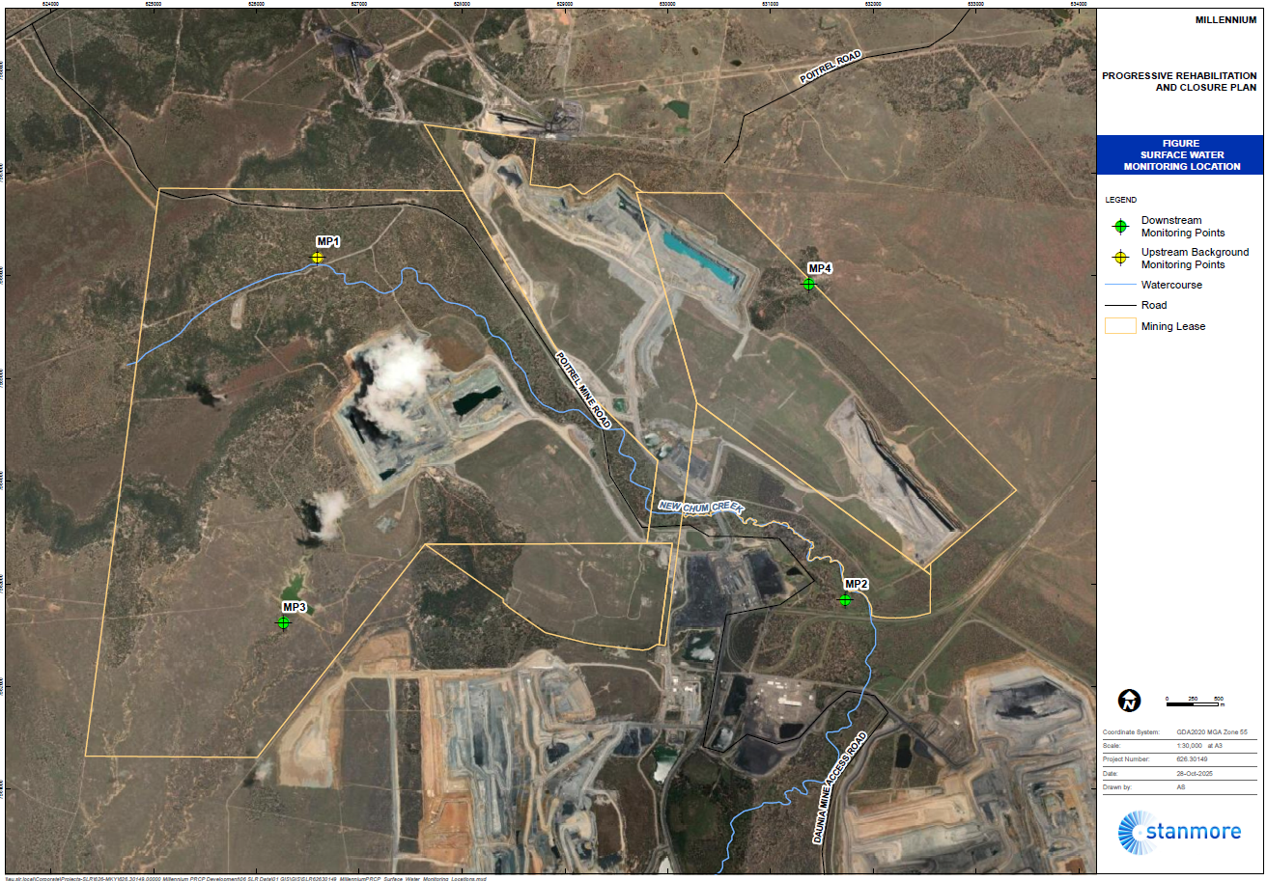
Appendix 11: Surface water quality limits.

Quality Characteristics | Units | Limit | Source
pH |  | 6.5-8.5 | WQO
Electrical Conductivity | µS/cm | 720 | WQO
Turbidity | NTU | 217 | Site-specific
Sulphate | mg/L | 25 | WQO
Aluminium - dissolved | µg/L | 360 | Site-specific
Antimony - dissolved | µg/L | 9 | ANZG 2018
Arsenic – dissolved | µg/L | 13 | ANZG 2018
Boron – dissolved | µg/L | 940 | ANZG 2018
Cadmium - dissolved | µg/L | 0.2 | ANZG 2018
Chromium - dissolved | µg/L | 1 | ANZG 2018
Cobalt - dissolved | µg/L | 1 | ANZG 2018
Copper - dissolved | µg/L | 2 | Site-specific
Iron - dissolved | µg/L | 300 | ANZG 2018
Manganese - dissolved | µg/L | 1900 | ANZG 2018
Mercury - dissolved | µg/L | 0.06 | ANZG 2018
Molybdenum - dissolved | µg/L | 16 | Site-specific
Nickel - dissolved | µg/L | 11 | ANZG 2018
Selenium - dissolved | µg/L | 5 | ANZG 2018
Silver - dissolved | µg/L | 1.0* | For aquatic ecosystem protection, based on LOR for ICPMS
Uranium - dissolved | µg/L | 1.3 | Site-specific
Vanadium - dissolved | µg/L | 6 | ANZG 2018
Zinc - dissolved | µg/L | 8 | ANZG 2018
Ammonia | µg/L | 150 | Site-specific
Nitrate | µg/L | 150 | Site-specific
Petroleum hydrocarbons (C6-C9) | µg/L | 20
Petroleum hydrocarbons (C10-C36) | µg/L | 100
Major ions  Calcium, chloride, potassium, magnesium, sodium, bicarbonate, carbonate | mg/L | For interpretation purposes
Hardness | mg/L | For interpretation purposes
Notes:
  - All metals and metalloids must be measured as ‘dissolved’ (from analysis of a field filtered sample) and total (unfiltered).
  - *Limit of Reporting (LOR) is the lowest concentration of an analyte that a laboratory can reliably report for a given sample and method. ICPMS/CV FIMS/GCMS– analytical method required to achieve LOR.
  - Limits for metals and metalloids apply to dissolved results.
  - ANZG (2018) Aquatic ecosystem protection for moderately disturbed system (95% protection).
  - WQO. Upper Isaac River catchment waters. Environmental Protection (Water) Policy 2009 Isaac River Sub-basin Environmental Values and Water Quality Objectives Basin No. 130 (part), including all waters of the Isaac River Sub-basin (including Connors River) September 2011.

Appendix 12: Groundwater monitoring locations.
Monitoring Site ID | Hydrogeological unit | Latitude (GDA2020) | Longitude (GDA2020) | Ground elevation (mAHD) | Depth (mbgl) | Screens (mbgl) | Monitoring Frequency | Monitoring Parameters
MB2 | Rangal Coal Measures (Sandstone) | 22° 01' 49.95" S | 148° 14' 18.03" E | 262.4 | 90 | 72 - 90 | Quarterly | SWL
MB8A | Rewan Group | 22° 00' 27.95" S | 148° 14' 3.03" E | 259.1 | 30 | 22 - 28 | Quarterly | SWL and Quality
MB8B | Rangal Coal Measures (Sandstone) | 22° 00' 27.95" S | 148° 14' 3.03" E | 259.1 | 80 | 62 - 74 | Quarterly | SWL and Quality
MB9A | Fort Cooper Coal Measures (Coal) | 22° 00' 33.95" S | 148° 14' 43.03" E | 251.8 | 30 | 22 - 30 | Quarterly | SWL and Quality
MB9B | Fort Cooper Coal Measures (Sandstone) | 22° 00' 33.95" S | 148° 14' 43.03" E | 251.8 | 80 | 60 - 74 | Quarterly | SWL and Quality
MB10A | Fort Cooper Coal Measures (Sandstone) | 22° 01' 32.95" S | 148° 16' 0.03" E | 233.9 | 35 | 27 - 35 | Quarterly | SWL and Quality
MB10B | Fort Cooper Coal Measures (Sandstone) | 22° 01' 32.95" S | 148° 16' 0.03" E | 233.9 | 80 | 64 - 76 | Quarterly | SWL and Quality
CS_MB2 | Rangal Coal Measures (Coal) | 22° 01' 9.95" S | 148° 17' 16.03" E | 236.4 | 170 | 161-164 | Quarterly | SWL

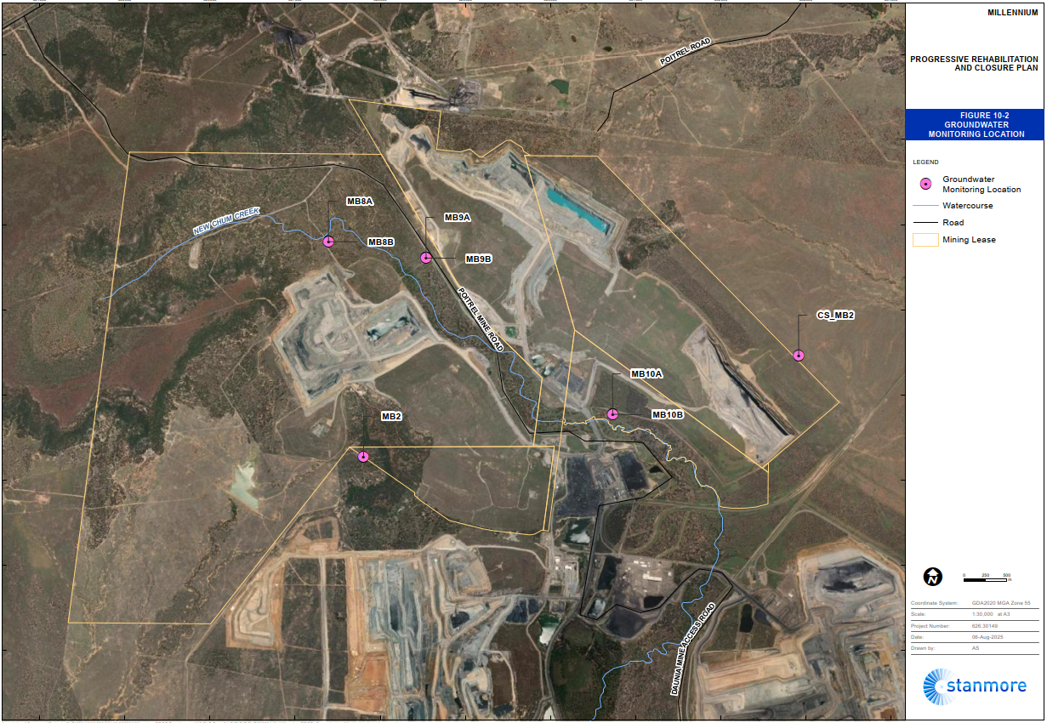
Appendix 12.1: Groundwater monitoring locations.

Appendix 13: Groundwater quality limits.
Quality Characteristic | Unit | MB8A | MB8B | MB9A | MB9B | MB10A | MB10B
 |  | Rewan Group | Rangal Coal Measures (Coal) | Fort Cooper Coal Measures (Coal)
Field pH |  | 6.5-8.5
Field EC | µS/cm | 8,910^{C} | 24,300 | 20,500 | 13,650 | 3,862 | 10,833
Sulfate | mg/L | 318 ^{C} | 480 | 110 | 80 | 84 | 173
Nitrate | mg/L | 5.3 ^{C}
Aluminium (Al) – Dissolved | µg/L | 55^{B}
Antimony (Sb) – dissolved | µg/L | 9^{B} | 9^{B} | 50 | 9^{B} | 9^{B} | 9^{B}
Arsenic (As) – dissolved | µg/L | 13 | 13 | 2 | 3 | 8 | 13
Boron - dissolved | µg/L | 940 ^{B}
Cadmium - dissolved | µg/L | 0.2 ^{B}
Chromium - dissolved | µg/L | 1 ^{B}
Cobalt - dissolved | µg/L | 1 ^{B}
Copper (Cu) – dissolved | µg/L | 1.4 ^{B}
Mercury (Hg) - dissolved | µg/L | 0. 6^{B}
Molybdenum (Mo) - dissolved | µg/L | 34 | 34 | 6 | 10 | 5 | 2
Nickel - dissolved | µg/L | 11 ^{B}
Selenium (Se) - dissolved | µg/L | 11^{B}
Vanadium - dissolved | µg/L | 6 ^{B}
Zinc (Zn) - dissolved | µg/L | 45
Iron (Fe) - dissolved | µg/L | 140 ^{C} | 5,250 | 140 ^{C} | 1,980 | 450 | 1073
Petroleum hydrocarbons C6 – C9 | µg/L | 20
Petroleum hydrocarbons C10 – C36 | µg/L | 100
Major ions Calcium, chloride, potassium, magnesium, sodium, bicarbonate, carbonate (Ca, Na, Mg, K, HCO₃, CO₃, SO4, Cl) | mg/L | Interpretation
Water level | mAHD | Interpretation

Notes:
- No note – values are derived from site-specific data.
- B - ANZG (2018) Aquatic ecosystem protection for moderately disturbed system (95% protection).
- C Upper Isaac River catchment waters. Environmental Protection (Water) Policy 2009 Isaac River Sub-basin Environmental Values and Water Quality Objectives Basin No. 130 (part), including all waters of the Isaac River Sub-basin (including Connors River) September 2011. Fitzroy Water Plan WQ1310, Zone 34 Shallow 80th percentile.

END OF PRCP SCHEDULE

