

Permit
Environmental Protection Act 1994
Environmental Authority EPML00819213 Millennium Mine
This environmental authority is issued by the administering authority under Chapter 5 of the Environmental Protection Act 1994.

Environmental authority number: EPML00819213
Environmental authority takes effect on the 18 March 2026
The anniversary date of this environmental authority is 17 December . The payment of the annual fee will be due each year on this day.
An annual return will be due each year on 1 April.

Environmental authority holder(s)

Name(s) | Registered address
METRES PTY LTD | Level 32, 12 Creek Street BRISBANE CITY QLD 4000 Australia.

Environmentally relevant activity and location details

Environmentally relevant activity/activities | Location(s)
Schedule 3 13: Mining black coal | ML70344, ML70457, ML70313, ML70485, ML70401, ML70483
Schedule 3 09: A mining activity involving drilling, costeaning, pitting or carrying out geological surveys causing significant disturbance | ML70344, ML70457, ML70313, ML70485, ML70401, ML70483
Ancillary 07 - Chemical Manufacturing 3: Manufacturing, in a year, a total of 200t or more of any of the following  (d) explosives | ML70344, ML70457, ML70313, ML70485, ML70401, ML70483
Ancillary 08 - Chemical Storage 3: Storing more than 500 cubic metres of chemicals of class C1 or C2 combustible liquids under AS 1940 or dangerous goods class 3 under subsection (1)(c) | ML70344, ML70457, ML70313, ML70485, ML70401, ML70483
Ancillary 60 - Waste disposal 2: Operating a facility for disposing of, in a year, the following quantity of waste mentioned in subsection (1)(b) (d) more than 10,000t but not more than 20,000t | ML70344, ML70457, ML70313, ML70485, ML70401, ML70483

Page 1 of 60 • ESR/2016/3415 • Version 4.01 • Last reviewed: 21 JAN 26 ABN 46 640 294 485

Environmentally relevant activity/activities | Location(s)
Ancillary 63 - Sewage Treatment 1: Operating sewage treatment works, other than no-release works, with a total daily peak design capacity of (a-ii) 21 to 100EP otherwise | ML70344, ML70457, ML70313, ML70485, ML70401, ML70483

Additional information for applicants

Environmentally relevant activities
The description of any environmentally relevant activity (ERA) for which an environmental authority (EA) is issued is a restatement of the ERA as defined by legislation at the time the EA is issued. Where there is any inconsistency between that description of an ERA and the conditions stated by an EA as to the scale, intensity or manner of carrying out an ERA, the conditions prevail to the extent of the inconsistency.
An EA authorises the carrying out of an ERA and does not authorise any environmental harm unless a condition stated by the EA specifically authorises environmental harm.
A person carrying out an ERA must also be a registered suitable operator under the Environmental Protection Act 1994
(EP Act).

Contaminated land
It is a requirement of the EP Act that an owner or occupier of land give written notice to the administering authority if they become aware of the following:
- the presence of, or happening of an event involving, a hazardous contaminant on the land that is causing, or is reasonably likely to cause, serious or material environmental harm (notice must be given within 24 hours); or
- if the land is contaminated land – a change in the condition of the land that is causing, or is reasonably likely to cause, serious or material environmental harm (notice must be given within 24 hours); or
- a notifiable activity (as defined in Schedule 3) having been carried out, or is being carried out, on the land (notice must be given within 20 business days).
For further information, including the form for giving written notice, refer to the Queensland Government website www.qld.gov.au, using the search term ‘duty to notify’.

Take effect
Please note that, in accordance with section 200(1) of the EP Act, an EA has effect:
- if the authority is for a prescribed ERA and it states that it takes effect on the day nominated by the holder of the authority in a written notice given to the administering authority—on the nominated day; or
- if the authority states a day or an event for it to take effect—on the stated day or when the stated event happens; or
- otherwise—on the day the authority is issued.
However, in accordance with section 200(2) of the EP Act, the day that the EA takes effect may not be before:
- if the authority is for a resource activity—the day the relevant tenure is granted to the applicant; or

- if a development permit for a material change of use of premises under the Planning Act 2016 is necessary for carrying out an activity that related to the authority—the day the development permit takes effect; or
- if an SDA Approval under the State Development and Public Works Organisation Act 1971 is necessary for carrying out an activity that relates to the authority—the day the approval takes effect.

If this EA takes effect when the additional authorisation takes effect, you must provide the administering authority written notice within 5 business days of receiving notification of the related additional authorisation taking effect.
The anniversary day of this EA is the same day each year as the effective date. The payment of the annual fee will be due each year on this day.
If you have incorrectly claimed that an additional authorisation is not required, carrying out the ERA without the additional authorisation is not legal and could result in your prosecution for providing false or misleading information or operating without a valid EA.

 | 18 March 2026
Signature | Date
Jason Dunlop | Enquiries:
Department of the Environment, Tourism, Science and Innovation  Delegate of the administering authority  Environmental Protection Act 1994 | Business Centre Coal  PO Box 3028, Emerald QLD 4720  Phone: (07) 4987 9320  Email: CRMining@detsi.qld.gov.au

Obligations under the Environmental Protection Act 1994
In addition to the requirements found in the conditions of this EA, the holder must also meet their obligations under the EP Act, and the regulations made under the EP Act. For example, the holder must comply with the following provisions of the Act:
- general environmental duty (section 319)
- duty to restore the environment (section 319C)
- duty to notify environmental harm (section 320-320G)
- offence of causing serious or material environmental harm (sections 437-439)
- offence of causing environmental nuisance (section 440)
- offence of depositing prescribed water contaminants in waters and related matters (section 440ZG)
- offence to place contaminant where environmental harm or nuisance may be caused (section 443).

Other permits required
This permit only provides an approval under the EP Act. In order to lawfully operate you may also require permits / approvals from your local government authority, other business units within the department, and other State and Federal Government agencies prior to commencing any activity at the site. For example, this may include permits or approvals with your local Council (for planning approval), the Department of Transport and Main Roads (to access State controlled roads), the Department of Natural Resources and Mines, Manufacturing, and Regional and Rural Development (to clear vegetation), and the Department of Primary Industries (to clear marine plants or to obtain a quarry material allocation).
Obligations under the Environment Protection and Biodiversity Conservation Act 1999 (EPBC Act)
Matters of national environmental significance (MNES) are regulated under the Commonwealth EPBC Act rather than under state legislation. You may need to submit a referral if your project potentially impacts any matters protected under the EPBC Act. For more information on self-assessments, and referral and assessment processes, please visit the Australian Government Department of Climate Change, Energy, the Environment and Water’s website at www.dcceew.gov.au/environment/epbc/advice.
Obligations under the Aboriginal Cultural Heritage Act 2003 and Torres Strait Islander Cultural Heritage Act 2003 (the Cultural Heritage Acts)
The Cultural Heritage Acts require anyone who carries out a land-use activity to exercise a duty of care. This ‘duty of care’ means land users must take all reasonable and practicable measures to ensure their activity does not harm Aboriginal or Torres Strait Islander cultural heritage, and applies to any activity where Aboriginal or Torres Strait Islander cultural heritage is located. For more information on your obligations under this legislation, please visit the Department of Women, Aboriginal and Torres Strait Islander Partnerships and Multiculturalism webpage at, www.dwatsipm.qld.gov.au.

Conditions of environmental authority

Schedule A: General
Condition  number | Condition
A1 | Prevent and/or minimise likelihood of environmental harm  In carrying out the environmentally relevant activities, the holder of this environmental authority must take all reasonable and practicable measures to prevent and/or to minimise the likelihood of environmental harm being caused. Any environmentally relevant activity, that, if carried out incompetently, or negligently, may cause environmental harm, in a manner that could have been prevented, shall be carried out in a proper manner in accordance with the conditions of this authority.  NOTE: This authority authorises the environmentally relevant activity. It does not authorise environmental harm unless a condition contained within this authority explicitly authorises that harm. Where there is no condition or the authority is silent on a matter, the lack of a condition or silence shall not be construed as authorising harm.
A2 | Scope of activity  Coal extraction under this environmental authority and coal receival under Condition A16 must not total more than five and a half (5.5) million tonnes per annum (mtpa) of run-of-mine (ROM) coal.
A3 | In carrying out the mining activity (other than exploration) authorised by this environmental authority, the holder of this environmental authority must not cause disturbance greater than 1,872.53ha. All disturbance (other than exploration) must be located within the authorised disturbance footprint detailed within Figure 2: Authorised Disturbance Footprint.
A4 | Maintenance of measures, plant and equipment  The environmental authority holder must ensure:  - that all measures, plant and equipment necessary to ensure compliance with the conditions of this environmental authority are installed  - that such measures, plant and equipment are maintained in a proper condition  - that such measures, plant and equipment are operated in a proper manner  - ensure all instruments and devices used for the measurement or monitoring of any parameter under any condition of this environmental authority are properly calibrated.
A5 | Monitoring and records  Record, compile and keep for a minimum of five (5) years all monitoring results required by this environmental authority and make available for inspection all or any of these records upon request by the administering authority.
A6 | All monitoring and sampling required by the conditions of this environmental authority must be carried out, interpreted, and recorded by an appropriately qualified person (AQP).

A7 | Upon request from the administering authority, copies of all records, results, plans, reports, programs, and other documentation required by the conditions of this environmental authority must be made available and provided to the administering authority within—  - ten (10) business days; or  - an alternative timeframe agreed between the administering authority and the environmental authority holder.
A8 | Notification of emergencies, incidents and exceptions  All reasonable actions are to be taken to minimise environmental harm, or potential environmental harm, resulting from any emergency, incident, or circumstances not in accordance with the conditions of this environmental authority.
A9 | As soon as practicable after becoming aware of any emergency, incident or information about circumstances which results or may result in environmental harm not in accordance with the conditions of this environmental authority, the administering authority must be notified within twenty-four (24) hours, by telephone or email.
A10 | Within ten (10) business days following the initial notification of an emergency or incident, or receipt of monitoring results, whichever is the latter, further written advice must be provided to the administering authority, including the following:  - results and interpretation of any samples taken and analysed;  - outcomes of actions taken at the time to prevent or minimise unlawful environmental harm; and  - proposed actions to prevent a recurrence of the emergency or incident.
A11 | Third-party reporting  The holder of this environmental authority must:  - On or prior to 7 December 2022, obtain from an appropriately qualified person a report on compliance with the conditions of this environmental authority.  - Obtain further such reports at regular intervals, not exceeding three-yearly intervals, from the completion of the report referred to above.  - Provide each report to the administering authority within ninety (90) days of its completion.
A12 | Where a condition of this environmental authority requires compliance with a standard, policy or guideline published externally to this environmental authority and the standard is amended or changed subsequent to the issue of this environmental authority, the holder of this environmental authority must:  - Comply with the amended or changed standard, policy or guideline within two years of the amendment or change being made, unless a different period is specified in the amended standard or relevant legislation, or where the amendment or change relates specifically to a condition, the time specified in that condition; and  - Until compliance with the amended or changed standard, policy or guideline is achieved, continue to remain in compliance with the corresponding provision that was current  immediately prior to the relevant amendment or change.

A13 | Complaints  The holder of this environmental authority must record all environmental complaints received about the mining activities including:  - name, address and contact number of the complainant  - time and date of complaint  - reasons for the complaint  - investigations undertaken  - conclusions formed  - actions taken to resolve the complaint  - any abatement measures implemented  - person responsible for resolving the complaint.
A14 | The holder of this environmental authority must, when requested by the administering authority, undertake relevant specified monitoring within a reasonable timeframe nominated or agreed to by the administering authority to investigate any complaint of environmental harm. The results of the investigation (including an analysis and interpretation of the monitoring results) and abatement measures, where implemented, must be provided to the administering authority within 10 business days of completion of the investigation, or no later than 10 business days after the end of the timeframe nominated by the administering authority to undertake the investigation.
A15 | Coal is permitted to be transported from Isaac Downs Coal Mine (EA0002817) to the Red Mountain CHPP (EPML00819113) via Millennium Mine using the haul road shown in Figure 2: Authorised Disturbance Footprint.
A16 | Coal from Vulcan coal mine (EA0002912) and Isaac Downs mine (EA0002817) is permitted to be received and temporarily stored at Millennium Mine, at the locations shown in Figure 4: RMI coal storage and rejects/tailings disposal.

Schedule B: Air
Condition  number | Condition
B1 | Dust nuisance  The environmental authority holder shall ensure that all reasonable and feasible avoidance and mitigation measures are employed so that the dust and particulate matter emissions generated by the mining activities do not cause exceedances of the following levels when measured at any sensitive or commercial place:  - Dust deposition of 120 milligrams per square metre per day, averaged over one month, when monitored in accordance with the most recent version of Australian Standard AS3580.10.1 Methods for sampling and analysis of ambient air—Determination of particulate matter—Deposited matter-Gravimetric method.  - A concentration of particulate matter with an aerodynamic diameter of less than 10 micrometres (PM10) suspended in the atmosphere of 50 micrograms per cubic metre over a 24-hour averaging time, when monitored in accordance with the most recent version of either:  - Australian Standard AS3580.9.6 Methods for sampling and analysis of ambient air—Determination of suspended particulate matter—PM10 high volume sampler with size selective inlet – Gravimetric method, or  - Australian Standard AS3580.9.9 Methods for sampling and analysis of ambient air—  Determination of suspended particulate matter—PM10 low volume sampler—  Gravimetric method, or  - Australian Standard AS3580.9.11 Methods for sampling and analysis of ambient air  - Determination of suspended particulate matter PM10 Environmental Beta Attenuation Monitor (E-BAM).  - A concentration of particulate matter with an aerodynamic diameter of less than 2.5 micrometres (PM2.5) suspended in the atmosphere of 25 micrograms per cubic metre over a 24-hour averaging time, when monitored in accordance with:  - The most recent version of AS/NZS3580.9.10 Methods for sampling and analysis of ambient air—Determination of suspended particulate matter—PM2.5 low volume sampler—Gravimetric method, or  - Australian Standard AS3580.9.11 Methods for sampling and analysis of ambient air  - Determination of suspended particulate matter PM2.5 Environmental Beta Attenuation Monitor (E-BAM).  (d) A concentration of particulate matter suspended in the atmosphere of 90 micrograms per cubic metre over a 1-year averaging time, when monitored in accordance with the most recent version of AS/NZS3580.9.3:2003 Methods for sampling and analysis of ambient air—Determination of suspended particulate matter—Total suspended particulate matter (TSP)—High volume sampler gravimetric method.

B2 | Ambient Dust Monitoring Program  The environmental authority holder must develop an Ambient Dust Monitoring Program to specify how the ambient dust impacts resultant from the activities conducted under this environmental authority will be monitored. The Program must include, but not necessarily be limited to:  - identification of an integrated air quality monitoring network, developed in consultation with the owner/operator of the coal mining site  - locations, frequencies and methods for monitoring PM10 and deposited particulate matter  - provision for the use of at least one hi-volume air sampler (HVAS) or Tapered Element Oscillating Microbalance Sampler (TEOMS) or Environmental Beta Attenuation Monitor (E-BAM), five dust depositional gauges and a meteorological station capable of monitoring wind direction and speed  - investigation of the use of HVAS or TEOMS or E-BAM as part of the integrated air quality monitoring network using Australian Standard AS3580.9.11 Methods for sampling and analysis of ambient air – Determination of suspended particulate matter. Should an alternative sampling method be required; the holder may seek approval from the administering authority to exclude this requirement. In seeking such exclusion, the reasons for the exclusion shall be provided and be fully justified  - provided that the use of TEOMS is proven to be justified (as outlined in 4 above), the holder shall utilise real time monitoring data to inform environmental management decisions associated with the project  - a framework for identifying actual and potential dust impacts, and for applying pro-active and reactive mitigation and management measures to address those impacts  - provision for independent review and auditing of the Program  - mechanisms for updating.
B3 | Excluding during care and maintenance, ongoing monitoring must be conducted in accordance with the standards and at the locations specified in Table B1: Air Quality Monitoring Details and Figure 6: Air Quality Monitoring Locations.
B4 | During the care and maintenance, periodic air monitoring using the installed dust deposition gauges must continue in accordance with the appropriate standards and at the relevant locations specified in Table B1: Air Quality Monitoring Details and Figure 6: Air Quality Monitoring Locations.

Table B1: Air Quality Monitoring Details
Air Quality Parameter | Monitoring Standard | Monitoring Point  Description | Approximate Monitoring Point Location
Air Quality Parameter | Monitoring Standard | Monitoring Point  Description | Latitude | Longitude
PM10 | AS/NZS 3580.9.6:2003  or AS 3580.9.8:2008  or AS3580.9.11:2022 | PM10 station 1 Upwind | 22° 01’25” S | 148° 19’35” E
PM10 | AS/NZS 3580.9.6:2003  or AS 3580.9.8:2008  or AS3580.9.11:2022 | PM10 station 2 Downwind | 22° 00'7"S | 148°12'40"E
Dust Deposition | AS/NZS 3580.10.1:2003 | DG1 | 22° 00′ 01′′ S | 148° 12′ 40′′ E
Dust Deposition | AS/NZS 3580.10.1:2003 | DG2 | 21° 59′ 53′′ S | 148° 15′ 23′′ E
Dust Deposition | AS/NZS 3580.10.1:2003 | DG3 | 22° 01′ 52′′ S | 148° 16′ 59′′ E
Dust Deposition | AS/NZS 3580.10.1:2003 | DG4 | 22° 02'21"S | 148°13'40"E
Dust Deposition | AS/NZS 3580.10.1:2003 | DG5 | 22° 02'11"S | 148°12'39"E
Dust Deposition | AS/NZS 3580.10.1:2003 | MS1 | 22° 00′ 33′′ S | 148° 14′ 43′′ E

B5 | Where monitoring at locations identified in Table B1: Air Quality Monitoring Details indicates that the air quality objectives detailed in Condition B1 have been exceeded, the environmental authority holder must investigate the matter and report to the administering authority within fourteen days:  - the concentration of PM10 particulates or dust deposition rate recorded  - a description of meteorological conditions occurring at the time  - the measures taken to reduce dust generated by the mining activities.
B6 | When requested by the administering authority or as a result of a complaint (which is neither frivolous nor vexatious nor based on mistaken belief in the opinion of the authorised officer), additional dust and particulate monitoring (including dust deposition, total suspended particles (TSP), PM10 and PM2.5) must be undertaken, and the results thereof notified to the administering authority within fourteen days following completion of monitoring. This includes providing interim reports if the monitoring lasts for more than one month.  The measurement of air emissions for a sensitive place or commercial place is either:  - at that place (if measured there); or  - at the monitoring location representative (whether by reason of correlation or otherwise) of the sensitive place or commercial place (where there is no measure at the sensitive place or commercial place).
B7 | If monitoring conducted as a result of a complaint indicates an exceedance of the guidelines detailed in Condition B1, the environmental authority holder must:  - address the complaint through the use of appropriate dispute resolution if required  - in consultation with the administering authority and within an agreed timeframe, implement dust abatement measures.

B8 | If requested by the administering authority, the results of PM10, dust deposition and meteorological monitoring must be made available for use in any air quality monitoring network in the Moranbah region operated independently of mining operations.
B9 | Odour nuisance  The release of noxious or offensive odour(s) or any other noxious or offensive airborne contaminant(s) resulting from the mining activity must not cause an environmental nuisance at any nuisance sensitive or commercial place.
B10 | When requested by the administering authority, odour monitoring must be undertaken within a reasonable and practicable timeframe nominated by the administering authority to investigate any complaint (which is neither frivolous nor vexatious nor based on mistaken belief in the opinion of the authorised officer) of environmental nuisance at any sensitive or commercial place, and the results must be notified within fourteen days to the administering authority following completion of monitoring.
B11 | If the administering authority determines the odour released to constitute an environmental nuisance, then the environmental authority holder must:  - address the complaint including the use of appropriate dispute resolution if required  - immediately implement odour abatement measures so that emissions of odour from the activity do not result in further environmental nuisance.

Schedule C: Surface Water
Condition  number | Condition
C1 | Contaminants that will/or have the potential to cause environmental harm must not be released directly or indirectly to any waters as a result of the mining activities, except as permitted under the conditions of this environmental authority.
C2 | The release of mine affected water to waters must only occur from the release points specified in Table C1: Mine affected water release Points, sources and receiving waters and as depicted in Figure 1: Mine affected water release points and receiving waters monitoring locations attached to this environmental authority.

Table C1: Mine affected water release points, sources and receiving waters

Release Point (RP) | Latitude (decimal degrees GDA94) | Longitude (decimal degrees GDA94) | Mine affected water source and  location | Monitoring Point | Receiving Waters Description
RP2 | 22° 01′ 19′′ S | 148° 15′ 28′′ E | Mavis ROM Dam | End of Pipe | New Chum Creek
RP3 | 22° 00′ 11′′ S | 148° 14′ 31′′ E | Carborough ROM Dam | Nominated Low Point and End of Pipe | New Chum Creek

C3 | The release of mine affected water to waters must only be released from the release points specified in Table C1: Mine affected water release points, sources and receiving waters in accordance with the release requirements specified in Table C2: Mine affected water release limits and Table C3: Release contaminant trigger investigation levels.
C4 | The release of mine affected water to waters from the release points must be monitored at the locations specified in Table C1: Mine affected water release points, sources and receiving waters for each quality characteristic and at the frequency specified in Table C2: Mine affected water release limits and Table C3: Release contaminant trigger investigation levels.
Table C2: Mine affected water release limits

Quality Characteristic | Contaminant Release Limits | Monitoring Frequency
Electrical conductivity (µS/cm) | 1400 | Daily during release (first sample within 2 hours of commencement of release)
pH (pH Unit) | 6.5 (minimum)  9.0 (maximum)
Turbidity (NTU) | 500
Suspended solids (mg/L) | 265
Sulphate (SO42-) (mg/L) | 1000

Table C3: Release contaminant trigger investigation levels

Quality Characteristic¹ | Trigger Levels (µg/L) | Comment on Trigger Level ^{2,} ³ | Monitoring Frequency
Aluminium | 55 | For aquatic ecosystem protection, based on LOR for ICPMS | Commencement of release and thereafter weekly during the release.
Arsenic | 13 | For aquatic ecosystem protection, based on SMD guideline
Cadmium | 0.2 | For aquatic ecosystem protection, based on SMD guideline
Chromium | 1 | For aquatic ecosystem protection, based on SMD guideline
Copper | 2 | For aquatic ecosystem protection, based on LOR for ICPMS
Iron | 300 | For aquatic ecosystem protection, based on low reliability  guideline
Lead | 10 | For aquatic ecosystem protection, based on LOR for ICPMS
Mercury (inorganic) | 0.2 | For aquatic ecosystem protection, based on LOR for CV FIMS
Nickel | 11 | For aquatic ecosystem protection, based on SMD guideline
Zinc | 8 | For aquatic ecosystem protection, based on SMD guideline
Boron | 370 | For aquatic ecosystem protection, based on SMD guideline
Cobalt | 90 | For aquatic ecosystem protection, based on low reliability  guideline
Manganese | 1900 | For aquatic ecosystem protection, based on SMD guideline
Molybdenum | 34 | For aquatic ecosystem protection, based on low reliability  guideline
Selenium | 10 | For aquatic ecosystem protection, based on LOR for ICPMS
Silver | 1 | For aquatic ecosystem protection, based on LOR for ICPMS
Uranium | 1 | For aquatic ecosystem protection, based on LOR for ICPMS
Vanadium | 10 | For aquatic ecosystem protection, based on LOR for ICPMS
Ammonia | 900 | For aquatic ecosystem protection, based on SMD guideline
Nitrate | 1100 | For aquatic ecosystem protection, based on ambient Qld WQ  Guidelines (2006) for TN
Petroleum hydrocarbons (C6-C9) | 20 | For aquatic ecosystem protection, based on LOR for GCMS
Petroleum hydrocarbons (C10-C36) | 100 | For aquatic ecosystem protection, based on LOR for GCMS
Fluoride (total) | 2000 | Protection of livestock and short-term irrigation guideline

NOTE:

1. All metals and metalloids must be measured as total (unfiltered) and dissolved (filtered). Trigger levels for metal/metalloids apply if dissolved results exceed trigger.
2. SMD – slightly moderately disturbed level of protection, guideline refers ANZECC and ARMCANZ (2000).
3. LOR – typical reporting for method stated. ICPMS/CV FIMS/GCMS– analytical method required to achieve LOR.

C5 | If quality characteristics of the release exceed any of the trigger levels specified in Table C3: Release Contaminant Trigger Investigation Levels during a release event, the environmental authority holder must compare the downstream results in the receiving waters to the trigger values specified in Table C3: Release Contaminant Trigger Investigation Levels and:  - where the trigger values are not exceeded then no action is to be taken; or  - where the downstream results exceed the trigger values specified in Table C3: Contaminant Release Trigger Investigation Levels for any quality characteristic, compare the results of the downstream site to the data from background monitoring sites and;  - if the result is less than the background monitoring site data, then no action is to be taken; or  - if the result is greater than the background monitoring site data, complete an investigation in accordance with the ANZECC & ARMCANZ (2000) methodology, into the environmental harm and provide a written report to administering authority in the next annual return, outlining:  - details of the investigations carried out; and  - actions taken to prevent environmental harm.  NOTE: Where an exceedance of a trigger level has occurred and is being investigated in accordance with Condition C5(2)(b)(ii) of this condition, no further reporting is required for subsequent trigger events for that quality characteristic.
C6 | If an exceedance in accordance with Condition C5(2(b)(ii) is identified, the holder of the authority must notify the administering authority within fourteen days of receiving the result.
C7 | Mine affected water release events  The environmental authority holder must ensure a stream flow gauging station/s is installed, operated and maintained to determine and record stream flows at the locations and flow recording frequency specified in Table C4: Mine affected water Release during Flow Events.

Table C4: Mine affected water release during flow events

Receiving Water Description | Release Point | Gauging Station Description | Gauging station latitude (decimal degrees GDA94) | Gauging station longitude (decimal degrees GDA94) | Minimum Flow in Receiving Water Required for a Release Event | Percentage for Maximum Release | Flow Recording Frequency
New Chum Creek | RP2 RP3 | MP1 | 22° 00′ 16′′ S | 148° 13′ 35′′ E | ≥ 0.05 | Cumulative | Continuous
 |  |  |  |  | m3/sec | 20% of flow | (minimum
 |  |  |  |  |  | in receiving | daily)
 |  |  |  |  |  | waters
New Chum Creek | RP2 RP3 | Railway | 22° 2′ 3′′ S | 148° 16′ 42′′ E | ≥ 0.05 | Cumulative | Continuous
New Chum Creek | RP2 RP3 | Culvert – DS  gauging station | 22° 2′ 3′′ S | 148° 16′ 42′′ E | m3/sec | 20% of flow in  receiving waters | (minimum daily)
New Chum Creek | RP2 RP3 | (GS1) | 22° 2′ 3′′ S | 148° 16′ 42′′ E

C8 | Notwithstanding any other condition of this environmental authority, the release of contaminants to waters must only take place during periods of natural flow events specified as minimum flow in Table C4: Mine affected water release during flow events for the contaminant release point(s) specified in Table C1: Mine affected water release points, sources and receiving Waters.
C9 | The cumulative volume released through the release point(s) must not exceed the maximum allowable flow at any time determined by multiplying the recorded flow at the corresponding gauging station in Table C4: Mine affected water release during flow events with the corresponding percentages for maximum release in Table C4: Mine affected water release during flow events.
C10 | The daily quantity of contaminants released from each release point must be measured at the release points specified in Table C1: Mine affected water release points, sources and receiving waters and recorded.
C11 | Releases to waters must be undertaken so as not to cause erosion of the bed and banks of the receiving waters or cause a material build-up of sediment in such waters.

C12 | Notification of release event  The environmental authority holder must notify the administering authority via WaTERS as soon as practicable but no later than twenty-four (24) hours after commencing the release of mine affected water to the receiving environment. Notification must include the submission of the following information:  - release commencement date/time  - details regarding the compliance of the release with the conditions of Schedule C: Surface water of this environmental authority (that is, contaminant limits, natural flow, discharge volume etc.)  - release point(s)  - release rate  - release volume (estimated)  - receiving water(s) including the natural flow rate  - any details (including available data) regarding likely impacts on the receiving water(s).expected release cessation date/time.  NOTE: Notification to the administering authority must be via the WaTERS reporting system.
C13 | The environmental authority holder must notify the administering authority as soon as practicable but no later than twenty-four hours after the cessation of a release event notified under Condition C12 and within twenty-eight days provide the following information in writing:  - release cessation date/time  - natural flow volume in receiving water  - volume of water released  - details regarding the compliance of the release with the conditions of Schedule C:Surface Water of this environmental authority (i.e. contaminant limits, natural flow, discharge volume)  - all in-situ water quality monitoring results  - any other matters pertinent to the water release event.
C14 | Notification of release event exceedance  If the release limits defined in Table C2: Mine affected water release limits are exceeded, the environmental authority holder must notify the administering authority within twenty-four hours of receiving the results.

C15 | Within twenty-eight days of a release that exceeds the conditions of this authority, the environmental authority holder must provide a report to the administering authority detailing:  - the reason for the release  - the location of the release  - all water quality monitoring results  - any general observations  - all calculations  - any other matters pertinent to the water release event.
C16 | Monitoring of water storage quality  All water storages must be monitored for the quality characteristics specified in Table C5: Onsite Water Storage Contaminant Limits on a quarterly basis.

Table C5: Onsite Water Storage Contaminant Limits

Quality Characteristic³ | Test Value | Contaminant Limit
pH (pH unit) | Range | Greater than 4, less than 92
EC (µS/cm) | Maximum | 59701
Sulphate (mg/L) | Maximum | 10001
Fluoride (mg/L) | Maximum | 2.01
Aluminium (mg/L) | Maximum | 5.01
Arsenic (mg/L) | Maximum | 0.51
Cadmium (mg/L) | Maximum | 0.011
Cobalt (mg/L) | Maximum | 1.01
Copper (mg/L) | Maximum | 1.01
Lead (mg/L) | Maximum | 0.11
Nickel (mg/L) | Maximum | 1.01
Zinc (mg/L) | Maximum | 201
Major ions (Ca, Mg, K, Na, HCO3-, CO32-, Cl, SO42-) | Interpretation only | Interpretation only

NOTE:

1. Contaminant limit based on ANZECC & ARMCANZ (2000) stock water quality guidelines.
2. Page 4.2-15 of ANZECC & ARMCANZ (2000) “Soil and animal health will not generally be affected by water with pH in the
range of 4–9”.
3. Total measurements (unfiltered) must be taken and analysed.

C17 | In the event that a mine water storage exceeds the contaminant limits defined in Table C5: Onsite Water Storage Contaminant Limits, the environmental authority holder must implement measures, where practicable, to prevent access to that water storage by all livestock.

C18 | Receiving environment monitoring and contaminant trigger levels  The quality of the receiving waters must be monitored at the locations specified in Table C7: Receiving Water Upstream Background Sites and Down Stream Monitoring Points and depicted in Figure 1: Mine affected water release points and receiving waters monitoring locations attached to this environmental authority for each quality characteristic and at the monitoring frequency stated in Table C6: Receiving Waters Contaminant Trigger Levels.
Table C6: Receiving Waters Contaminant Trigger Levels

Quality Characteristic | Trigger Level | Monitoring Frequency
pH | 6.5 – 8.0 | Daily during a release for MP1 and MP2.1  First day of release and thereafter every second day during release for MP71, for all releases.
Electrical Conductivity (µS/cm) | 1000
Suspended solids (mg/L) | 400
Sulfate (SO42- ) (mg/L) | 1000
Turbidity (NTU) | 750
NOTE: 1. MP1 (upstream monitoring point) and MP2 (downstream monitoring point) must be monitored during a release from any release point for contaminant trigger levels as per Table C7: Receiving Water Upstream Background Sites and Down Stream Monitoring Points

Table C7: Receiving Water Upstream Background Sites and Down Stream Monitoring Points

Monitoring Points | Receiving Waters Location Description | Latitude | Longitude
Upstream Background Monitoring Points
MP1 | New Chum Creek 3713 metres upstream of RP2 | 22° 00′ 16′′ S | 148° 13′ 35′′ E
Downstream Monitoring Points
MP2 | New Chum Creek 2539 metres downstream of RP2 | 22° 2′ 3′′ S | 148° 16′ 42′′ E
NOTE: The data from background monitoring points must not be used where they are affected by releases from other mines.

C19 | If quality characteristics of the receiving water at the downstream monitoring points exceed any of the trigger levels specified in Table C6: Receiving Waters Contaminant Trigger Levels during a release event the environmental authority holder must compare the downstream results to the upstream results in the receiving waters and:  - where the downstream result is the same or a lower value than the upstream value for the quality characteristic then no action is to be taken; or  - where the downstream results exceed the upstream results complete an investigation in accordance with the ANZECC & ARMCANZ (2000) methodology, into the potential for environmental harm and provide a written report to the administering authority within twenty-eight  (28) days, outlining:  - details of the investigations carried out  - actions taken to prevent environmental harm.  NOTE: Where an exceedance of a trigger level has occurred and is being investigated in accordance with  Condition C19(2), no further reporting is required for subsequent trigger events for that quality characteristic.
C20 | If an exceedance in accordance with condition C19(2) is identified, the holder of the authority must notify the administering authority via WaTERS within fourteen 14 days of receiving the result.
C21 | Receiving Environment Monitoring Program  The environmental authority holder must develop and implement a Receiving Environment Monitoring Program (REMP) to monitor, identify and describe any adverse impacts to surface water environmental values, quality and flows due to the authorised mining activity. This must include monitoring the effects of the mine on the receiving environment periodically (under natural flow conditions) and while mine affected water is being discharged from the site.  For the purposes of the REMP, the receiving environment is the waters of New Chum Creek, West Creek and North Creek and connected or surrounding waterways within ten (10) kilometres downstream of the release. The REMP should encompass any sensitive receiving waters or environmental values downstream of the authorised mining activity that will potentially be directly affected by an authorised release of mine affected water.

C22 | The REMP must:  - assess the condition or state of receiving waters, including upstream conditions, spatially within the REMP area, considering background water quality characteristics based on accurate and reliable monitoring data that takes into consideration temporal variation (e.g. seasonality);  - be designed to facilitate assessment against water quality objectives for the relevant environmental values that need to be protected;  - include monitoring from background reference sites (e.g. upstream or background) and downstream sites from the release (as a minimum, the locations specified in Table C6: Receiving Waters Contaminant Trigger Levels);  - specify the frequency and timing of sampling required in order to reliably assess ambient conditions and to provide sufficient data to derive site specific background reference values in accordance with the Queensland Water Quality Guidelines 2009 This should include monitoring during periods of natural flow irrespective of mine or other discharges;  - include monitoring and assessment of dissolved oxygen saturation, temperature and all water quality parameters listed in Table C1: Mine affected water release points, sources and receiving waters and Table C2: Mine affected water release limits;  - include, where appropriate, monitoring of metals/metalloids in sediments (in accordance with ANZECC & ARMCANZ 2000, BATLEY and/or the most recent version of AS5667.12 Guidance on Sampling of Bottom Sediments);  - include, where appropriate, monitoring of macroinvertebrates in accordance with the AusRivas methodology;  - apply procedures and/or guidelines from ANZECC & ARMCANZ 2000 and other relevant guideline documents;  - describe sampling and analysis methods and quality assurance and control; and  - incorporate stream flow and hydrological information in the interpretations of water quality and biological data.
C23 | A REMP Annual Report must be prepared annually by 1 August.
C24 | The REMP Annual Report required by condition C23 must:  - be prepared by an appropriately qualified person; and  - outline the findings of the REMP, including but not limited to:  - an assessment of long-term upstream water quality; and  - an assessment of the long-term condition or state of surface waters, sediment and aquatic ecosystem health; and  - recommendations for further investigation or actions; and  - recommendations for changes or improvements to the monitoring program; and  - potential changes to management of the authorised activity to minimise impacts; and  - all monitoring results; and  - a description of all conclusions formed.

C25 | Water re-use  Mine affected water may be piped or trucked or transferred by some other means that does not contravene the conditions of this environmental authority between the Millennium Mine and Poitrel (EPML00963013), Isaac Downs (EA0002817), Isaac Plains (EPML00932713) and Red Mountain (EPML00819113).
C26 | Mine affected water piped or trucked or transferred in accordance with C25, is only be deposited into artificial mine affected water storage structures at respective mine site or used directly on the mine site in accordance with the respective environmental authorities Millennium mine (EPML00819213), Poitrel (EPML00963013), Isaac Downs (EA0002817), Isaac Plains (EPML00932713) and Red Mountain (EPML00819113) requirements.
C27 | Mine affected water may be piped or trucked or transferred as per condition C25 and stored as per condition C26 only for following purposes:  - supplying water for construction and/or road maintenance including dust suppression in accordance with the conditions of this environmental authority; or  - transferring and supplying water between environmental authority holders for the purposes of disposing of the water in accordance with their environmental authority conditions*.  *Note: Millennium mine (EPML00819213), Poitrel (EPML00963013), Isaac Downs (EA0002817), Isaac Plains (EPML00932713) and Red Mountain (EPML00819113).
C28 | If the responsibility for mine affected water generated by Millennium Mine activities under this EA is given or transferred to another environmental authority holder in accordance with Condition C25 and C26:  - the responsibility for the mine affected water must only be given or transferred in accordance with relevant environment authority for the mine; and  - the use of mine affected water must be in such a way as to prevent environmental harm in accordance with the applicable environment authority.
C29 | Water general  All determinations of water quality must be:  - performed by a person or body possessing appropriate experience and qualifications to perform the required measurements  - made in accordance with methods prescribed in the latest edition of the administering authority’s  Monitoring and Sampling Manual  - collected from the monitoring locations identified within this environmental authority, within ten hours of each other where possible  - carried out on representative samples  - laboratory testing must be undertaken using a laboratory accredited (e.g. the National Association of Testing Authorities [NATA]) for the method of analysis being used.  NOTE: Condition C29 requires the Monitoring and Sampling Manual to be followed and where it is not followed because of exceptional circumstances, this should be explained and reported with the results.

C30 | The authorised release of contaminants directly or indirectly to waters:  - must not produce any visible discolouration of receiving waters; and  - must not produce any slick or other visible or odorous evidence of oil, grease or petrochemicals nor contain visible floating oil, grease, scum, litter or other objectionable matter.
C31 | Annual water monitoring reporting  The following information must be recorded in relation to all water monitoring required under the conditions of this environmental authority and submitted annually to the administering authority via WaTERS on 1 April :  - the date on which the sample was taken  - the time at which the sample was taken  - the monitoring point at which the sample was taken  - the measured or estimated daily quantity of the contaminants released from all release points  - the release flow rate at the time of sampling for each release point  - the results of all monitoring  - details of any exceedance with the conditions of this environmental authority.
C32 | Temporary interference with waterways  Temporarily destroying native vegetation, excavating, or placing fill in a watercourse, lake or spring necessary for and associated with mining operations must be undertaken in accordance with the latest version of the Department of Resources’ ‘Guideline – Activities in a watercourse, lake or spring associated with a resource activity or mining operations.
C33 | Water Management Plan  A Water Management Plan must be developed by an appropriately qualified person and implemented.
C34 | The Water Management Plan must:  - provide for effective management of actual and potential environmental impacts resulting from water management associated with the mining activity carried out under this environmental authority; and  - to include:  - a study of the source of contaminants  - a water balance model for the site  - a water management system for the site  - measures to manage and prevent saline drainage  - measures to manage and prevent acid rock drainage  - contingency procedures for emergencies  - a program for monitoring and review of the effectiveness of the Water Management Plan.

C35 | The Water Management Plan must be reviewed each calendar year and a report prepared by an appropriately qualified person. The report must:  - assess the plan against the requirements under Condition C34  - include recommended actions to ensure actual and potential environmental impacts are effectively managed for the coming year  - identify any amendments made to the water management plan following the review.
C36 | The holder of this environmental authority must attach to the Review Report required by Condition C35, a written response to the report and recommended actions, detailing the actions taken or to be taken by the environmental authority holder on stated dates:  - to ensure compliance with this environmental authority  - to prevent a recurrence of any non-compliance issues identified.
C37 | The Review Report required by Condition C35 and the written response to the Review Report required by Condition C36 must be submitted to the administering authority with the subsequent annual return under the signature of the appointed signatory for the annual return.
C38 | Saline drainage  The holder of this environmental authority must ensure proper and effective measures are taken to avoid or otherwise minimise the generation and/or release of saline drainage.
C39 | Acid rock drainage  The holder of this environmental authority must ensure proper and effective measures are taken to avoid or otherwise minimise the generation and/or release of acid rock drainage.
C40 | Stormwater and water sediment controls  An Erosion and Sediment Control Plan must be developed by an appropriately qualified person and implemented for all stages of the mining activities on the site to minimise erosion and the release of sediment to receiving waters and contamination of storm water.
C41 | Stormwater, other than mine affected water, is permitted to be released to waters from:  - erosion and sediment control structures that are installed and operated in accordance with the Erosion and Sediment Control Plan required by Condition C40  - water management infrastructure that is installed and operated, in accordance with a Water Management Plan that complies with Conditions C33 to C37 inclusive, for the purpose of ensuring water does not become mine affected water.
C42 | The maintenance and cleaning of any vehicles, plant or equipment must not be carried out in areas from which contaminants can be released into any receiving waters.
RR1 | Conditions C21 to C24 do not apply if the environmental authority holder is a participant of the FRREMP.
RR2 | The environmental authority holder must notify the administering authority in a written statement within twenty (20) business days of ceasing to be a participant of the FRREMP. The written statement must detail how the environmental authority holder is going to fulfil the requirements of conditions C21 to C24.

Schedule D: Groundwater
Condition  number | Condition
D1 | Groundwater  Contaminants from the activity must not be released to groundwater.
D2 | Groundwater Monitoring and Management Program  A groundwater monitoring and management program must be developed, implemented and maintained.
D3 | Groundwater Monitoring and Management Program  The Groundwater Monitoring and Management Program required by condition D2 must:  - provide a hydrogeological conceptual groundwater model  - identify all potential sources of contamination to groundwater from the activities authorised under this environmental authority  - identify all environmental values that may be impacted  - detail groundwater levels in all identified hydrogeological units present across and adjacent to the site to confirm existing groundwater flow paths  - ensure all potential groundwater impacts due to the activities authorised under this environmental authority are identified, monitored and mitigated  - ensure adequate groundwater monitoring and data analysis is undertaken to achieve the following objectives:  - detect any impacts to groundwater quality due to the activities authorised under this environmental authority  - detect any changes to groundwater level due to the activities authorised under this environmental authority  - determine compliance with conditions D9, D10 and D11;  - determine trends in groundwater quality  - determine any interaction or impact from groundwater on surface water (groundwater monitoring locations should align with receiving environment surface water quality monitoring locations, if appropriate)  - document groundwater management and monitoring methodologies undertaken for the duration of all the activities authorised under this environmental authority  - provide an appropriate quality assurance and quality control program  - include a review process to identify improvements to the program that includes addressing any comments provided by the administering authority.
D4 | The Groundwater Monitoring and Management Program, required by condition D2, must be reviewed on a biennial basis by an appropriately qualified person to determine if it continues to meet the requirements stated in condition D3.
D5 | Monitoring and sampling must be carried out in accordance with written procedures that address  and comply with the requirements of the latest version of the Queensland Government’s  'Monitoring and Sampling Manual 2018 – Environmental Protection (Water) Policy 2009', unless

 | otherwise approved by the administering authority.
D6 | Groundwater Monitoring Bores  The construction, maintenance, operation and decommissioning of each monitoring bore must be undertaken in a manner that:  - prevents contaminants entering the groundwater  - ensures representative groundwater samples from the target hydrogeological unit  - maintains the hydrogeological environment within the hydrogeological unit.
D7 | Groundwater monitoring  The holder of the environmental authority must submit all groundwater monitoring data required by this environmental authority to the administering authority annually by 1 April via WaTERS.
D8 | Groundwater must be monitored at the locations and frequency defined in Table D1: Groundwater monitoring locations and frequency and Figure 5: Groundwater monitoring bore network for the parameters defined in Table D1: Groundwater monitoring locations and frequency, Table D2: Groundwater quality triggers and Table D3: Groundwater level thresholds.

Table D1: Groundwater monitoring locations and frequency

Monitoring Site ID | Latitude (GDA94) | Longitude (GDA94) | Ground elevation  (mAHD) | Depth (mbgl) | Screens (mbgl) | Aquifer | Monitoring Frequency | Monitoring Parameters
MB21 | 22°1’50” S | 148°14’18” E | 262.4 | 90 | 72 - 90 | Rangal Coal  Measures ( Sandstone) | Quarterly | SWL2
MB8A | 22°0’28” S | 148° 14′ 3′′ E | 259.1 | 30 | 22 - 28 | Rewan Group | Quarterly | SWL and Quality
MB8B | 22° 0′ 28′′ S | 148° 14′ 3′′ E | 259.1 | 80 | 62 - 74 | Rangal Coal  Measures (Sandstone) | Quarterly | SWL and Quality
MB9A | 22° 0′ 34′′ S | 148° 14′ 43′E | 251.8 | 30 | 22 - 30 | Fort Cooper Coal Measures (Coal) | Quarterly | SWL and Quality
MB9B | 22° 0′ 34′′ S | 148° 14′ 43′ E | 251.8 | 80 | 60 - 74 | Fort Cooper Coal Measures (Sandstone) | Quarterly | SWL and Quality
MB10A | 22° 1′ 33′′ S | 148° 16′ 0′′ E | 233.9 | 35 | 27 - 35 | Fort Cooper Coal Measures (Sandstone) | Quarterly | SWL and Quality
MB10B | 22° 1′ 33′′ S | 148° 16′ 0′′ E | 233.9 | 80 | 64 - 76 | Fort Cooper Coal Measures (Sandstone) | Quarterly | SWL and Quality
CS_MB2 | 22° 1' 10"S | 148° 17' 16"E | 236.4 | 170 | 161-164 | Rangal Coal Measures (Coal) | Quarterly | SWL

NOTE:

1 bore MB2 is water level only.
2 SWL means standing water level. Recorded measurements to be provided in mAHD.

D9 | Groundwater quality  Results of monitoring of groundwater from compliance bores identified in Table D1: Groundwater monitoring locations and frequency must not exceed any of the groundwater quality limits in Table D2: Groundwater quality triggers on three (3) consecutive occasions.
D10 | Groundwater SWL  Groundwater SWL when measured at the compliance bores identified in Table D1: Groundwater monitoring locations and frequency must not exceed the groundwater level thresholds specified in Table D3: Groundwater level thresholds as a result of mining activities conducted under this  environmental authority.
D11 | Exceedance notification  If any exceedance(s) occurs as defined under conditions D9 and/or D10, then the environmental authority holder must notify the administering authority via WaTERS within twenty-four hours of receiving the analysis results.
D12 | Exceedance investigation  For each notification made under condition D9 and condition D10, the approval holder must complete an investigation within twenty-eight (28) days of receiving results that:  - compares the results to baseline data and other relevant data  - determines the potential for environmental harm  - determines if the exceedance is the result of:  - activities authorised under this environmental authority, or  - natural or seasonal variation, or  - a neighbouring land use, resulting in groundwater impacts.
D13 | The exceedance investigation under Condition D12 must be completed and a report submitted to the administering authority via WaTERS within three (3) months of notifying the administering authority under Condition 11.
D14 | Annual Groundwater Monitoring Report  From 31 March 2023, an Annual Groundwater Monitoring Report must be completed by an AQP  1 April each year.
D15 | The Annual Groundwater Monitoring Report required by condition D14 must include:  - a review of all the groundwater quality and SWL data of all groundwater bores listed within  Table D1: Groundwater monitoring locations and frequency  - an assessment of groundwater quality and SWL trends for all data from all groundwater bores listed in Table D1: Groundwater monitoring locations and frequency  - details of any review undertaken of the groundwater conceptual model  - an assessment of any impacts on groundwater level due to the mining activities  - comparison with receiving environment surface water quality and water level monitoring results to determine any interaction or impact from groundwater on surface water.

Permit

Environmental authority EPML00819213 Millennium Mine

Table D2: Groundwater Quality Triggers

Aquifer | Monitoring Point | Field pH | Lab EC  (μS/cm) | Al (mg/L)  (dissolved) | As (mg/L)  (dissolved) | Cu (mg/L)  (dissolved) | Hg (mg/L)  (dissolved) | Mo (mg/L)  (dissolved) | Sb (mg/L)  (dissolved) | Se (mg/L)  (dissolved) | Zn (mg/L)  (dissolved) | C6 - C10  Fraction (µg/L) | C10 - C40  Fraction (µg/L) | Major ions (Ca, Na, Mg, K, HCO3, CO3, SO4, Cl)  (mg/L) | Fe (mg/L)  (dissolved)
Rewan Group | MB8A | 6.0 -7.5A | 8,910C | 0.055B | 0.013B | 0.03C | 0.0006B | 0.034B | 0.009B | 0.011B | 0.06C | 20 | 100 | Interpretation only | 0.28
Rangal Coal Measures  Sandstone | MB8B | 6.5 - 7.2 E | 24,300 | 0.055B | 0.013B | 0.03D | 0.0006B | 0.034B | 0.009B | 0.011B | 0.317D | 30 | 100 | Interpretation only | 5.25
Fort Cooper  Coal Measures Coal | MB9A | 6.6 -7.0E | 20,500 | 0.055B | 0.002 | 0.03C | 0.0006B | 0.005 | 0.05 | 0.011B | 0.06C | 20 | 100 | Interpretation only | 0.14
Fort Cooper Coal Measures  Sandstone | MB9B | 7.3 - 7.7E | 16,000D | 0.055B | 0.003 | 0.03D | 0.0006B | 0.01 | 0.004 | 0.011B | 0.317D | 94 | 100 | Interpretation only | 1.98
Fort Cooper Coal Measures  Sandstone | MB10A | 6.7 - 7.6 E | 3,862 | 0.055B | 0.008 | 0.03C | 0.0006B | 0.005 | 0.009B | 0.011B | 0.06C | 20 | 100 | Interpretation only | 0.45
Fort Cooper Coal Measures  Sandstone | MB10B | 6.7 - 7.5 E | 16,000D | 0.055B | 0.013B | 0.03D | 0.0006B | 0.002 | 0.009B | 0.011B | 0.317D | 94 | 100 | Interpretation only | 1.073
Notes
No note - values are derived from the 95th percentile of site-specific data.
A ANZECC 2000 Guidelines - Freshwater Upland River Table 3.3.4.
B ANZECC Aquatic Ecosystem (95%) Protection Guideline (ANZG 2018).
C Fitzroy Water Plan, WQ1310, Zone 34 Shallow 80th percentile.
D Fitzroy Water Plan, WQ1310, Zone 34 Deep 80th percentile.
E Bore specific 5th and 95th percentiles of data.

Page 28 of 60 Department of the Environment, Tourisum, Science and Innovation

Table D3 – Groundwater level thresholds

Monitoring bore ID | Aquifer/Formation | Ground Elevation  (mAHD) | Depth (mbgl) | Level trigger threshold (m) drawdown from reference water  level | Reference water level (mTOC)¹ | Reference water level (mAHD) ²
MB2 | Rangal Coal  Measures (Sandstone) | 262.38 | 90 | 4.3 | 86.6 | 175.7
MB8A | Rewan Group | 259.1 | 30 | Dry | Dry | Dry
MB8B | Rangal Coal Measures (Sandstone) | 259.1 | 80 | 2.0 | 64.4 | 194.7
MB9A | Fort Cooper Coal Measures (Coal) | 251.8 | 30 | 2.0 | 25.1 | 226.7
MB9B | Fort Cooper Coal Measures (Sandstone) | 251.8 | 80 | 2.0 | 30.9 | 221.0
MB10A | Fort Cooper Coal Measures (Sandstone) | 233.9 | 35 | 2.0 | 19.7 | 214.3
MB10B | Fort Cooper Coal Measures (Sandstone) | 233.9 | 80 | 2.0 | 19.9 | 214.0
CS_MB2 | Rangal Coal Measures (Coal) | 236.4 | 170 | 51.3 | 84.6 | 151.8

NOTES:

1 Reference water level metres below top of casing. To obtain the trigger limit, add the trigger threshold from this reference level.
2 Reference water level metres Australian Height datum (elevation. To obtain trigger limit, subtract the trigger threshold from this reference level.

Schedule E: Acoustic
Condition  number | Condition
E1 | Noise nuisance  Noise from mining activities must not cause an environmental nuisance at any noise sensitive or commercial place.
E2 | All noise from mining activities must not exceed the levels specified in Table E1: Noise Limits at any noise affected place.
E3 | Noise monitoring  When requested by the administering authority, noise monitoring must be undertaken to investigate any complaint of noise nuisance, and the results notified within fourteen days to the administering authority. Monitoring must include:  - LA10, adj, 10 mins  - LA1, adj, 10 mins  - the level and frequency of occurrence of impulsive or tonal noise  - atmospheric conditions including wind speed and direction  - effects due to extraneous factors such as traffic noise  - location, date and time of recording.
E4 | Noise is not considered to be a nuisance under Condition E1 if monitoring shows that noise does not exceed the following levels in the time periods specified in Table E1: Noise Limits.
E5 | The method of measurement and reporting of noise monitoring must comply with the current edition  of the administering authority’s Noise Measurement Manual.
E6 | If monitoring indicates exceedance of the relevant limits in Condition E4, then the environmental authority holder must:  - address the complaint including the use of appropriate dispute resolution if required  - in consultation with the administering authority and within an agreed timeframe, implement noise abatement measures so that emissions of noise from the activity do not result in further environmental nuisance.

Table E1: Noise limits

Noise Level dB(A) | Monday to Saturday |  |  | Sundays and Public Holidays
Noise Level dB(A) | 7am - 6pm | 6pm - 10pm | 10pm - 7am | 9am - 6pm | 6pm - 10pm | 10pm - 9am
Noise Measured at a 'Noise Sensitive Place'
LA10, adj, 10  mins | B/g + 5 | B/g + 5 | B/g + 0 | B/g + 5 | B/g + 5 | B/g + 0
LA1, adj, 10 mins | B/g + 10 | B/g + 10 | B/g + 5 | B/g + 10 | B/g + 10 | B/g + 5
Noise Measured at a 'Commercial Place'
LA10, adj, 10  mins | B/g + 10 | B/g + 10 | B/g + 5 | B/g + 10 | B/g + 10 | B/g + 5
LA1, adj, 10 mins | B/g + 15 | B/g + 15 | B/g + 10 | B/g + 15 | B/g + 15 | B/g + 10

E7 | Vibration nuisance  Vibration from the licensed activities must not cause an environmental nuisance, at any sensitive or commercial place.
E8 | When requested by the administering authority, vibration monitoring must be undertaken within a reasonable and practicable timeframe nominated by the administering authority to investigate any complaint (which is neither frivolous nor vexatious nor based on mistaken belief in the opinion of the Authorised Officer) of environmental nuisance at any sensitive or commercial place, and the results must be notified within fourteen (14) days to the administering authority following completion of monitoring.
E9 | Airblast overpressure nuisance  The Airblast overpressure level from blasting operations on the premises must not exceed the limits defined in Table E2: Airblast Overpressure Level at any nuisance sensitive or commercial place.

Table E2: Airblast Overpressure Level

Location | Airblast Overpressure Measured
Sensitive or commercial place | Air blast overpressure level of 115 dB (Linear peak) for nine out of ten  consecutive blasts initiated and not greater than 120 dB (Linear peak) at any time.

E10 | When requested by the administering authority, Airblast overpressure monitoring must be undertaken within a reasonable and practicable timeframe nominated by the administering authority to investigate any complaint (which is neither frivolous nor vexatious nor based on mistaken belief in the opinion of the Authorised Officer) of environmental nuisance at any sensitive or commercial place, and the results must be notified within fourteen days to the administering authority following completion of monitoring.
E11 | Airblast overpressure monitoring must include the following descriptors, characteristics and conditions:  - location of the blast(s) within the mining area (including which bench level)  - atmospheric conditions including temperature, relative humidity and wind speed and direction (as per the Millennium Meteorological Station or closest recognised weather station)  - location, date and time of recording.
E12 | If monitoring indicates exceedance of the relevant limits in Table E2: Airblast Overpressure Level, then the environmental authority holder must:  - address the complaint including the use of appropriate dispute resolution if required  - in consultation with the administering authority and within an agreed timeframe, implement Airblast overpressure abatement measures so that Airblast overpressure from the activity does not result in further environmental nuisance.
E13 | The method of measurement and reporting of Airblast overpressure levels must comply with the current  edition of the administering authority’s Noise Measurement Manual.

Schedule F: Land and Rehabilitation
Conditio  n number | Condition
F1 | Topsoil  Topsoil must be strategically stripped ahead of mining and stockpiled in accordance, with a Topsoil Management Plan. This plan must be provided to the administering authority upon request.
F2 | A topsoil inventory which identifies the topsoil requirements for all areas disturbed by mining activities, including availability of suitable topsoil on-site, must be detailed in the Topsoil Management Plan.
F3 | PRCP schedule  Progressive rehabilitation of the disturbed land must be carried out in accordance with the approved  Progressive Rehabilitation and Closure Plan (PRCP) schedule P-PRCP-100987739 for this environmental authority
F4 | Maintain a subsidence management plan developed by an appropriately qualified person for implementation on site and it must at a minimum include the following:  - Identified areas impacted by subsidence or proposed to be impacted by subsidence  - Subsidence modelling prior to mining  - Subsidence monitoring procedures  - Subsidence impact management strategies  - Land management practices pre and post subsidence  - Periodic review requirement as per suitability to the mine plan.
F5 | Nature conservation  A buffer distance of not less than one hundred metres must be retained on either side of New Chum Creek within ML70313, to minimise environmental impacts to regional ecosystems except as indicated in Table F1: Work Areas in Nature Conservation Areas and depicted in Figure 3: Work areas in nature conservation areas (as per Table F1).

Table F1: Work areas in nature conservation areas

Description | Latitude (GDA94) | Longitude (GDA94)
Water Storage – West Creek | 22° 02′ 13′′S  22° 01′ 46′′ S  22° 01′ 44′′ S  22° 02′ 10′′ S | 148° 13′ 38′′ E  148° 13′ 38′′ E  148° 13′ 29′′ E  148° 13′ 18′′ E
Haul Road Crossings | 22° 01′ 36′′ S | 148° 15′ 51′′ E
Reload Facility (including access track) | 22° 00′ 30′′ S  22° 00′ 24′′ S  22° 00′ 26′′ S  22° 00′ 26′′ S  22° 00′ 27′′ S  22° 00′ 28′′ S  22° 00′ 29′′ S  22° 00′ 31′′ S  22° 00′ 30′′ S  22° 00′ 30′′ S  22° 00′ 29′′ S  22° 00′ 29′′ S  22° 00′ 30′′ S  22° 00′ 31′′ S  22° 00′ 31′′ S  22° 00′ 30′′ S | 148° 13′ 02′′ E  148° 13′ 19′′ E  148° 13′ 17′′ E  148° 13′ 13′′ E  148° 13′ 12′′ E  148° 13′ 12′′ E  148° 13′ 11′′ E  148° 13′ 06′′ E  148° 13′ 06′′ E  148° 13′ 07′′ E  148° 13′ 06′′ E  148° 13′ 05′′ E  148° 13′ 03′′ E  148° 13′ 07′′ E  148° 13′ 08′′ E  148° 13′ 10′′ E

F6 | Preventing contaminant release to land  Contaminants must not be released to land in a manner which constitutes nuisance, material or serious environmental harm.
F7 | Storage and spillage of chemicals and flammable or combustible liquids  All flammable or combustible liquids must be contained within an on-site containment system and controlled in a manner that prevents environmental harm and maintained in accordance with the current version of AS 1940 - Storage and handling of flammable and combustible liquids.
F8 | Spillage of all flammable and combustible liquids must be controlled in a manner that prevents environmental harm.
F9 | Storage and handling of chemicals  All chemicals must be contained within an on-site containment system and controlled in a manner that prevents environmental harm and maintained in accordance with the current version of the relevant Australian Standard.
F10 | Spillage of all chemicals must be controlled in a manner that prevents environmental harm.

F11 | Exploration activities  The environmental authority holder must comply with each of the Standard Environmental Conditions contained in the Eligibility criteria and standard conditions for exploration and mineral development project (ESR/2016/1985), except Conditions A2 and A13 of ESR/2016/1985, which is replaced by the conditions within this environmental authority.
F12 | Exploration within Endangered Regional Ecosystem (ERE) buffer  This environmental authority authorises exploration activities within the 500m buffer zone of ERE on ML70313 only. Exploration activities are not permitted within ERE.
F13 | This environmental authority authorises the construction of Line of Oxidation drilling activities within the 500m buffer zone of ERE on ML70313.
F14 | Land disturbance on ERE buffer  The operational area of drill sites must not exceed 1,200m² in area.
F15 | Drill holes are limited to no more than 200mm in diameter.
F16 | The construction of sumps must not exceed 25m2, with a maximum of three sumps per drill site.
F17 | Topsoil stripping associated with exploration activities must be limited to the sump area.
F18 | Exploration activities within the 500m buffer zone of ERE must not involve costeaning or bulk sampling activities.
F19 | Exploration camps are not permitted to be established within ERE or ERE buffer.
F20 | All new tracks are to be recorded with GPS co-ordinates and records kept of their location and made available to the administering authority on request.
F21 | Exploration reporting  An annual exploration report must be prepared each year and submitted with the annual return. The report must include a map identifying all exploration activities undertaken to date, in accordance with EPML00819213. The map is to clearly distinguish between proposed, completed and rehabilitated mining activities to demonstrate compliance with this environmental authority.
F22 | Surrender  The holder must meet the conditions and the rehabilitation milestones under the PRCP schedule P-PRCP-100987739 prior to the surrender of the environmental authority

Schedule G: Regulated Structures
Condition  number | Condition
G1 | Assessment of consequence category  The consequence category of any structure must be assessed by a suitably qualified person in accordance with the Manual for Assessing Consequence Categories and Hydraulic Performance of Structures (ESR/2016/1933) at the following times:  - prior to the design and construction of the structure, if it is not an existing structure; or  - if it is an existing structure, prior to the adoption of this schedule; or  - prior to any change in its purpose or the nature of its stored contents.
G2 | A consequence assessment report and certification must be prepared for each structure assessed and the report may include a consequence assessment for more than one structure.
G3 | Certification must be provided by the suitably qualified person who undertook the assessment, in the form set out in the Manual for Assessing Consequence Categories and Hydraulic Performance of Structures (ESR/2016/1933).
G4 | Design and construction of a regulated structure  Conditions G5 to G9 inclusive do not apply to existing structures.
G5 | All regulated structures must be designed by, and constructed under the supervision of, a suitably qualified person in accordance with the requirements of the Manual for Assessing Consequence Categories and Hydraulic Performance of Structures (ESR/2016/1933).
G6 | Construction of a regulated structure is prohibited unless:  - the holder has submitted a consequence category assessment report and certification to the administering authority  - certification for the design, design plan and the associated operating procedures has been certified by a suitably qualified person in compliance with the relevant condition of this authority.
G7 | Certification must be provided by the suitably qualified person who oversees the preparation of the design plan in the form set out in the Manual for Assessing Consequence Categories and Hydraulic Performance of Structures (ESR/2016/1933), and must be recorded in the Regulated Structures register.

G8 | Regulated structures must:  - Be designed and constructed in accordance with and conform to the requirements of the Manual for Assessing Consequence Categories and Hydraulic Performance of Structures (ESR/2016/1933).  - Be designed and constructed with due consideration given to ensuring that the design integrity would not be compromised on account of:  - floodwaters from entering the regulated structure from any watercourse or drainage line; and  - wall failure due to erosion by floodwaters arising from any watercourse or drainage line.  - Have the floor and sides of the dam designed and constructed to prevent or minimise the passage of the wetting front and any entrained contaminants through either the floor or sides of the dam during the operational life of the dam and for any period of decommissioning and rehabilitation of the dam.
G9 | Operation of a regulated structure  Operation of a regulated structure, except for an existing structure, is prohibited unless the holder has submitted to the administering authority:  - one electronic copy of the design plan and certification of the ‘design plan’ in accordance  with Condition G6  - a set of ‘as constructed’ drawings and specifications  - certification of those ‘as constructed drawings and specifications’ in accordance with  Condition G9  - where the regulated structure is to be managed as part of an integrated containment system for the purpose of sharing the DSA volume across the system, a copy of the certified system design plan  - the requirements of this authority relating to the construction of the regulated structure have been met  - the holder has entered the details required under this authority, into a Register of Regulated Structures  - there is a current operational plan for the regulated structure.
G10 | Existing structures  For existing structures that are regulated structures:  - where the existing structure that is a regulated structure is to be managed as part of an integrated containment system for the purpose of sharing the DSA volume across the system, the holder must submit to the administering authority within twelve months of the commencement of this condition a copy of the certified system design plan including that structure  - there must be a current operational plan for the existing structures.

G11 | Each regulated structure must be maintained and operated, for the duration of its operational life until decommissioned and rehabilitated, in a manner that is consistent with the current operational plan and, if applicable, the current design plan and associated certified ‘as constructed’ drawings.
G12 | Mandatory reporting level  Conditions G13 to G14 inclusive only apply to Regulated Structures which have not been certified  as low consequence category for ‘failure to contain – overtopping’.
G13 | The Mandatory Reporting Level (the MRL) must be marked on a regulated dam in such a way that during routine inspections of that dam, it is clearly observable.
G14 | The holder must, as soon as practical and within forty-eight hours of becoming aware, notify the administering authority when the level of the contents of a regulated dam reaches the MRL.
G15 | The holder must, immediately on becoming aware that the MRL has been reached, act to prevent the occurrence of any unauthorised discharge from the regulated dam.
G16 | The holder must record any changes to the MRL in the Register of Regulated Structures.
G17 | Design storage allowance  The holder must assess the performance of each regulated dam or linked containment system over the preceding November to May period based on actual observations of the available storage in each regulated dam or linked containment system taken prior to 1 July of each year.
G18 | By 1 November of each year, storage capacity must be available in each regulated dam (or network of linked containment systems with a shared DSA volume), to meet the DSA volume for the dam (or network of linked containment systems).
G19 | The holder must, as soon as possible and within forty-eight hours of becoming aware that the regulated dam (or network of linked containment systems) will not have the available storage to meet the DSA volume on 1 November of any year, notify the administering authority.
G20 | The holder must, immediately on becoming aware that a regulated dam (or network of linked containment systems) will not have the available storage to meet the DSA volume on 1 November of any year, act to prevent the occurrence of any unauthorised discharge from the regulated dam or linked containment systems.
G21 | Annual inspection report  Each regulated structure must be inspected each calendar year by a suitably qualified person.
G22 | At each annual inspection, the condition and adequacy of all components of the regulated structure must be assessed and a suitably qualified person must prepare an annual inspection report containing details of the assessment and include a recommendations section, with any recommended actions to ensure the integrity of the regulated structure or a positive statement that no recommendations are required.

G23 | The suitably qualified person who prepared the annual inspection report must certify the report in accordance with the Manual for Assessing Consequence Categories and Hydraulic Performance of Structures (ESR/2016/1933).
G24 | The holder must within twenty business days of receipt of the annual inspection report, provide to the administering authority:  - the recommendations section of the annual inspection report  - if applicable, any actions being taken in response to those recommendations  - if, following receipt of the recommendations and (if applicable) actions, the administering authority requests a full copy of the annual inspection report from the holder, provide this to the administering authority within ten business days of receipt of the request.
G25 | Transfer arrangements  The holder must provide a copy of any reports, documentation and certifications prepared under this authority, including but not limited to any Register of Regulated Structures, consequence assessment, design plan and other supporting documentation, to a new holder on transfer of this authority.
G26 | Register of Regulated Structures  A Register of Regulated Structures must be established and maintained by the holder for each regulated structure.
G27 | The holder must provisionally enter the required information in the Register of Regulated Structures when a design plan for a regulated structure is submitted to the administering authority.
G28 | The holder must make a final entry of the required information in the Register of Regulated Structures once compliance with Conditions G9 and G10 has been achieved.
G29 | The holder must ensure that the information contained in the Register of Regulated Structures is current and complete on any given day.
G30 | All entries in the Register of Regulated Structures must be approved by the chief executive officer for the holder of this authority, or their delegate, as being accurate and correct.
G31 | The holder must, at the same time as providing the annual return, supply to the administering authority a copy of the records contained in the Register of Regulated Structures, in the electronic format required by the administering authority.

Schedule H: Waste
Condition number | Condition
H1 | Storage and disposal of scrap tyres  Scrap tyres stored awaiting disposal or transport for take-back and recycling, or waste-to-energy options must be stored in stable stacks and at least ten metres from any other scrap tyre storage area, or combustible or flammable material, including vegetation.
H2 | All reasonable and practicable fire prevention measures must be implemented, including removal of grass and other materials within a ten metre radius of the scrap tyre storage area.
H3 | Disposing of scrap tyres resulting from the authorised activities in waste rock emplacements is acceptable, provided tyres are placed as deep in the waste rock as reasonably practicable. A record must be kept of the number and location of tyres disposed.
H4 | Scrap tyres resulting from the mining activities disposed within the operational land must not impede saturated aquifers or compromise the stability of the consolidated landform.

H5 | Waste management  A Waste Management Plan must be implemented for the site and must:  - describe how the Millennium Coal Mine recognises and applies the waste management hierarchy  - identify characteristics of wastes generated from the Millennium Coal Mine and general volume trends over the past five years  - cover a program for safe recycling or disposal of all wastes - reusing and recycling where possible  - identify waste commitments with auditable targets to reduce, re-use and recycle  - describe waste management control strategies, including:  - the type of wastes  - segregation of the wastes  - storage of the wastes  - transport of the wastes  - monitoring and reporting matters concerning the waste  - emergency response planning  - disposal, reuse and recycling options  - identify the potential adverse and beneficial impacts of the wastes generated;  - detail the hazardous characteristics of the waste generated (if any):  - detail the disposal procedure for hazardous wastes  - outline the process to be implemented to allow for continuous improvement of the waste management systems  - identify responsible staff (positions) for implementing, managing and reporting the Waste Management Plan  - detail a staff awareness and induction program that encourages re-use and recycling.
H6 | Receiving Waste  The only waste permitted to be received at Millennium mine is rejects and tailings generated at Red Mountain Coal Handing and Processing Plant (CHPP, EPML00819113), and mineral waste generated from Poitrel Mine (EPML00963013).
H7 | Waste disposal  Waste received in accordance with Condition H6 is permitted to be disposed of within the specified features shown in Figure 4: ROM storage, spoil and rejects/tailings disposal in accordance with Condition H5.
H8 | Waste must not be burned or allowed to be burned on the licensed site unless by approval of the administering authority.
H9 | A designated area must be set aside for the segregation of economically viable, recyclable solid and liquid waste.

H10 | Records must be kept for five years, and must include the following information:  - date of pickup of waste  - description of waste  - cross reference to relevant waste transport documentation  - quantity of waste  - origin of the waste  - destination of the waste  - intended fate of the waste, for example, type of waste treatment, reprocessing or disposal.  NOTE: Records of documents maintained in compliance with a waste tracking system established under the Environmental Protection Act 1994 or any other law for regulated waste will be deemed to satisfy this condition.
H11 | Records of trade and regulated wastes or material leaving the mining lease for recycling or disposal, including the final destination and method of treatment, must be in accordance with the Waste Reduction and Recycling Act 2011.
H12 | All regulated waste received at and removed from the site must be transported by a person who holds a current authority to transport such waste under the provisions of the Environmental Protection Act 1994.
H13 | Except as otherwise provided by the conditions of this authority, all waste removed from the site must be taken to a facility that is lawfully allowed to accept such waste under the provisions of the Environmental Protection Act 1994.

Schedule I: Sewage treatment
Condition  number | Condition
I1 | The only contaminant permitted to be released to land is treated sewage effluent in compliance with the release limits stated in Table I1: Contaminant release limits to land.
I2 | Treated sewage effluent may be released to land used as haul roads onsite and other land for the purpose of dust suppression and/or firefighting.
I3 | The application of treated effluent to land must be carried out in a manner such that:  - vegetation is not damaged  - there is no surface ponding of effluent  - there is no run-off of effluent.
I4 | If areas irrigated with effluent are accessible to employees or the general public, prominent signage must be provided advising that effluent is present, and care should be taken to avoid consuming or otherwise coming into unprotected contact with the effluent.
I5 | All sewage effluent released to land must be monitored at the frequency and for the parameters specified in Table I1: Contaminant Release Limits to Land.
I6 | The daily volume of effluent release to land must be measured and records kept of the volumes of effluent released.
I7 | When circumstances prevent the irrigation or beneficial reuse of treated sewage effluent such as during or following rain events, waters must be directed to a wet weather storage or alternative measures must be taken to store/lawfully dispose of effluent.
I8 | A minimum area of 5.73ha of land, excluding any necessary buffer zones, must be utilised for the irrigation and/or beneficial reuse of treated sewage effluent.
I9 | Treated sewage effluent must only be supplied to another person or organisation that has a written plan detailing how the user of the treated sewage effluent will comply with their general environmental duty under section 319 of the Environmental Protection Act 1994 whilst using the treated sewage effluent.

Table I1: Contaminant release limits to land

Contaminant | Unit | Release Limit | Limit Type | Frequency
5 day Biochemical Oxygen Demand (BOD) | mg/L | 20 | Maximum | Monthly
Total Suspended Solids | mg/L | 30 | Maximum | Monthly
Nitrogen | mg/L | 30 | Maximum | Monthly
Phosphorus | mg/L | 15 | Maximum | Monthly
E-coli | Organisms/100mL | 1000 | Maximum | Monthly
pH | pH units | 6.0 – 9.0 | Range | Monthly

END OF CONDITIONS

Definitions
Key terms and/or phrases used in this document are defined in this section. Where a term is not defined, the definition in the Environmental Protection Act 1994, its regulations or environmental protection policies must be used. If a word remains undefined it has its ordinary meaning.
“acid rock drainage” means any contaminated discharge emanating from a mining activity formed through a series of chemical and biological reactions, when geological strata is disturbed and exposed to oxygen and moisture as a result of mining activity.

“administering authority” means the Department of Environment and Science or its successor.

“AEP” means the Annual Exceedance Probability, which is the probability that at least one event in excess of a particular magnitude will occur in any given year.

“affected person” is someone whose drinking water can potentially be impacted as a result of discharges from a dam or their life or properly can be put at risk due to dwellings or workplaces being in the path of a dram break flood.

“Airblast overpressure” means energy transmitted from the blast site within the atmosphere in the form of pressure waves. The maximum excess pressure in this wave, above ambient pressure is the peak air blast overpressure measured in decibels linear (dBL).

“annual exceedance probability or AEP” the probability that at least one event in excess of a particular magnitude will occur in any given year.

“annual inspection report” means an assessment prepared by a suitably qualified and experience person containing details of the assessment against the most recent consequence assessment report and design plan (or system, design plan);
- against recommendations contained in previous annual inspections reports;
- against recognised dam safety deficiency indicators;
- for changes in circumstances potentially leading to a change in consequence category;
- for conformance with the conditions of this authority;
- for conformance with the ‘as constructed’ drawings;
- for the adequacy of the available storage in each regulated dam, based on an actual observation or observations taken after 31 May each year but prior to 1 November of that year, of accumulated sediment, state of the containment barrier and the level of liquids in the dam (or network of linked containment systems).

“ANZECC” means the Australian and New Zealand Guidelines for Fresh Marine Water Quality 2000.

“appropriately qualified person” means a person who has professional qualifications, training, skills or experience relevant to the nominated subject matter and can give authoritative assessment, advice and analysis on performance relative to the subject matter using the relevant protocols, standards, methods or literature.

“authority” means environmental authority (resource activities) under the Environmental Protection Act 1994.

“assessed” or “assessment” by a suitably qualified person in relation to a hazard assessment of a dam, means that a statutory declaration has been made by that person and, when taken together with any attached or appended documents referenced in that declaration, all of the following aspects are addressed and are sufficient to allow an independent audit at any time:
- exactly what has been assessed and the precise nature of that assessment;
- the relevant legislative, regulatory and technical criteria on which the assessment has been based;
- the relevant data and facts on which the assessment has been based, the source of that material, and the efforts made to obtain all relevant data and facts; and

- the reasoning on which the assessment has been based using the relevant data and facts, and the relevant criteria.

“associated works” in relation to a dam, means:
- operations of any kind and all things constructed, erected or installed for that dam; and
- any land used for those operations.

“authority” means an environmental authority or development approval.

“bed and banks” for a waters, river, creek, stream, lake, lagoon, pond, swamp, wetland or dam means land over which the water of the waters, lake, lagoon, pond, swamp, wetland or dam normally flows or that is normally covered by the water, whether permanently or intermittently; but does not include land adjoining or adjacent to the bed and banks that is from time to time covered by floodwater.

“beneficial use” in respect of dams means that the current or proposed owner of the land on which a dam stands, has found a use for that dam that is:
  - of benefit to that owner in that it adds real value to their business or to the general community;
  - in accordance with relevant provisions of the Environmental Protection Act 1994;
  - sustainable by virtue of written undertakings given by that owner to maintain that dam; and
  - the transfer and use have been approved or authorised under any relevant legislation.

“blasting” means the use of explosive materials to fracture:
- rock, coal and other minerals for later recovery; or
- structural components or other items to facilitate removal from a site or for reuse.

“care and maintenance” means the phase where a mine is temporarily closed but maintained in a condition that allows for the potential resumption of operations in the future. During this period, production is halted, but the site is managed to ensure it remains safe and stable.

“certification” means assessment and approval must be undertaken by a suitably qualified person in relation to any assessment or documentation required by this Manual, including design plans ‘as constructed’ drawings and specifications, construction, operation or an annual report regarding regulated structures, undertaken in accordance with the Board of Professional Engineers of Queensland Policy Certification by REPCs (ID:1.4 (2A)). by a suitably qualified person in relation to a design plan or an annual report regarding dams, means that a statutory declaration has been made by that person and, when taken together with any attached or appended documents referenced in that declaration, all of the following aspects are addressed and are sufficient to allow an independent audit at any time:
- exactly what is being certified and the precise nature of that certification;
- the relevant legislative, regulatory and technical criteria on which the certification has been based;
- the relevant data and facts on which the certification has been based, the source of that material, and
- the efforts made to obtain all relevant data and facts; and
- the reasoning on which the certification has been based using the relevant data and facts, and the relevant criteria.

“certifying, certify or certified’ have a corresponding means as ‘certification’.

“chemical” means:
- an agricultural chemical product or veterinary chemical product within the meaning of the Agricultural and Veterinary Chemicals Code Act 1994 (Commonwealth); or

- a dangerous good under the dangerous goods code; or
- a lead hazardous substance within the meaning of the Workplace Health and Safety Regulation 1997; or
- a drug or poison in the Standard for the Uniform Scheduling of Drugs and Poisons prepared by the Australian
Health Ministers’ Advisory Council and published by the Commonwealth; or
- any substance used as, or intended for use as –
  - a pesticide, insecticide, fungicide, herbicide, rodenticide, nematocide, miticide, fumigant or related product; or
  - a surface active agent, including, for example, soap or related detergent; or
  - a paint solvent, pigment, dye, printing ink, industrial polish, adhesive, sealant, food additive, bleach, sanitiser, disinfectant, or biocide; or
  - a fertiliser for agricultural, horticultural or garden use; or
- a substance used for, or intended for use for –
  - mineral processing or treatment of metal, pulp and paper, textile, timber, water or wastewater; or
  - manufacture of plastic or synthetic rubber.

“commercial place” means a work place used as an office or for business or commercial purposes, which is not part of the mining activity and does not include employees accommodation or public roads.

“competent person” means a person with the demonstrated skill and knowledge required to carry out the task to a standard necessary for the reliance upon collected data or protection of the environment.

“consequence” in relation to a structure as defined, means the potential for environmental harm resulting from the collapse or failure of the structure to perform its primary purpose of containing, diverting or controlling flowable allowances.

“consequence category” means a category, either low, significant or high, into which a dam is assessed as a result of the application of tables and other criteria in the Manual for assessing consequence categories and hydraulic performance of structures (ESR/2016/1933).

“construction or constructed” in relation to a dam which includes building a new dam and modifying or lifting an existing dam, but does not include investigations and testing necessary for the purpose of preparing a design plan.

“contaminate” means to render impure by contact or mixture.

“contaminated” means the substance has come into contact with a contaminant.

“contaminant” a contaminant can be:
- a gas, liquid or solid; or
- an odour; or
- an organism (whether alive or dead), including a virus; or
- energy, including noise, heat, radioactivity and electromagnetic radiation; or
- a combination of contaminants.

“dam” means a land-based structure or a void that is designed to contain, divert or control flowable substances, and includes any substances that are thereby contained, diverted or controlled by that land based structure or void and associated works.

“dam crest volume” means the volume of material (liquids and/or soils) that could be within the walls of a dam at any time when the upper level of that material is at the crest level of that dam. This is, the instantaneous maximum volume within the walls, without regards to flows or entering or leaving (for example, the spillway).

“design plan” is a document setting out how all identified consequence scenarios are addressed in the planned

design and operations of a regulated structure.

“design storage allowance” or “DSA” means an available volume, estimated in accordance with the Manual for assessing consequence categories and hydraulic performance of structures (ESR/2016/1933) published by the administering authority, must be provided in a dam as at the 1 November each year in order to prevent a discharge from that dam to an annual exceedance probability (AEP) specified in that Manual.
“designer” for the purposes of a regulated dam, means the certifier of the design plan for the regulated dam.

“disturbed” means any area that has had its natural state altered by the action or interference of carrying out an activity associated with the exploration project.

“emergency action plan” means documentation forming part of the operational plan held by the holder or a nominated responsible officer, that identified emergency conditions that sets out procedures and actions that will be followed and taken by the dam owner and operating personnel in the event of an emergency. The actions are to minimise the risk and consequence of failure, and ensure timely warning to affected persons and the implementation of protection measures. The plan must require dam owners to annual review and update contact information where required.

“environmental authority” means an environmental authority granted in relation to an environmentally relevant activity under the Environmental Protection Act 1994.

“environmental authority holder” means the holder of this environmental authority.

“environmentally relevant activity” means an environmentally relevant activity as defined under Section 18 of the Environmental Protection Act 1994 and listed under Schedule 2 or Schedule 2A of the Environmental Protection Regulation 2008.

“existing structure” means a structure that prior to 23 January 2017 meets any or both of the following, a structure:
- with a design that is in accordance with the Manual for assessing consequence categories and hydraulic performance of structures (ESR/2016/1933) and that is considerably in progress;
- that is under considerable construction or that is constructed.

“flowable substance” means matter or a mixture of materials which can flow under any conditions potentially affecting that substance. Constituents of a flowable substance can include water, other liquids fluids or solids, or a mixture that includes water and any other liquids fluids or solids either in solution or suspension.

“foreseeable future” is the period used for assessing the total probability of an event occurring. Permanent structures and ecological sustainability should be expected to still exist at the end of a 150 year foreseeable future with an acceptable probability of failure before that time.

“FRREMP” means a Fitzroy Basin Receiving Environment Monitoring Program for the region in which the EA is located, that has been endorsed in writing by the administering authority.

“hazard” in relation to a dam as defined, means the potential for environmental harm resulting from the collapse or failure of the dam to perform its primary purpose of containing, diverting or controlling flowable substances.

“hazard category” means a category, either low significant or high, into which a dam is assessed as a result of the application of tables and other criteria in the Site Water Management Technical Guideline for Environmental Management of Exploration and Mining in Queensland (DME 1995).

“hydraulic performance” means the capacity of a regulated dam to contain or safely pass flowable substances

based on a probability (AEP) of performance failure specified for the relevant consequence category in the Manual for assessing consequence categories and hydraulic performance of structures (ESR/2016/1933).

“infrastructure” means water storage dams, roads and tracks, buildings and other structures built for the purpose of mining activities but does not include other facilities required for the long term management of mining impacts or the protection of potential resources. Such other facilities include dams, waste rock dumps, voids, or ore stockpiles and buildings as well as other structures whose ownership can be transferred and which have a residual beneficial use for the next owner of the operational land or the background land owner.

“LA 10, adj, 10 mins” means the A-weighted sound pressure level, (adjusted for tonal character and impulsiveness of the sound) exceeded for 10% of any 10-minute measurement period, using Fast response.

“LA 1, adj, 10 mins” means the A-weighted sound pressure level, (adjusted for tonal character and impulsiveness of the sound) exceeded for 1% of any 10-minute measurement period, using Fast response.

“LA, max adj, T” means the average maximum A-weighted sound pressure level, adjusted for noise character and measured over any 10 minute period, using Fast response.
“lake” includes:
- lagoon, swamp or other natural collection of water, whether permanent or intermittent; and
- the bed and banks and any other element confining or containing the water.

“land” in the “Agency interest: Land” schedule of this document means land excluding waters and the atmosphere.

“levee” means an embankment that only provides for the containment of and diversion of stormwater or flood flows from a contributing catchment, or containment and diversion of flowable materials resulting from unplanned releases from other works during the progress of those stormwater or flood flows or those releases, and does not store any significant volume of water or flowable substances at any other times.
“low consequence dam” means any dam that is not a high or significant consequence category as assessed using the Manual for assessing consequence categories and hydraulic performance of structures (ESR/2016/1933).
“mandatory reporting level” or “MRL” means a warning and reporting level determined in accordance with the Site Water Management Technical Guideline for Environmental Management of Exploration and Mining in Queensland (DME 1995).
“manual” means that Manual for assessing consequence categories and hydraulic performance of structures (ESR/2016/1933) published by the administering authority.

“mg/L” means milligrams per litre.

“mine affected water” means the following types of water:
- pit water, tailings dam water, processing plant water;
- water contaminated by a mining activity which would have been an environmentally relevant activity under Schedule 2 of the Environmental Protection Regulation 2019 if it had not formed part of the mining activity;
- rainfall runoff which has been in contact with any areas disturbed by mining activities which have not yet been rehabilitated, excluding rainfall runoff discharging through release points associated with erosion and sediment control structures that have been installed in accordance with the standards and requirements of an Erosion and Sediment Control Plan to manage runoff containing sediment only, provided that this water has not been mixed with pit water, tailings dam water, processing plant water or workshop water;
- groundwater which has been in contact with any areas disturbed by mining activities which have not yet been

rehabilitated;
- groundwater from the mine’s dewatering activities;
- a mix of mine affected water (under any of paragraphs a)-e)) and other water.

“modification or modifying” (see definition of ‘construction’)

“natural flow” means the flow of water through waters caused by nature.

“native vegetation” means vegetation that occurs naturally in a certain area. “nature” includes:
- ecosystems and their constituent parts;
- all natural and physical resources; and
- natural dynamic processes.

“noxious” means harmful or injurious to health or physical wellbeing.

“offensive” means causing reasonable offence or displeasure; is disagreeable to the sense; disgusting, nauseous or repulsive, other than trivial harm.

“operational land” means the land associated with the project for which this environmental authority has been issued.

“operational plan” includes:
- normal operating procedures and rules (including clear documentation and definition of process inputs in the DSA);
- contingency and emergency action plans including operating procedures designed to avoid and/or minimise environmental impacts including threats to human life resulting from any overtopping or loss of structural integrity of the regulated structure.

“Participant of the FRREMP” means an environmental authority holder that is identified as a current participant by the organisation carrying out the Regional REMP.
“PRCP Schedule”, for this environmental authority means a schedule P-PRCP-100987739 that is approved under chapter 5, part 5, division 2 of the Environmental Protection Act 1994 with conditions.

“process water” means water used or produced during the mineral development activities.

“receiving environment” means all groundwater, surface water, land, and sediments that are not disturbed areas authorised by this environmental authority.
“receiving waters” means all groundwater and surface water that are not disturbed areas authorised by this environmental authority.

“recycled water” means appropriately treated effluent and urban stormwater suitable for further use.

“register of regulated structures” includes:
- date of entry in the register;
- name of the structure, its purpose and intended/actual contents;
- the consequence category of the dame as assessed using the Manual for assessing consequence categories and hydraulic performance of structures (ESR/2016/1933);

- dates, names and reference for the design plan plus dates, names and reference numbers of all document(s) lodged as part of a design plan for the dam;
- name and qualifications of the suitably qualified person who certified the design plan and ‘as constructed drawings’;
- for the regulated dam, other than in relation to any levees –
  - the dimensions (metres) and surface areas (hectares) of the dam measured at the footprint of the dam;
  - coordinates (latitude and longitude in GDA94) within five metres at any point from the outside of the dam including its storage area;
  - dam crest volume (megalitres);
  - spillway crest level (metres AHD);
  - maximum operating level (metres AHD);
  - storage rating table of stored volume versus level (metres AHD);
  - design allowance (megalitres) and associated level of the dam (metres AHD);
  - mandatory reporting level (metres AHD).
- the design plan title and reference relevant to the dam;
- the date construction was certified ad compliance with the design plan;
- the name and details of the suitably qualified person who certified that the constructed dam was compliance with the design plan;
- details of the composition and construction of any liner;
- the system for the detection of any leakage through the floor and sides of the dam;
- dates when the regulated dam underwent an annual inspection for structural and operations adequacy, and to ascertain the available storage volume for 1 November of any year;
- dates when recommendations and actions arising from the annual inspections were provided to the administering authority;
- dam water quality as obtained from any monitoring required under this authority as at 1 November of each year.

“regulated structure” means any dam in the significant or high hazard category as assessed using the Manual for assessing consequence categories and hydraulic performance of structures (ESR/2016/1933) published by the administering authority. A regulated structure does not include:
- a fabricated or manufactured tank or container, designed to and constructed to an Australia Standard that deals with strength and structural integrity of that tank or container;
- a sump or earthen put used to store residual drilling material fluid only for the duration of drilling and well completing activities;
- a flare pit.

“regulated waste” means non-domestic waste mentioned in schedule 7 of the Environmental Protection Regulation 2008 (whether or not it has been treated or immobilised), and includes:
- for an element – any chemical compound containing the element; and
- anything that has contained the waste.

“rehabilitation” the process of reshaping and revegetating land to restore it to a stable landform and in accordance with the milestone criteria set out in the PRCP schedule P-PRCP-100987739 and, where relevant, includes remediation of contaminated land.

"representative" means a sample set which covers the variance in monitoring or other data either due to natural changes or operational phases of the mining activities.

“residual drilling material” means waste drilling material including muds and cutting or cement returns from well holes which have been left behind after the drilling fluids are pumped out.

“saline drainage” means the movement of waters, contaminated with salt(s), as a result of the mining activity.

“sensitive place” means:
- a dwelling, residential allotment, mobile home or caravan park, residential marina or other
- residential premises; or
- a motel, hotel or hostel; or
- an educational institution; or
- a medical centre or hospital; or
- a protected area under the Nature Conservation Act 1992, the Marine Parks Act 2004 or a World Heritage Area; or
- a public park or gardens.

“sewage” means the used water of person’s to be treated at a sewage treatment plant.

“spillway” means a weir, channel, conduit, tunnel, gate or other structure designed to permit discharges from the dam, normally under flood conditions or in anticipation of flood conditions.

“stable” in relation to land, means land form dimensions are or will be stable within tolerable limits now and in the foreseeable future. Stability includes consideration of geotechnical stability, settlement and consolidation allowances, bearing capacity (trafficability), erosion resistance and geochemical stability
with respect to seepage, leachate and related contaminant generation.

“structure” means dam or levee.

“storm water” means all surface water runoff from rainfall.

“suitably qualified person” in relation to regulated structures means a person who is a Registered Professional Engineer of Queensland (RPEQ) under the provisions of the Professional Engineers Act 2002, and has demonstrated competency and relevant experience:
- for regulated dams, an RPEQ who is a civil engineer with the required qualifications in dam safety and dam design;
- for regulated levees, an RPEQ who is a civil engineer with the required qualifications in the design of flood protection embankments.

Note: It is permissible that a suitably qualified person obtain subsidiary certification from an RPEQ who has demonstrated competence and relevant experience in either geomechanics, hydraulics design or engineering hydrology.
“system design plan” means a plan that manages an integrated containment system that shares the required DSA and/or ESS volume across the integrated containment system.

“µg/L” means micrograms per litre.

“µS/cm” means micro siemens per centimetre.

“waste” as defined in section 13 of the Environmental Protection Act 1994.

“waste management hierarchy” has the meaning given by the Waste Reduction and Recycling Act 2011. “waste water” means used water from the activity, process water or contaminated storm water.

"waters" includes a river, stream, lake, lagoon, pond, swamp, wetland, unconfined surface water, unconfined natural or artificial watercourse, bed and bank of any waters, dams, non-tidal or tidal waters (including the sea), stormwater channel, stormwater drain, and groundwater and any part thereof.

“watercourse” has the meaning in Schedule 4 of the Environmental Protection Act 1994 and means:
  - a river, creek of stream in which water flows from permanently or intermittently –
    - in a natural channel, whether artificial improved or not; or
    - in an artificial channel that has changed the course of the watercourse.
  - Watercourse includes the bed and banks and any other element of a river, creek or stream confining or containing water.
“water quality” means the chemical, physical and biological condition of water.

“wet season” means for the time of the year, covering one or more months, when most of the average annual rainfall in a region occurs. For purposes of DSA determination, this time of year is deemed to extend from 1 November in one year to 31 May in the following year inclusive.

END OF DEFINITIONS


Appendix 1: Figures
Figure 1: Mine affected water release points and receiving waters monitoring locations
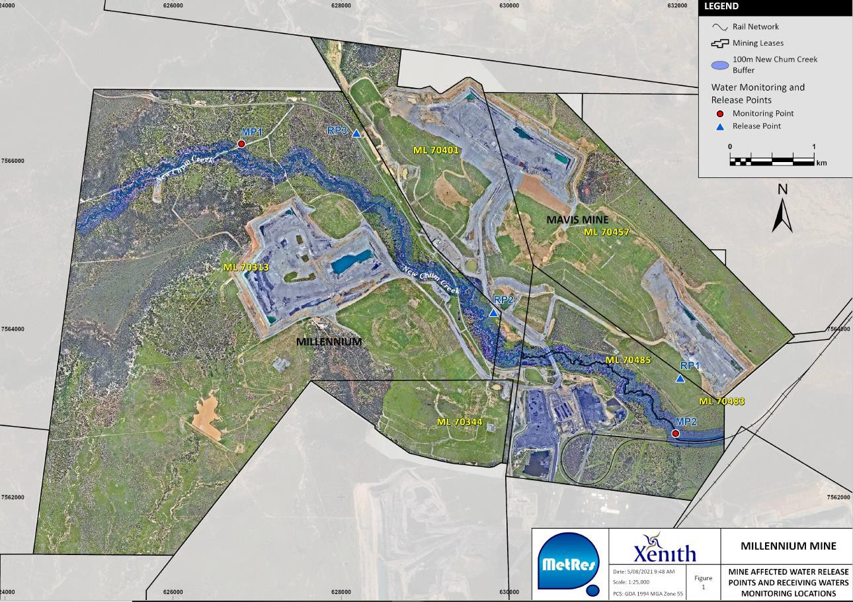

Page 54 of 60 • ESR/2016/3415 • Version 4.01 • Last reviewed: 21 JAN 26 ABN 46 640 294 485

Figure 2: Authorised disturbance footprint

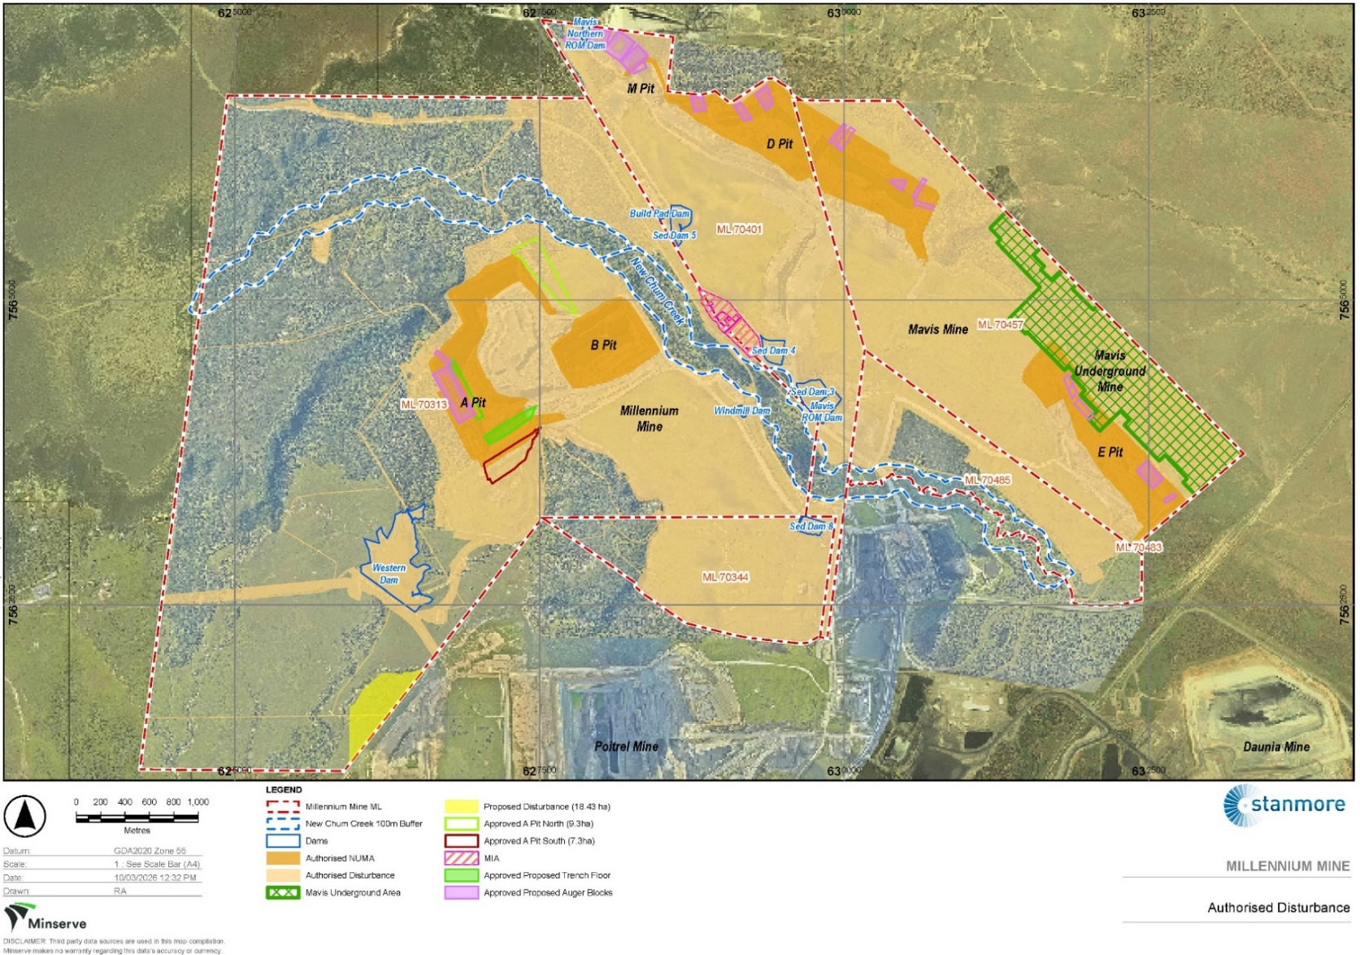

Figure 3: Work areas in nature conservation areas (as per Table F3)
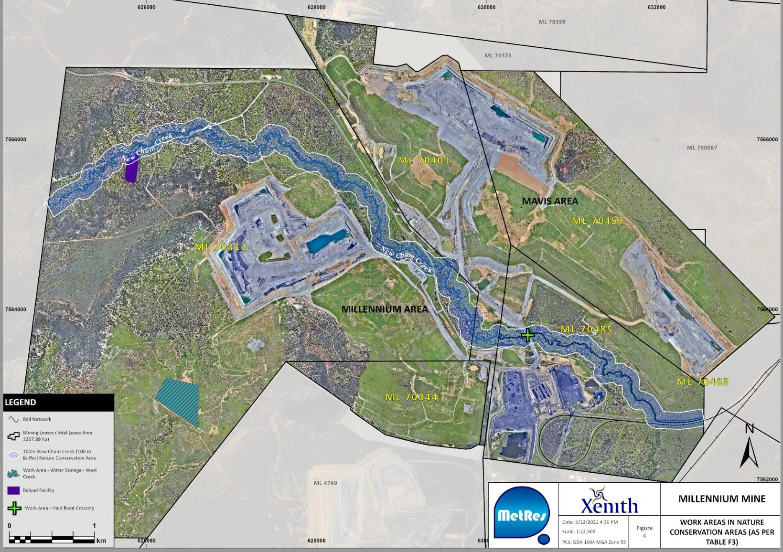

Figure 4: ROM storage, spoil and rejects/tailings disposal

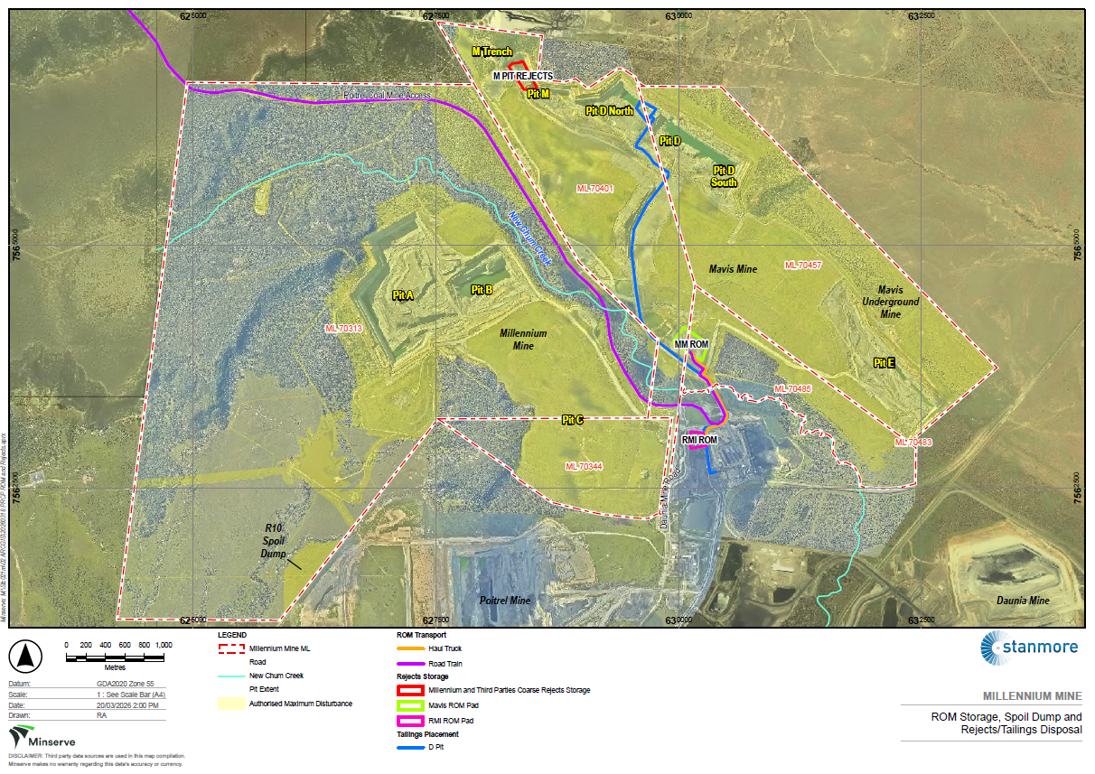

Figure 5: Groundwater monitoring bore network
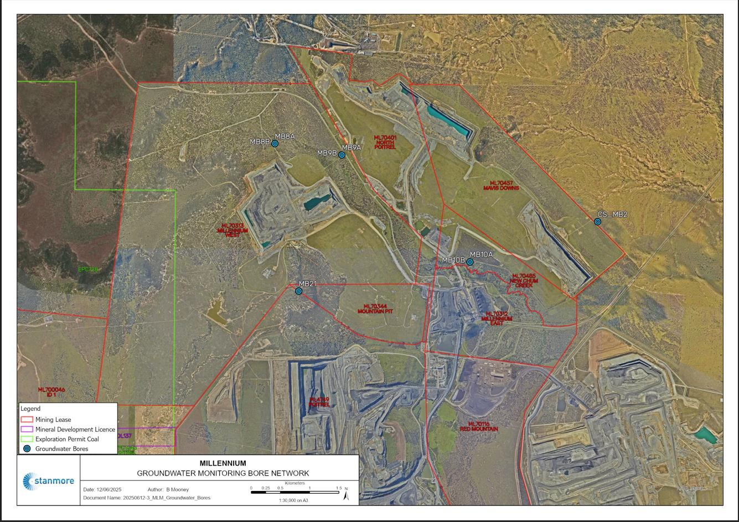

Figure 6: Air Quality Monitoring Locations
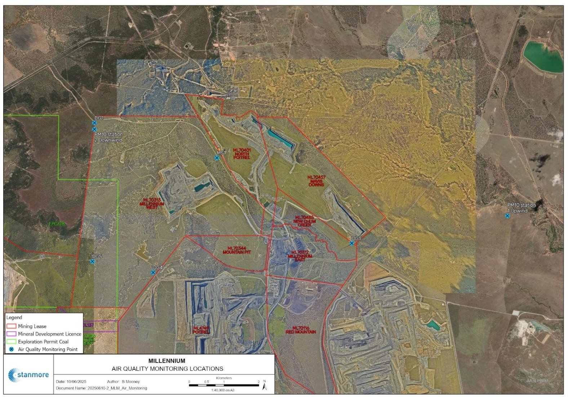

END OF ENVIRONMENTAL AUTHORITY

Page 60 of 60 • ESR/2016/3415 • Version 4.01 • Last reviewed: 21 JAN 26 ABN 46 640 294 485

